2015 Odyssey

Greeting to all my golf friends,

2015 was another exciting and gratifying year. The highlights:

Top 100 Lists Revised

Trips
May: Arizona (Stone Canyon), Mexico (Diamante Dunes & El Cardonal, Quivira), South Korea (Whistling
Rock, South Cape, Haesley Nine Bridges, Nine Bridges Jeju)
July: Rochester, NY (Oak Hill West & East, CC of Rochester, Monroe)
August: West Virginia (Greenbrier-The Greenbrier, The Meadow, The Snead, The Old White)
September: Canada (Devil’s Pulpit & Paintbrush, Toronto GC, Beacon Hall, Cabot Cliffs and Links)
November/December: South Africa (14 courses plus safari; 28 days; 23,200 miles round trip)

Significant One Day
Florida: CC of Florida (April) & Mountain Lake (October) - New York: Fenway (June)

Other Items
Website/Blog “The Odyssey” (thegolfodyssey.com) going strong with more content added.
Writing of book, A Golf Odyssey with The Real McCoy, will pickup in 2016.
Moving northern home from Boston area to Boothbay, Maine.
Miscellaneous: Facebook, finally shooting my age, playing in all 50 states, hosting Roger Clemens.

Future Plans
2016
Bermuda: Mid Ocean
Canada/Alaska/Washington: Banff Springs, Jasper, Moose Run (Creek), Gamble Sands
New Zealand/Australia/Singapore/Vietnam/Thailand: Tara-iti, Kinloch, Hills, Jack’s Point, Cape Wickham,
Ocean Dunes, Sentosa, The Bluffs Ho Tram Strip, Amata Springs, Ayodhya Links
2017
France/Netherlands/Scotland/England/Ireland: Sperone, St. Emilion, Les Bordes, Morfontaine, De Pan,
Royal Hague, Silloth on Solway, Trump Turnberry (Ailsa), Royal Portrush (Dunluce),
Illinois/Wisconsin/Minnesota/North Dakota/South Dakota/Iowa: Chicago Golf, Erin Hills, Sand Valley,
Lawsonia, White Bear Yacht Club, Hawktree, Sutton Bay, The Harvester
Florida: Streamsong (Black)

Top 100 Lists Revised

In the odd-numbered years, both GOLF Magazine (World 100) and Golf Digest (USA 100) revise their biennial rankings. Participating in the GOLF Magazine voting since 1987 is an honor and great fun because I have to review every candidate course I have played over the years. The GOLF Magazine nomination list has 493 courses and I have played 389 (79%). In my mind I replay each course and all the circumstances, including the travel to and from each, and remember all the nice people I have been fortunate to meet. I guess you could say I am really into nostalgia.

Added to GOLF Magazine World List (6)
#73 Ellerston*, Ellerston, Australia, Greg Norman/Bob Harrison 2001
76 Ayodhya Links*, Bangkok, Thailand, Thompson/Perrett/Lobb/Pitak 2007
81 California Golf Club*, San Francisco, CA, Macan 1926, MacKenzie 1928, Phillips 2007
84 Winged Foot (East)*, Mamaroneck, NY, A.W. Tillinghast 1923, Gil Hanse 2015
92 Koninklijke Haagsche*, Wassenaar, Netherlands, Colt/Alison 1938, Frank Pont 2007
95 Sunningdale (New)*, Sunningdale, England, H.S. Colt 1922
* Played as of 12/31/2015

Eliminated from GOLF Magazine World List (6)
#85 Medinah (#3), Medinah, IL, Tom Bendelow 1926
88 Old Macdonald, Bandon, OR, Tom Doak/Jim Urbina 2010
89 Loch Lomond, Luss, Scotland, Tom Weiskopf/Jay Moorish 1994
90 Old Sandwich, Plymouth, MA, Bill Coore/Ben Crenshaw 2004
94 Royal Melbourne (East), Melbourne, Australia, Alex Russell 1926
99 Royal Adelaide, Adelaide, Australia, Alister MacKenzie 1926

Fortunately, I had already played the six new additions on the world list, so there was nothing to do to stay current. In 1988, I first completed the World Top 100 (1987 list) and have stayed current with the 14 revised lists since then.

Added to Golf Digest USA List (7)
#42 Erin Hills*, Erin, WI, Michael Hurdzan/Dana Fry/Ron Whitten 2006
51 Oak Tree*, Edmond, OK, Pete/Alice Dye 1975
52 Camargo*, Indian Hill, OH, Seth Raynor/Charles Banks 1927
64 Yeamans Hall*, Charleston, SC, Seth Raynor/Charles Banks 1926
83 Valley Club of Montecito*, Montecito, CA, Alister MacKenzie/Robert Hunter 1929
99 Shoreacres*, Lake Bluff, IL, Seth Raynor 1921
100 Streamsong (Red)* Bill Coore/Ben Crenshaw 2012
* Played as of 12/31/2015

Eliminated from Golf Digest USA List (7)
#71 Shoal Creek, Shoal Creek, AL, Jack Nicklaus 1997
82 Sahalee (S/N), Sammamish, WA, Ted Robinson 1969
85 Forest Highlands (Canyon), Flagstaff, AZ, Tom Weiskopf/Jay Moorish 1998
86 Mayacama, Santa Rosa, CA, Jack Nicklaus 2001
96 Harbor Town, Hilton Head Island, SC, Pete Dye/Jack Nicklaus 1969
97 Kapalua (Plantation), Kapalua Maui, HI, Bill Coore/Ben Crenshaw 1991
98 Grandfather, Linville, NC, Ellis Maples 1967

Just as with the world list, I had already played the seven new additions on the USA list, so there was nothing to do to stay current. In 1984, I first completed the USA Top 100 (1983 list) and have stayed current with the 16 revised lists since then.

Arizona (Stone Canyon), Mexico (Diamante Dunes & El Cardonal, Quivira), South Korea (Whistling Rock, South Cape, Haesley Nine Bridges, The Club at Nine Bridges)

Arizona-The Stone Canyon Club
The first big trip of 2015 started on Saturday night May 9 with a flight from Boston to Phoenix and then a 100- mile drive south to Oro Valley (just north of Tucson). The Stone Canyon Club is a high-end real estate development course designed by Jay Morrish in 2000. The course received its highest recognition with a one-time placement on the Golf Digest USA Top 100 in 2009 at #68. The Phil Mickelson golf course investment group bought Stone Canyon in 2014 and is making investments to complete the project such as a clubhouse just past the 18th green. The sloping terrain is at the base of the Tortolita Mountains with the taller Catalina Mountains as a backdrop. Downtown Tucson is visible from some elevated tees. The holes twist through rock formations and tall saguaros.

Back in Phoenix there was dinner with Tim Mickelson, just named Pac-12 Men's Golf Coach of the Year (Arizona State). Before dinner Tim took me on a tour of his golf facilities including team rooms, practice facilities, and 18-hole course. I was impressed to see his #1 player, Jon Rahm, out practicing on a Sunday evening. The next week Jon would win the Ben Hogan Award as the #1 college golfer of the year. He is from Spain, so we chatted for a few minutes about golf courses in that country. Jon is a likable young man and it will be interesting to seen how his senior year goes and on into the professional ranks.

Mexico-Diamante
From Phoenix it is on to the Los Cabos Airport at the southern tip of Baja California Sur, Mexico. A one-hour drive south brings you to Diamante, just west of Cabo San Lucas. The area is still recovering from hurricane Odile seven months ago. A new highway is almost finished from the airport that bypasses the busy town of Cabo San Lucas. Diamante is a high-end real estate development where the Sea of Cortez meets the Pacific Ocean.

This is a return trip. A warm greeting comes from host Jeff Scott who took care of the World Club Championship group in October 2012. (I’m a spectator in that group). On the 1st tee of the Dunes course I am joined by Tony Maramarco, a buddy for 30 years. Davis Love III and brother Mark designed the course in 2010 and it is currently ranked #38 in the world by GOLF Magazine. One of the reasons for returning here is to see two replacement holes. The old mundane inland holes 12 and 13 were redesigned and moved much closer to the ocean. These new water views further enhance the overall Diamante Dunes experience (massive sand dunes, extensive sea vistas, wind throughout most of the course).

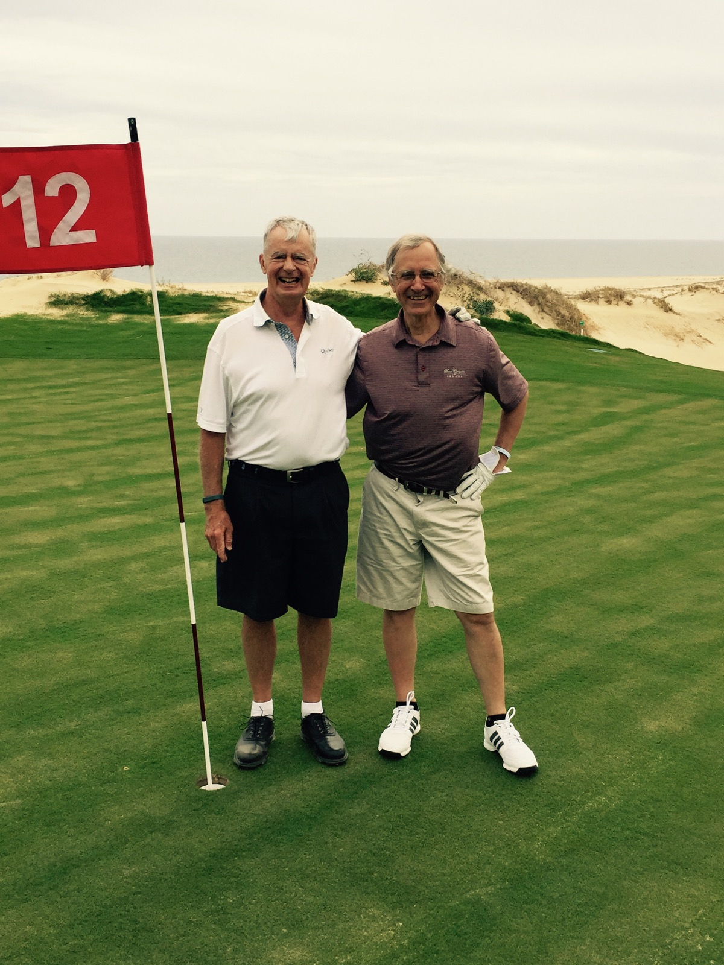
Diamante Dunes new par 5 12th green. Senor Roberto with Senor ‘tonio Maramarco.

More course changes are coming: a par 3 hole between the 9th green and the old 10th tee. The present awkwardly long and straight up hill par 4 10th hole will become a shorter 11th hole with the green placed in a right side dune. The dramatic par 5 17th hole will now become the finishing hole with the difficult 18th hole, near the clubhouse, eliminated. All these changes make sense as I like to see courses evolve with expert design input. Tom Fazio once told me that no matter what you think, every great course has been altered over time.

The real reason for being at Diamante is to get a crack at Tiger Woods’ first completed golf course design effort. The El Cardonal course is on a hillside among deep arroyos with some distant Pacific Ocean views. So what is Tiger bringing to the world of golf course architecture? Wide fairways dotted by many strategically placed large and deep bunkers (some in middle of fairways, plus uphill and downhill sloping approach shots to very large challenging greens surrounded by large areas for chipping and pitching. Lurking behind Tiger's smiling pearly whites are versions of Pete Dye almost over-the-top-greens. Four greens measure 60 yards in depth and two are 45 yards wide. In addition to noticeable humps and slopes are false fronts, sides and backs (Tiger calls them fold-offs). Bottom line: a good first effort in need of a little green softening.
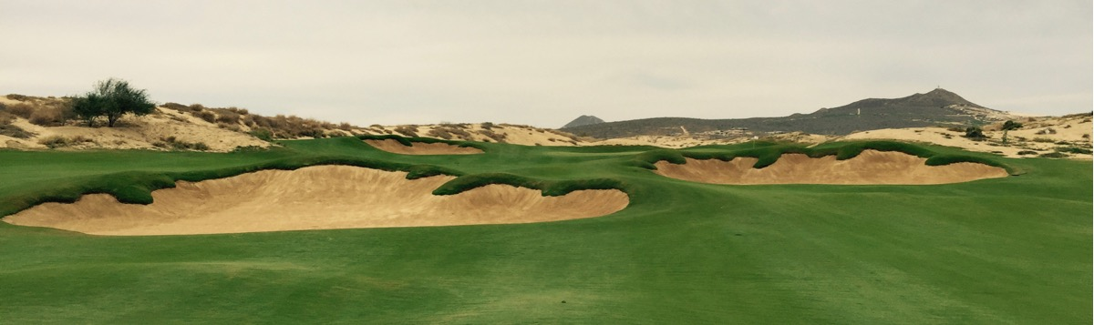
Diamante El Cardonal mid-fairway deep bunkers.

Quivira Golf Club
The Quivira Golf Club, near Diamante as the crow flies, is a long percolating (15 years in planning) Jack Nicklaus design that opened in December 2014 as part of a hotel and time share resort. Again, time share owner Tony Maramarco is a playing companion. You cannot play the course without a cart as many of the holes are on extremely steep terrain. It takes almost five minutes to get from the 4th green to the 5th tee. Quivira is a fun course consisting of many really good holes with beautiful Pacific Ocean views and crashing surf.

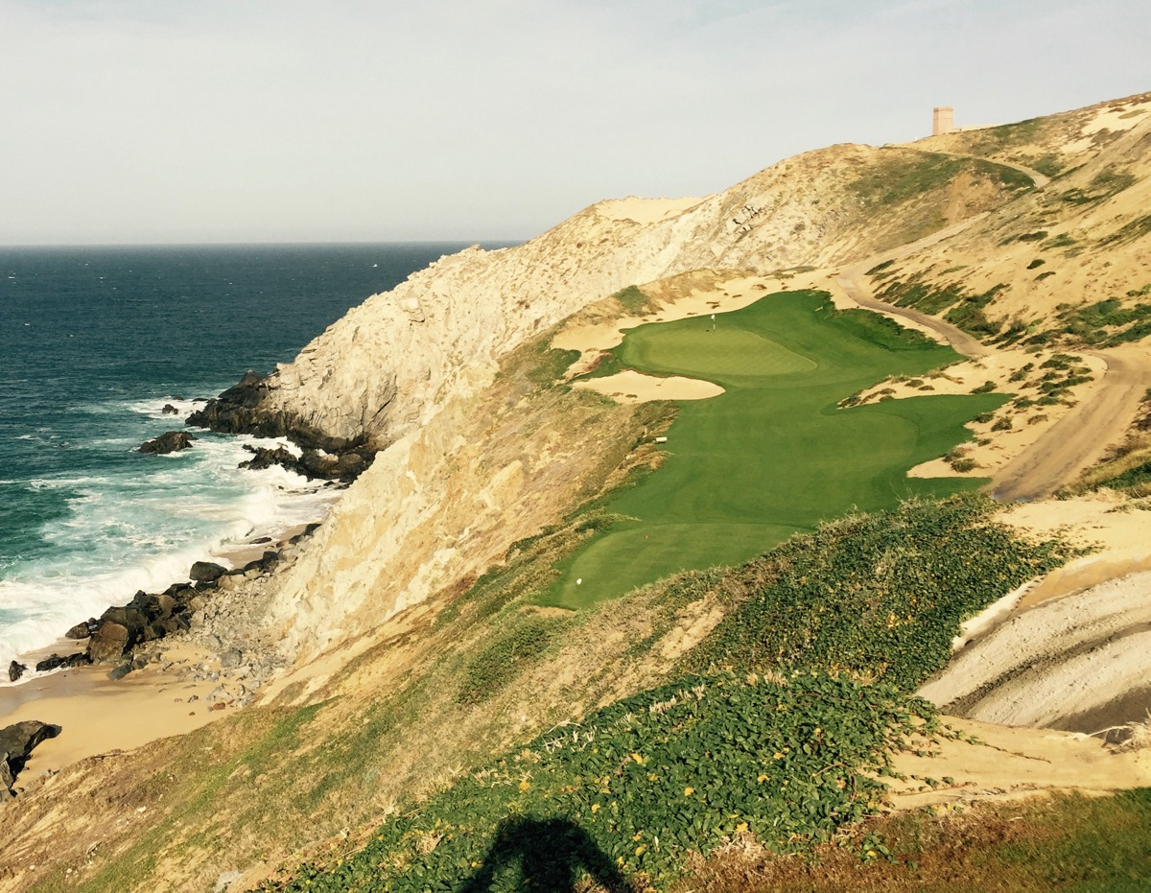
Quivira par 3 #6 at 180 downhill yards.

South Korea
The next three days were hectic to say the least: drive from Diamante to airport, fly to Los Angeles (915 miles 2 hours 15 minutes), fly to Seoul (Incheon Airport) leaving Wednesday 11:30pm (a 6,000-mile 12-hour flight) arriving 4:40am Friday (Thursday disappears with the international dateline crossing), drive one hour east to Whistling Rock Country Club, play the 27-hole course walking, banquet style meal, drive one hour west to Gimpo (domestic airport), 6:45pm one-hour bumpy flight (190 miles) to Jinju, drive one hour south to South Cape Owners Club, snack, in bed at 11pm. Summary: started 6am Wednesday in Mexico, 3 flights (7,100 miles), play 45 holes (27 walking), after 49 hours finally in a real bed (Duxiana).

The original plan for Korea was to rest Friday, play a course in Seoul on Saturday, and then meet up with a group on Sunday. A few weeks before trip liftoff, I saw an article in English based Golf Course Architecture magazine (Adam Lawrence provides most of the material) about a new course in South Korea called South Cape. I contacted Joann Dost, a fellow GOLF Magazine panelist, former LPGA player, and long-time golf course photographer. She is involved in the photography for South Cape and asked me if I would also like to play at her other Korean client, Whistling Rock. The answer was “of course” so she organized and accompanied me on the two-day program. Both clubs were helpful with all the details, and the schedule went like clockwork. Special thanks go to Whistling Rock manager Kent Baek (spoke excellent English and is a great guy) for getting us through the tough Seoul area traffic for the entire two days.

Whistling Rock Country Club
Whistling Rock Country Club is in the mountainous and lakes resort area of Chuncheon. My host and playing companion was American David Fisher, a Vice President of this high-end, business-oriented private club with international members. The owner is the Taekwang Group, a Korean chaebol (conglomerate) involved in textiles, chemicals, cable TV, and financial services. It is a 27-hole course, rated #8 in South Korea, designed by American Ted Robinson, Jr with 18 holes opened in 2011 and last nine in 2012. It is. In the beautifully quiet environment, the holes are perched on steep slopes where much rock blasting was required (about one million cubic yards of rock and soil moved). Thousands of trees have been planted. Distinctive features include water hazards (many lakes connected by streams and waterfalls) along with large, challenging, busy greens.

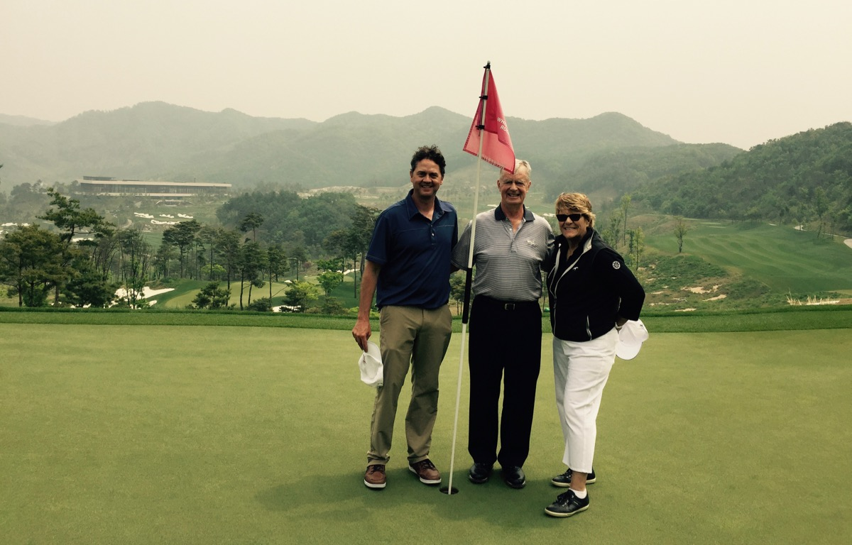
Whistling Rock with David Fisher & Joann Dost (note clubhouse upper left).

After playing the first 18 holes, we had a multi-course meal hosted by club Executive Director Eun-Mi Oh, KLPGA Pro Golfer. We were in one of several spacious conference rooms in the handsome, large, modern-designed clubhouse (167,000 square feet, four-level). Company Chairman Lee is an avid art collector so there are many paintings and sculptures in the clubhouse as well as sculptures outside in the numerous gardens and patios.

South Cape Owners Club
The South Cape Owners Club is on the south side of Namhae Island (off the southern tip of the Korean peninsula) on the Sea of Japan. Jeju Island is 120 miles southwest and Hokkaido, Japan is 165 miles southeast. The day was spent with owner Jae Bong Chung and Joann. Chung and wife, Ms. Moon, created a successful fashion company. A few years ago they were inspired to build a boutique resort after visiting Kauri Cliffs in New Zealand and seeing what Julian and Josie Robertson had created. About $200 million later they have: an American Kyle Phillips designed golf course opened in 2013; a large tastefully modern clubhouse (162,600 square feet); a separate comfortable 40-room hotel, spa, swimming pool; and luxury villas with sea views for sale. The remarkable clubhouse has curving concrete canopies with much glass exposing many attention-grabbing views throughout the property. Modern sculptures are present both inside and outside the clubhouse.

The course is on a rocky coastline in hilly terrain with water views from all 18 holes. Much blasting was done with some holes on the back nine hanging almost over clifftops. Part of the multi million-dollar tea house at the 15th green actually does jut out over the sea, which is about 100 feet below. The most memorable hole is #16, a par 3 of 223 yards to 151 yards from an elevated tee with a steep downhill shot over an inlet to a wide green with a bailout right. This is a “pay attention shot” (hit it extremely well or reload). It is comparable in excitement to #16 at Cypress Point (greatest par-3 in world). In all, South Cape is a world class experience.

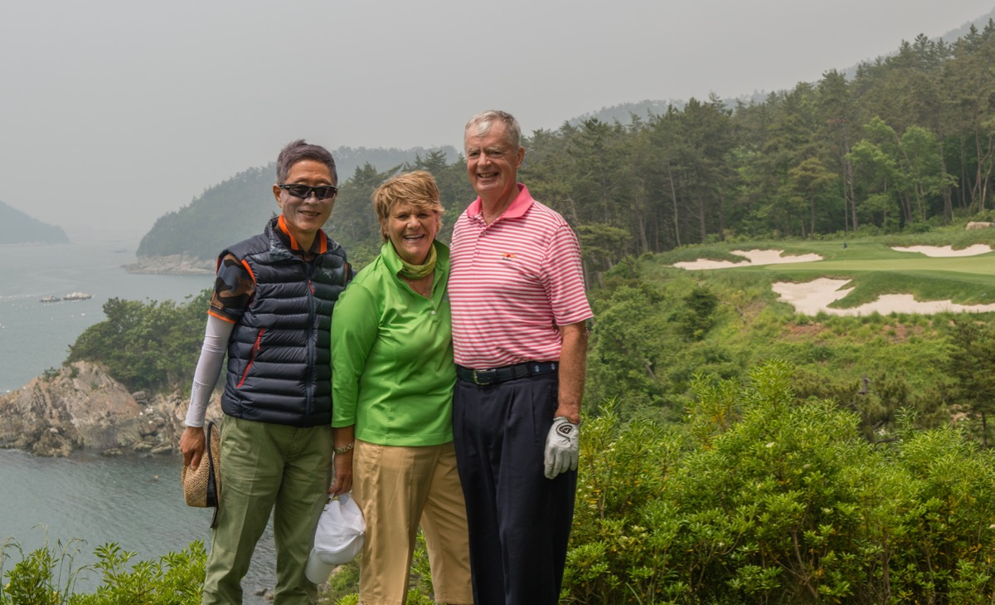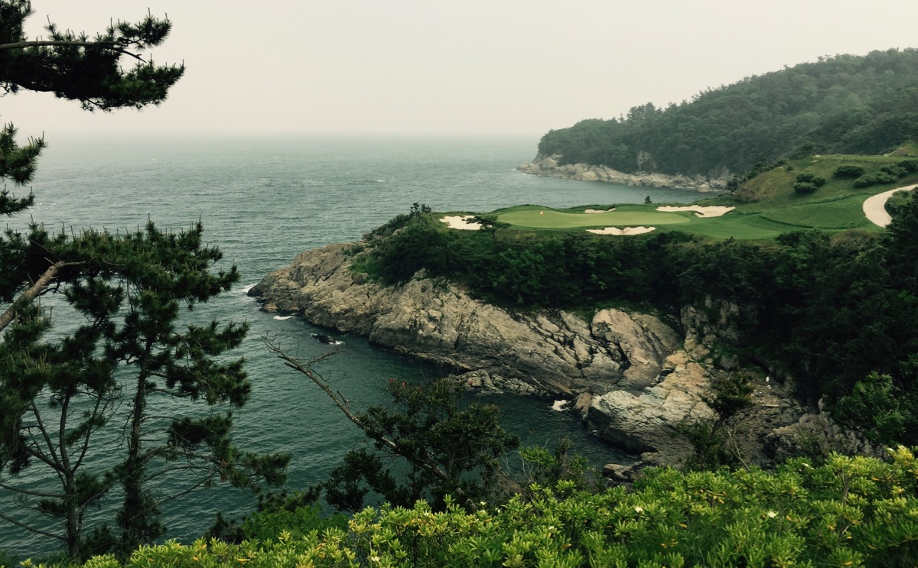
South Cape with owner Chung Jae Bong and Joann Dost. Par 3 16th hole downhill 223 yards to 151 yards.

At dinner Chairman Chung asked “…when will Americans start coming to South Korea to play golf?” I am always hesitant to say anything that is even remotely negative to an owner of a new golf facility because he has put his blood, sweat, tears, and money into his project and is rightfully extremely proud of what he has accomplished. Thus, I do not want to offend this person in any way. However, Chung wanted a truthful answer so I said Americans would not be coming to South Korea specifically to play golf. I told him Americans traveling overseas for golf go first and foremost to the UK and Ireland. If they are going west over the Pacific Ocean it is to New Zealand and Australia. After returning home I surveyed many overseas golf traveling friends and they all confirmed my initial reaction.

World Club Championship
Back in Seoul it is the start of a week with the World Club Championship (WCC) group. This production originated with the imaginative and energetic David Smith in 2002. Basically, each year he takes the GOLF Magazine World Top 100 ranking and invites about 20 of the clubs on the list to a two-man competition. The teams consist of the current club champion and a partner of the champion’s choosing from the same club. In some cases, the partner is a determined in a special club competition.

The WCC alternates between The Club at Nine Bridges on Jeju Island and other clubs on the Top 100 list. The competition is filmed for TV (the Golf Channel and Sky in the UK show it) with Terry Jastrow as producer/director. Terry was the producer/director at ABC Sports for many years and then did the resurrection of “Shell’s Wonderful World of Golf” series for Jack Nicklaus Productions. The quality of play is really good along with a warm feeling of sportsmanship and fellowship among the contestants.

Golf Magazine is one of the sponsors of the WCC and sixteen of the course rating panel have been invited to attend as spectators. During the week we have a lively panelist meeting with our leader, Joe Passov (Senior Editor Travel/Course Rankings and his famous ‘Travelin’ Joe’s” monthly article).

Haesley Nine Bridges
The first day is at Haesley Nine Bridges in Yeoju, about one-hour east of Seoul in mountains. This is a private club with the #3 ranked course in South Korea designed by American David Dale. It opened in 2009 along a modern-designed four-level 172,000 square foot clubhouse. One of the themes on this trip has been seeing uniquely designed, beautiful, enormous and expensive clubhouses. In three days at Whispering Rock, South Cape, and Haesley I have seen three of the most impressive golf clubhouses in the world. Koreans certainly know how to combine the creation of quality golf course design with quality clubhouse design.

Haesley Nine Bridges Golf Magazine panelists L/R Gary Hart, Brian Morgan, Prakash Bhandari.

The Club at Nine Bridges
From Haesley it is on to Jeju Island (off the southern tip of Korea) and The Club at Nine Bridges where we will be for the rest of the week. The private course is rated #43 in the world by GOLF Magazine and was designed by Ron Fream and David Dale in 2001. The course is a wonderful blend of good holes in a picturesque and totally quiet setting of forests with mountain backdrops (Mount Halla at 6,000 feet is the tallest mountain in South Korea).
Talking to golf course architects is a special treat, so I arranged a golf game with the course designer David Dale. If you look closely at the accompanied picture, David has a cauliflower ear from all the design questions I threw at him (the day of the 1,000 questions). He is really a great guy who answered all the questions in detail. I learned a tremendous amount this day about what happened here and about golf course architecture in general. Unlike all the rock blasting done to build golf courses on the mainland, no blasting is permitted on Jeju Island. Also, the bunker sand at Nine Bridges was imported from China. David is on a continuing program to make this course even better, and ownership (CJ Group) is accepting his ideas. David is knowledgeable, articulate, and enthusiastic about his profession.

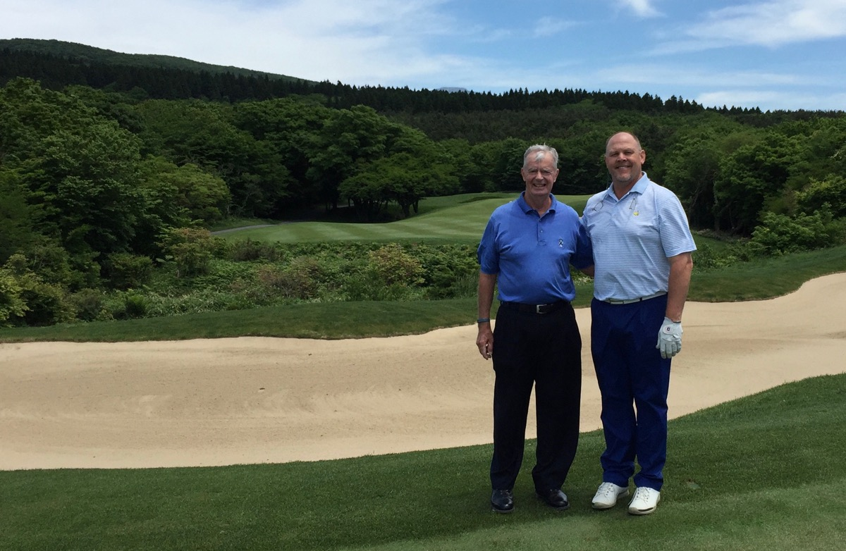
Nine Bridges with course designer David Dale.

The other neat person I had the privilege to be with at Nine Bridges was Eddie Merrins. I have heard so much about him. He is a legend in the golf world as player (starting in Louisiana), teacher, college coach (UCLA), director of golf for 40 years at Bel-Air Country Club in Los Angeles, and now Pro Emeritus there. After just the first 30 seconds of our initial conversation, I knew I was with someone special. I could not get enough of Eddie and was able to talk to him every day during the entire week.
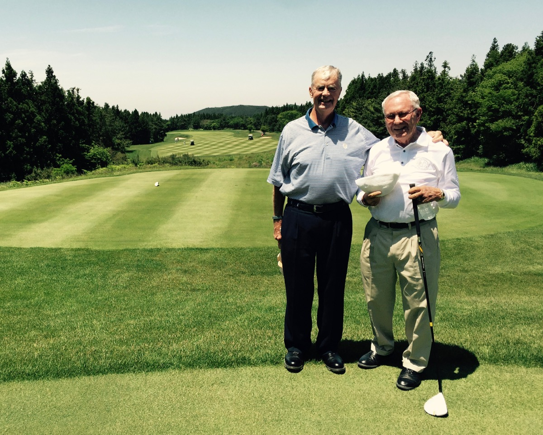
Nine Bridges with Eddie Merrins

Rochester, New York

In late July I drove 420 miles west from the Boston area to western New York State to play the best four courses in Rochester. In the Pittsford-Brighton area east of downtown, it is only four miles between the Country Club of Rochester and Monroe, with Oak Hill (East & West) in between. All three clubs are private and the four originally designed by Donald Ross. The week was organized by friend Griff Owen, who was my host at Oak Hill during the 1997 100-in-100 trip. We have played a few times since then with the continuing though of doing it once in Rochester.

I lived in Buffalo, NY for the first 12 years of my life (never playing golf). My dad was a food salesman covering Western NY. One summer day in 1950 he took me to Rochester, where I shagged practice balls for the legendary Sam Urzetta. Later that summer he won the U.S. Amateur (at age 24) and then joined the PGA Tour. In 1956 he became the much beloved head professional at The Country Club of Rochester and held that position until 1993. All I did that afternoon in 1950 was move back at 10 yard intervals and let all his shots float into my baseball glove as I remained stationary (no reaching or moving for any shot). I cannot recall how this all came about but clearly remember it as my introduction to golf.

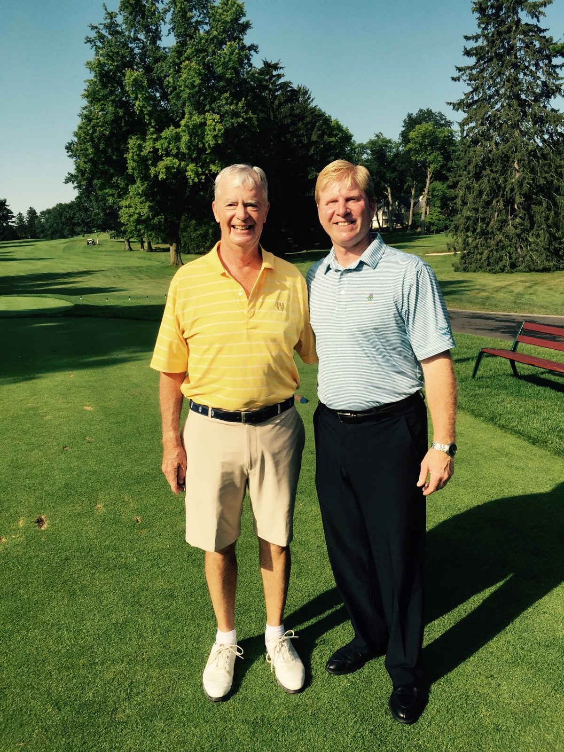
CC of Rochester with head professional Mike Urzetta, son of Sam Urzetta.

The Country Club of Rochester
At the The Country Club of Rochester (CCR) I had a picture taken with Mike Urzetta, Sam’s son and head professional. At this moment I reflect on how quickly 65 years have gone by between my meeting two generations of Urzetta’s in Rochester. What a truly amazing ride!

Walter Hagen started caddying here at age seven and later became the CCR head professional while pursuing a Hall of Fame professional career. The Hagen Lounge in the clubhouse is worth visiting to view all of his memorabilia.

CCR (rated #27 in NY State) was formed in 1895 and the current Donald Ross design came into being in 1912. Home town boy Robert Trent Jones did some remodeling in 1960 and then Gil Hanse implemented a full master plan in 2004. The clubhouse, pro shop, and holes 17 and 18 are on flat ground on one side of Elmwood Avenue. The other 16 holes are across the street in nicely rolling terrain including two steep hills. The compact routing (easy walk) goes through many mature trees (tall and thick), a few tight to fairways. There are 80 bunkers and water comes into play on six holes. The bunkers are grass faced and pinch the front of greens on several holes. The greens vary in size with emphasis more on medium-to-small. Most have gradual slopes with a couple severe.

Oak Hill Country Club (East)
At Oak Hill Country Club (East) I am with host Griff Owen and member Dr. David Fries. Some of the conversation on the course and at dinner is about the John R. Williams Tournament (four-ball scratch amateurs from around the USA and Canada), in which Dave and Griff have been heavily involved for many years. This year’s September event had Nick Faldo as guest speaker, so the excitement was particularly high. Nick’s favorite format is Q & A and not a formal speech. I received a tape of the presentation in October and Nick was insightful and entertaining.

This is my third crack at the East Course (1980 and 1997). The course is consistently included on world 100 lists and is currently rated #68. The club began in 1901 and after a land transaction with the University of Rochester in 1921, two Donald Ross-designed courses opened in 1926. Since then Robert Trent Jones worked here in 1956 and 1967, while George and Tom Fazio did some controversial work in 1979. Allen Creek meanders throughout the property and Ross made it a key feature on many holes. Streams act as cross hazards in front of seven greens, and other holes have the creek as a lateral hazard. There is also a pond at the right greenside on #15.

Oak Hill is noted for its thousands of mature trees (oaks, maples, evergreens, and elms, although the latter suffered from Dutch Elm disease in the 1970’s). The club is on a program to thin out the trees, but they still are a key factor in playing strategy. Combining this with many elevated and pinched greens (many of the 80 bunkers crowd green openings). The greens (small, medium, large) have mush slope and side banks, so good recovery chipping come into play. The bottom line: the East Course continues to be a major professional championship course.

Monroe Golf Club
At Monroe Golf Club, my playing companions were Griff and 35-year head professional Jim Mrva, a real treat because Jim was the 2010 PGA Golf Professional of the Year. While we were having lunch, Jim sprung into action with many players milling around the first tee and practice areas at the start of the mid-afternoon men’s group (125 total golfers). A couple of players looked a little confused, so Jim went directly over to help them out. I was so impressed, as this was something he could have asked his assistants to handled. Instead, I observed a true club professional do what came natural.

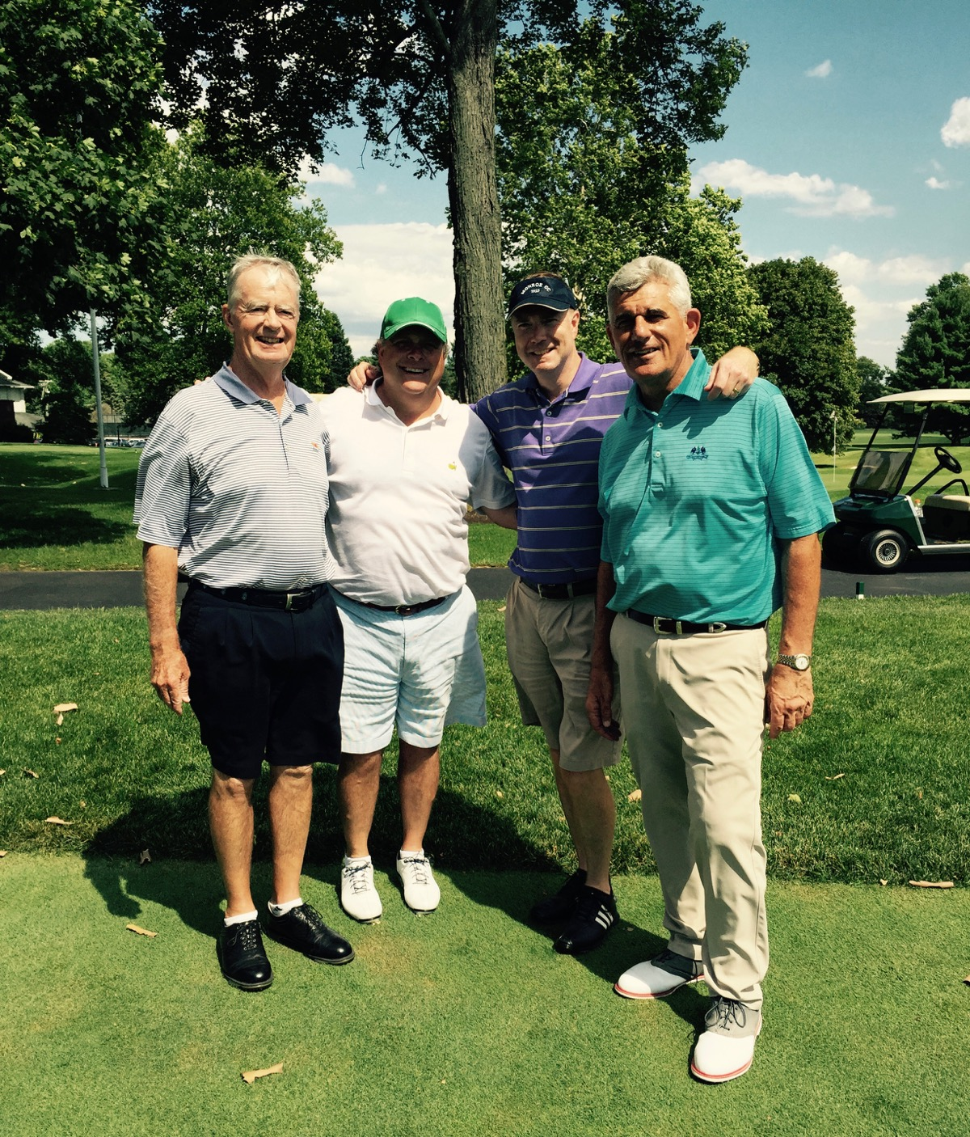
Monroe GC with Griff Owen on my left and Jim Mrva, PGA Golf Professional of the Year on my far left.

Monroe opened for play in 1924 with a Donald Ross design. It is the only sand-based course in the area and thousands of trees were planted after 1924. Brian Silva supervised fairway re-contouring in 1986. Tree removal started in 2003 (2,000 have been eliminated). Gil Hanse rebuilt all the bunkers and greens in 2007/2008.

One of the reasons Donald Ross became involved with the creation of the Oak Hill and Monroe courses was a girl friend living in Rome, NY (120 miles east of Rochester). In the early 1920’s Ross lost his first wife and while designing the Teugega Country Club course in Rome, he actually became engaged to the club’s best lady golfer. Sadly, the lady was stricken with cancer and died.

The course is presently rated #30 in NY State. Since 1937 the club has hosted the annual Monroe Invitational, a mid-June tournament for aspiring national junior and college golfers. Tiger played in 1993 (did not win) and Dustin Johnson won in 2007.

At the beginning of the round the course presents a somewhat flattish look, but natural deep fairway swales and ridges along with a few hills provide enough movement for many interesting holes. There are 100 bunkers and no water hazards. The compact routing makes for an easy walk. The many raised greens are steeply sloped at the sides and back, so bring your chipping and pitching game to keep the score under control.

Oak Hill West
The trip finale was at the Oak Hill West course, a Donald Ross original 1926 design not tampered with in any way. Many of the members think the West is better than the more highly rated East course. One rating service has the West as #23 in NY State while the East #8. What the members experience is two different looking and playing courses. The abundance of mature trees is also present on the West, but not to the strategic extent as the East. There are only 57 bunkers and the only water is a pond at the front left of the par 4 12th green (a really good short hole). There are several straight holes, some with ridges in fairways. The greens are mostly open in front so the ground game is important. Some of the greens are elevated with steep side falloffs.
My parting observation concerns the Rochester economy. The city had been the corporate headquarters for three major companies that saw their highly profitable core businesses disappear because of new technologies developed by other companies. Bausch & Lomb, Zerox, and Kodak had a large employee base in Rochester with good-paying jobs. All that went up in smoke, and you might expect to find a struggling city. The opposite is true. The former employees of these companies and the local suppliers to these company were well educated and highly motivated. The result is a stable and vibrant city based on many newly-created small businesses.

The Greenbrier Resort & Real Estate Development

In early September I went to The Greenbrier Resort in White Sulphur Springs, West Virginia. This is a famous place (28 USA presidents have stayed here) dating back to 1858. The Chesapeake & Ohio railroad bought the 10,000-acre property in 1910. Local entrepreneur and billionaire Jim Justice bought the resort out of bankruptcy in 2009 and has invested over $150 millions to upgrade all the facilities. There is a huge 710-bedroom hotel, four golf courses, and 54 other activities including tennis, falconry, horseback riding, fishing, and gambling in a new casino. Real estate development is also a major factor here with estate homes and cottages. Justice has dramatically increased the resort’s visibility by creating the mid-summer Greenbrier Classic on the PGA Tour.

The golf courses reside on a valley floor surrounded by the tall Allegheny Mountains. Three of the courses are connected to the resort. The Old White TPC (rated #3 in WV) is a C.B. Macdonald and Seth Raynor 1915 design. Lester George did a renovation in 2009. The Greenbrier (rated #6 in WV) is a Seth Raynor 1924 original with Jack Nicklaus updates in 1977 for the 1979 Ryder Cup. The Meadows (rated #11 in WV) is a mixture of Alexander Findlay (designed a nine-hole course called Lakeside), Dick Wilson (added the second nine in 1962), Bob Cupp (did a major upgrade in 1999 and the course name was changed to The Meadows), and Tom Fazio (changed two holes in 2004).

The Old White TPC
The Old White TPC is mostly on flat terrain with a few sloping holes. There are some of the famous Macdonald/Raynor green designs from Great Britain – Redan on #8, Alps on #13, and Eden on #15. Some of the greens are huge (#3 is 63 yards deep with a valley in the middle so it is a Biarritz design). There are 72 bunkers (some old style square). Water is around on eight holes, but only comes into play on three holes. There is also some old fashioned mounding, particularly around the 5th green. Trees are not really a factor unless you are way off line. Houses border some holes. Beautiful mountain views are present on other holes.

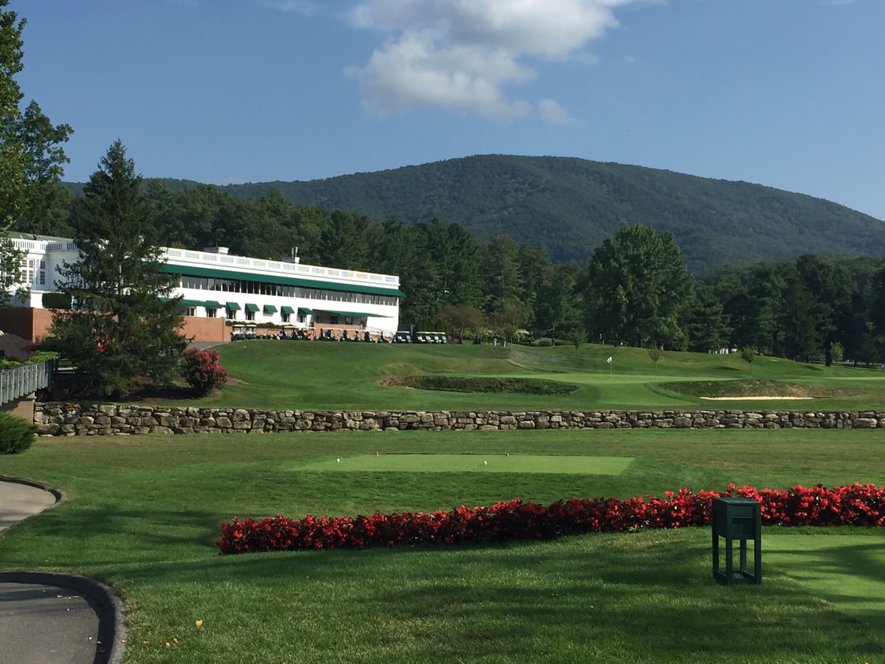
Old White par 3 #18

The Greenbrier
The Greenbrier course design is a nice blending of Seth Raynor and Jack Nicklaus. Although there are some forced carries into terraced greens, in general the course looks and plays more like a softer Raynor design. Jack was just getting started in the design business in 1977, so on this project it seems like he left many of the original design characteristics intact.

The Greenbrier course is the only one here with a lot of natural ground movement of up, down, and side. Many of the holes are lined by forests on both sides. Housing is only present on a few holes. A busy railroad track is close to a few holes with the feeling that you could almost touch the huge locomotives. There are 48 bunkers with most of the greens semi open. Water comes into play with a large pond influencing holes #2, #16, and #17 while a wide stream fronts the #10 and #11 greens. The finish is at a huge double green shared with #18 on The Meadow course.

The Meadow
The Meadow course lies between Old White and The Greenbrier. There is slope to some of the holes while others are flat. Mature hardwood trees dot many of the holes, but evergreens dominate on what looks like newly-constructed holes. Out in the open areas there are scenic views of the surrounding mountains. Several holes are straight and parallel to busy Route 60 (name plate on street signs Sam Snead Boulevard) which cuts through the entire resort property. There are only 53 bunkers and water comes into play on eight holes.

The Snead
Continuing the real estate development theme is The Snead course (rated #4 in WV) at The Greenbrier Sporting Club. This is a Tom Fazio 2004 design private equity club ($120,000 initiation fee which can be used to partially offset a home site purchase). Multi million dollar homes dot the course. Most of the terrain is on the former hotel airstrip. Three holes (#6, #7, #8) are tucked in sloping terrain on the other side of Route 60. On the opposite side of the property, hole #15 and the tee on #16 are perched 85 feet high on the side of a mountain. The beautiful views from this elevated part of the course stretch for miles.

A lot of dirt was moved to create interesting fairway contours. To make things exciting Fazio has 91 bunkers (many are big and deep with high faces). Water comes into play on 12 holes (streams, marshes, ponds). The final challenge is huge and wild greens with steep slopes, bowls, plateaus, and troughs. There are numerous false fronts, sides, and backs. Roll-offs to deep collection areas is possible at most of the greens. These might be the most extreme Tom Fazio greens that I have ever seen. This statement made me do something I have never done before. I went to my Excel spreadsheets listing all the courses I have played along with the architect. I have played 67 Tom Fazio designed courses!

5th Course Under Construction
Construction has started on a 5th course (part of The Sporting Club real estate development organization) designed by Nicklaus/Travino/Palmer/Player. It is within a new mountaintop subdivision called Oakhurst. There will be severe elevation changes along with lovely vistas. The course is expected to open in the fall 2016. Founding Partner memberships cost $500,000, but the offsets are full credit on a home site purchase plus a free Sporting Club membership with no annual dues.

Leaving the Greenbrier, I was impressed with the whole complex. The service here is efficient and friendly. There is so much to do in a beautiful (foliage on the mountain sides during the fall season must be spectacular) and accessible part of the country. The Roanoke Airport is 70 miles away, Richmond is 200 miles, Washington, DC 250 miles, and Charlotte 265 mile.

Canada-Devil’s Pulpit & Paintbrush, Toronto GC, Beacon Hall, Cabot Cliffs and Links

In mid-September I flew Boston to Toronto and then drove 30 miles north to the private Caledon Mountain Trout Club. Toronto friend and member John Hill suggested I stay here while in the area. The club and clubhouse date from 1901. It is quiet and relaxing with good food and service. I learned that trout clubs are popular throughout Ontario. Unfortunately, I am not a fisherman, so the excellent fishing opportunities here went to waste. For dinner on Tuesday and Wednesday I had the pleasure of being with John and wife Cathy.

Another treat during the Toronto part of the trip was having the pleasure of playing all the courses with golf writer and friend Lorne Rubenstein. He is the dean of Canadian golf writers with a friendly relationship among the entire Canadian golf industry. Lorne wrote a golf column for The Globe and Mail newspaper for many years and was elected to both the Ontario and Canadian Golf Halls of Fame. We first played golf in 1994 at Red Tail (Donald Steel/Tom Mackenzie 1992 design near London, Ontario built by the only two members Chris Goodwin and John Drake). Lorne has written several books including A Season in Dornoch. His latest is Moe & Me about golf’s most mysterious genius, Canadian Moe Norman. Lorne also writes a weekly on-line column for SCOREGolf Magazine “http://scoregolf.com/blog/lorne-rubenstein/” and published two feature articles in the latter part of 2015. One was an extensive interview with Tiger Woods (published in Time Magazine), which instantly received worldwide notoriety and the other was about our four days together. Here is the link:

http://thegolfodyssey.com/articles/the-traveling-man-by-lorne-rubenstein-2/

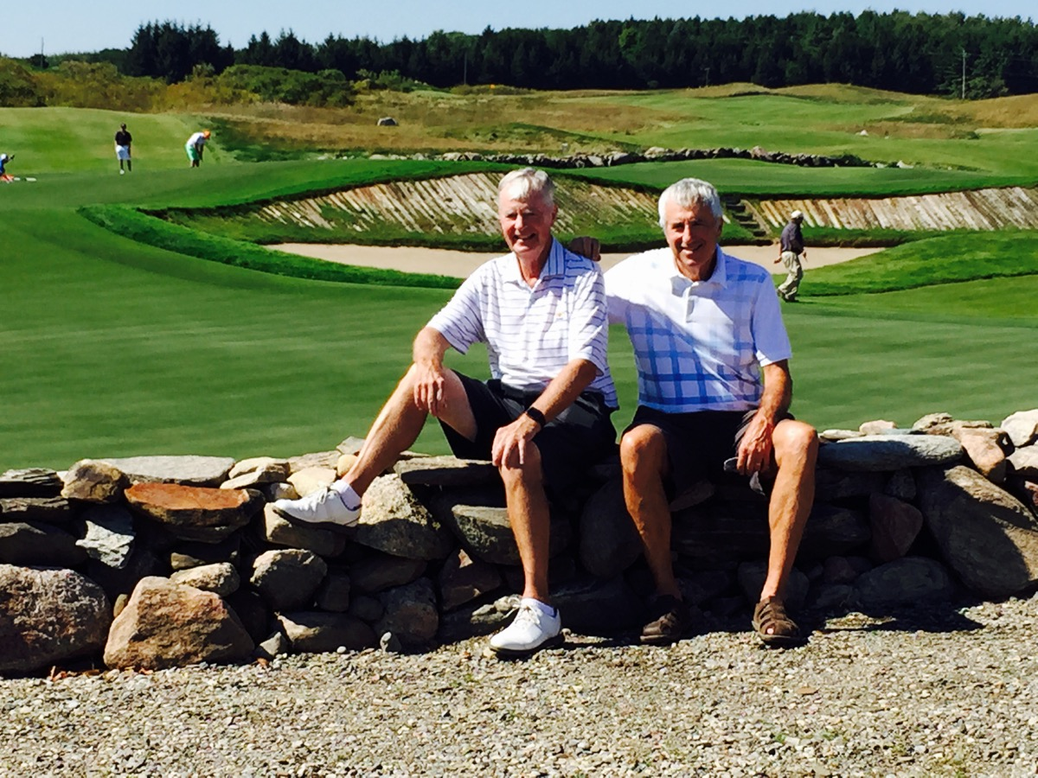
The ‘Brush 2nd & 9th greens with Lorne Rubenstein.

Devil's Pulpit and Devil's Paintbrush
The first two days Lorne and I were at the private Devil's Pulpit and Devil's Paintbrush (the ‘Brush) courses in Caledon. Pulpit is named after a rock formation seen from the 7th tee. The ‘Brush’s name comes from a wild flower that grows in the area. Both courses were designed by Michael Hurdzan and Dana Fry (Pulpit 1990 & the ‘Brush 1992). The courses are about 2 miles apart just off Route 10, a main road northwest from Brampton. Membership to both courses is through the Devil’s Pulpit Golf Association. The ‘Brush is rated #13 in Canada while Pulpit comes in at #19.

The owners were the creators of Trivial Pursuit (1979-1982), when some friends were asked to make $1,000 investments in the risky venture. Final return was $1.4 million on each $1,000. The above picture at The ‘Brush was taken by golf professional photographer Doug Ball, one of Lorne's thousands of friends. Doug was one of the many local guys to turn down the $1,000 opportunity. On the surface this seems like a “no-brainer” investment, but the back story is Chris Haney and Scott Abbott roped investors in on their earlier attempts at game development that were total failures and all investment money was lost. Chris is buried just off the 6th fairway at Pulpit.

Pulpit is parkland and mostly tree lined. The terrain is basically on a steep hillside so the holes run downhill and uphill. There is a mix of elevated tees and low tees with a few drives semi blind over ridges. There are 122 bunkers, many huge and deep. In addition, there are a few deep grass bunkers. Water, in the form of ponds and lakes, comes into play on six holes. Dual fairways are on the 1st and 13th holes. Greens are medium in size.

Pulpit was expensive to build and looks a little artificial. About 1.7 million cubic yards of dirt were moved with 300,000 just on the downhill 1st hole. This challenging opening hole is referred to the club’s million-dollar hole and reflects the razzle dazzle of Chris Haney. During play there are vistas to the nearby Niagara escarpment and downtown Toronto, which is 30 miles away.

After playing Pulpit, Lorne took me over to nearby Osprey Valley Golf were we played the Heathlands course with Bob McClure, Director of Golf. Osprey is a 54-hole public facility designed by Canadian Doug Carrick. The second course is called Hoot and the third Toot. As the names connote, this is an unpretentious and fun place where many golfers play all 54-holes in one day.
The ‘Brush is a totally different experience than Pulpit. Driving in, you see natural looking wild, wind-swept, barren (basically treeless), and rough-hued terrain. The cost to build was only a fraction of Pulpit, as minimal earth was moved. The design elements are links-style on an exposed bluff with gradually sloping ground. There are some blind tees shots and a couple of blind approaches. Water is on only two holes (just one large pond). There are 116 bunkers, many large and bold (some with railroad ties, some revetted, some pot bunkers). The greens are also bold and some huge. There are two double greens (#2 and #9 along with #11 and #14). Most of the holes are visible from all areas of the course. From some parts of the course the Niagara escarpment and downtown Toronto can be seen.

Toronto Golf Club
After playing The ‘Brush it was a drive south to Mississauga and the Toronto Golf Club (11 miles west of Toronto). I had a wonderful dinner with Harvard College classmate and ice hockey teammate Tom Heintzman, a successful Toronto lawyer and still full of energy. After a relaxing sleep I rolled out of bed the next morning for breakfast with host John Hill and Lorne. The club was organized in 1876; the current course designed by Englishman Harry Colt came along in 1912, and the stately red-bricked clubhouse was built in 1913. There has been an excellent course renovation by Englishman Martin Hawtree done in 2009 for $7 million. A 9-hole course was added in 1921 (currently being remodeled).

Even though the Toronto Golf Club is not rated in the top 20 in Canada, I had a sneaky suspicion there might be something worth playing because it was a Harry Colt design. And what a pleasant surprise as the course and clubhouse turned out to be a step back in time. The variety of looks and golf shots were outstanding.

The parkland course is private with no tee times. Fast play is encouraged, and we ended up playing in a quick 3:20. The course has a natural sand base and is tree-lined on both sides of the fairways on most holes. The start and finish are on flat ground, but most of the holes are on rolling terrain with some elevated tees on high ground.

There are 82 bunkers with water on only four holes (two streams and two creek). Green sizes are large-to-huge-to-mammoth. Hollows are cut in front of many greens adding a bit of optical allusion in judging approach shot distance. I think one of Colt’s design trademarks is long and difficult par-3’s (#5 at Pine Valley and #14 at Royal Portrush Dunluce come to mind). The four par-3 here are excellent with all-carry tee shots of 190, 221, 175, and 225 yards (#17 is referred to it as “the card breaker”). I am not into naming individual holes, but #17 as “Graveyard” certainly reflects the challenge.

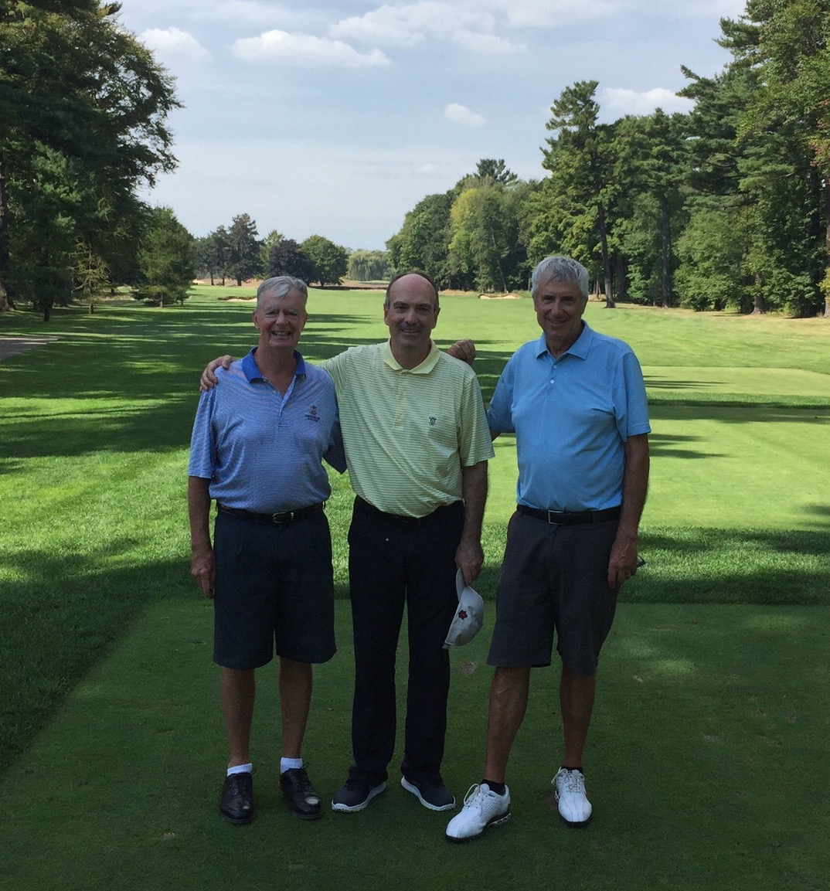
Toronto GC with member John Hill and Lorne Rubenstein
Beacon Hall Golf Club

The last day in the Toronto area is at Beacon Hall Golf Club, in Aurora, 30 miles north of downtown. The private course is rated #14 in Canada and was designed by Bob Cupp and Canadian Tom McBroom in 1988. It is part of a low-density, mature real estate development on hilly terrain. After being greeted by the enthusiastic and ever-friendly director of golf Phil Hardy, Lorne and I are on the first tee with two members.

There are two distinctive nines here. The front is tree-lined with fairly tight tee shot; the back nine is open with a few more bunkers and fescue rough being the tee shot challenge. In all, there are 72 bunkers plus a huge waste bunker at the dogleg of the15th hole par-5. At the 1st and 14th holes there are no bunkers at all. Water comes into play on six holes (three on each side). There is one stream fronting the 5th green and ponds (two huge) are a factor on the other five water holes. You can work the ball into most greens as the bunkers are mainly on one side or the other. The greens are large with slopes being the noticeable challenge.

Cabot Cliffs and Links
From Beacon Hall it was back to the airport for an Air Canada two-hour flight to Halifax, Nova Scotia (800 miles east and a time zone change). The flight was scheduled to arrive just before 10pm local time, but a five-hour delay got me into bed at 3am. The next morning, I met up with fellow GOLF Magazine panelist Lance St. Clair (Austin, Texas) and we drove 200 miles (3½ hours) northeast to Inverness on Cape Briton Island. This small village is on the west side of the Cabot Trail, a 185-mile scenic drive looping around the northern tip of the island. On the east side is the Atlantic Ocean, toward the north is Cabot Strait and then Newfoundland, and on the west side (where we are) is the Gulf of St. Lawrence and then Prince Edward Island. Visually, the best part of the Trail is from the northern tip down the west side overlooking the Gulf of St. Lawrence.

Perched on the edge of a rugged coastline and a huge expanse of beautiful churning water are two Top 100 golf courses. Cabot Links was designed by Canadian Ron Whitman in 2012 for Canadian Ben Cowan-Dewar. The course is rated #75 in the world. This is a return visit for me as I had the pleasure of being one of the first to play the full 18 holes in late 2012 with GOLF Magazine panelists Ran Morrissett (Golf Club Atlas creator) and Joe Andriole (also involved with Golf Club Atlas). The reason for coming back is to play the most anticipated new course opening that I can remember over the 50-years that I have been involved in playing the top courses. Cabot Cliffs (Bill Coore and Ben Crenshaw design for Mike Kaiser and Ben Cowen-Dewar) had a “soft opening” in the summer of 2015. It has been a forgone conclusion that this course would be rated as one of the Top 100 in the world in the next voting to take place in 2017.

Lance and I played 72 holes in two days (36 at Links & 36 at Cliffs). Cabot Links is a true links design – fescue grass, exposed to the elements (the two days we played here in the morning it was blowing 15 to 25 mph), dunes, lumpy fairways, mostly open in front of greens for run-in approach shots, water on only one hole, compact, walkable. The course borders the town on one side, and four of the holes on the opposite side are on the shoreline. There are 105 bunkers along with huge, humpy greens averaging 41 yards in depth. The double green for #8 and #13 is 110 yards wide.

The terrain gradually slopes from the higher north end of the property to the lower south end. At this end there is a beautiful inlet (MacIsaac’s Pond) with fishing boats bobbing in the water. The inlet guards the entire left side of the dogleg left 6th hole, with the green at water’s edge. Playing in clear fresh air provides an exhilarating feeling as you enjoy the Gulf of St. Lawrence vistas from almost every hole. At the southern end of the course white-capped crashing waves are at eye level with the sandy beach so close you could almost walk from a tee or green on to the beach and then into the water.

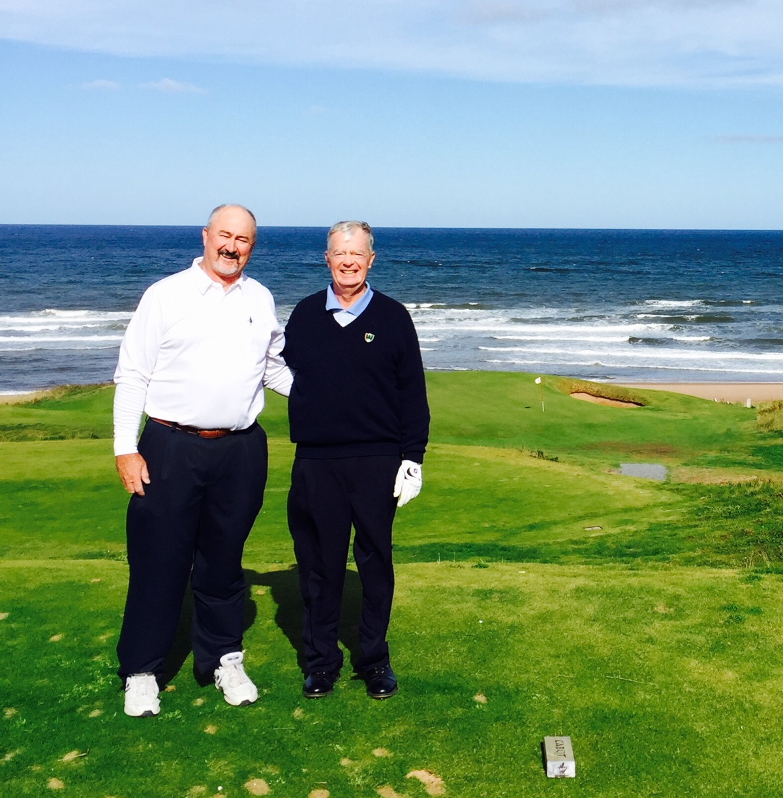
Cabot Links par 3 #14 hitting directly into Gulf of St. Lawrence on a windy day with Lance St. Clair.
About a ½ mile north of Cabot Links, driving through forests, you arrive at Cabot Cliffs. This is a totally different experience than Cabot Links. The heart of the course is on cliff tops 50 to 100 feet above the churning surf. From many holes the views are for miles down the coast and out to the Gulf of St. Lawrence. The terrain heaves and flows steeply in some places while other parts are flat. Water, in the form of streams, ponds, ravines, and the gulf impact 10 holes. There are holes in sand dunes and others totally tree-lined.

There are about 113 bunkers (the par 3 #4 has two greens with two bunkers at one and five at the other). Wind is a big factor on the many exposed holes. During our play it got to 30 mph. Because of the wind, the fairways are generous in width, but strategically-placed bunkers require thinking off the tee and on the approach shots. Most of the greens are huge. Nine range from 44 to 55 yards deep. The most photographed hole is the cliff-edged par-3 16th at an uphill 119 yards to 176 yards to a shallow green (only 10 yards deep on the right side). The site is at the most exposed part of the course, so a three club or more wind is likely. This might be one of the toughest holes in the world to make a par on a par 3 hole.

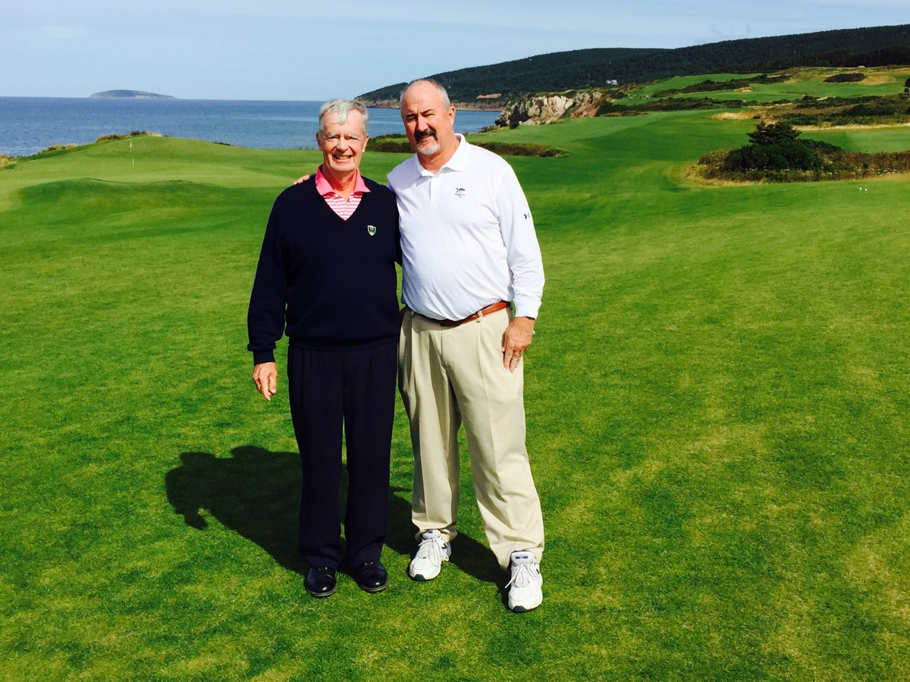
Cabot Cliffs par 5 #18 looking north on Gulf of St. Lawrence with Lance St. Clair.

Lance and I agreed that the 2nd hole, a 401-yard par 4, is the most unique hole on the course and is a candidate in the golf hole hall of fame. I have never seen a hole where one bunker affects both the tee shot and approach shot. The tee shot is from an elevated tee to a huge fairway. But you have to put a lot of thought into the placement which is actually small if you want to see the pin on the second shot. This approach shot is from a slightly down-sloping fairway to an elevated green obviously guarded by the tall and wide bunker. The longer the tee shot the closer you are to the bunker with a lesser chance to see the pin. Great hole!
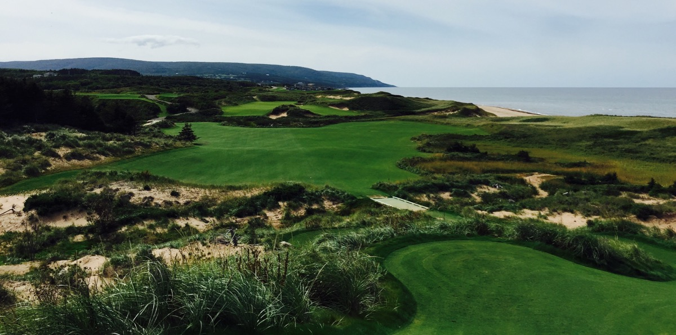
Cabot Cliffs par 4 #2 looking south (Cabot Links ½ mile away down the Gulf of St. Lawrence coastline).
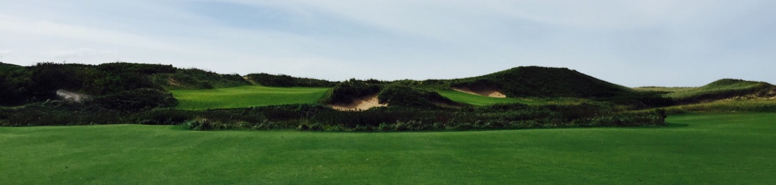
Hole #2 approach shot. Picture does not do justice as to how daunting is the second shot.
After the second day of golf we visited with managing partner Ben Cowan-Dewar and congratulated him on successfully transforming his 11-year quest to turn these spectacular sites into 2 world-class courses with excellent lodging, food, and service. This is a must visit and at the moment the exchange rate is very favorable with the Loonie (Canadian dollar).

South Africa
Introduction
The “big trip” of the year was a return visit to South Africa (SA). ZA is the official abbreviation for South Africa, but I am going to use SA in this document. The whole trip went from November 19 through December 16. Here is the link to the two-page itinerary:

http://thegolfodyssey.com/2010-england-sweden-denmark-portugal-spain-2/2015-south-africa/

It was a memorable trip combining the playing of high quality golf courses, being with old friends, and meeting interesting new people. One full year before the trip started I created a preliminary itinerary. Then I sent it to good friend John Terry-Lloyd, member of the Durban Country Club. He offered to grab it and make all the contacts. John also introduced me to travel agent Lindy Sack who turned out to be terrific in making all the non-golf arrangements for the entire trip. I highly recommend her to anyone going to SA. Contact information: Dynamic Horizons in Cape Town and London (lindy@sackfam.com +44-20-8959-6465 or +27-79-368-4499).

There must have been at least 10 major revisions to the itinerary over the next few months including turning the whole trip upside down. In May the European Tour changed the dates for the Alfred Dunhill at Leopard Creek by two weeks. I have learned over the years in planning these trips, flexibility is the name of the game. The only thing that was eliminated from the original schedule was the Blue Train. This is a 990-mile scenic and luxurious five-star journey between Pretoria and Cape Town with butler service.

Based on my brief visits to SA in 1988 and 1997, I knew I was going to be with very friendly people (this is one of the major reasons for the 2015 trip). This time Elaine came along and at the end of the trip we both agreed that there are no friendlier people in the world than South Africans.

As for golf courses, there was not a weak one in the group. All passed the test of wanting to play them again. The trip took place in November/December which is the equivalent of May/June in the mid-Atlantic region of the USA. The weather was sunny to partly cloudy with temperature 75 to 85 degrees and wind 0 to 20 mph. Only one day with rain and that happened on a long drive between St. Francis and Fancourt. The country was going through a severe draught, especially in the Johannesburg region. Therefore, I was unable to play Blair Athol (fell from #4 to #14 in most recent SA ranking) and Elements (fell from #19 to #26 in same tabulation) because they were not in good condition. Despite the draught, all the courses played were in above average condition with good lies in the fairways along with firm, fast, and true greens.

Driving around the country was fun. Most of the roads were well-posted. Traffic congestion in the major cities was a problem, but that is true in every part of the world (try driving in China for a real challenge). Lodging and food were excellent. The totally new experience was a safari, and that proved to be one of our all-time highlights. The extremely favorable exchange rate with the rand was certainly welcome.

Although doing SA is a 10,000-mile two-day trip each way from the east coast of the USA, it is absolutely worth the time and expense. I recommend SA to everyone in the travelling public. The total package of golf, scenery, safari and other tourist features, food, wine, road system, and of course the people compares very favorably with most golf oriented countries in the world. My top five ranking is: USA, the UK & Ireland, Australia along with New Zealand, and Continental Europe. SA comes next.

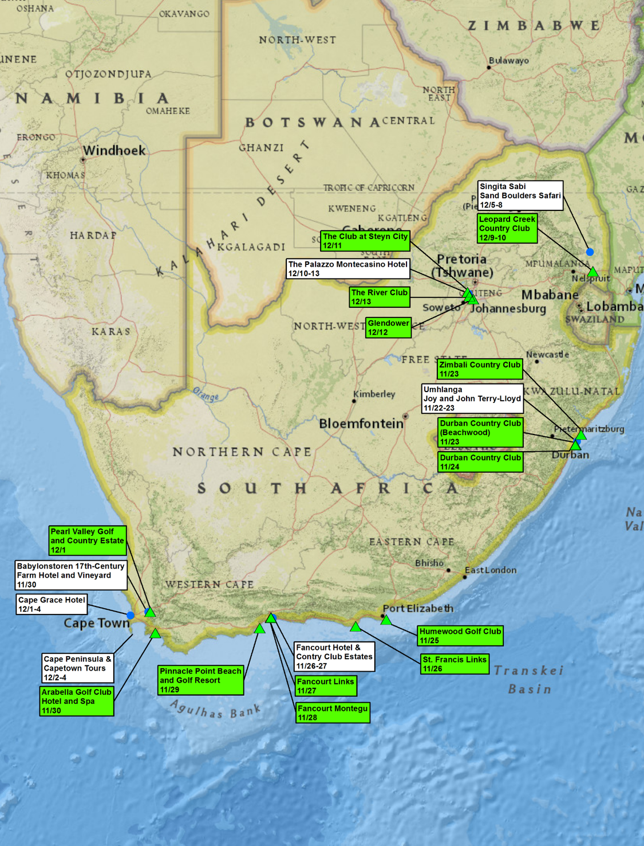

I was able to use British Air (BA) frequent flyer miles for most of the trip. That was the good news. Not surprisingly, BA would not let me have the most logical itinerary which was Miami/London/Johannesburg. They suggested Miami/Madrid/Doha/Johannesburg. That seemed a little circuitous, so I opted for Philadelphia/London/Johannesburg which meant getting to Philadelphia from Naples. In any event, Elaine and I arrived in Durban (seven-hour time change from the east coast of the USA) and were warmly greeted by Joy and John Terry-Lloyd. We stayed in their beautiful home on a clifftop overlooking the sparkling Indian Ocean. While John accompanied me with the golf, Elaine and Joy had a wonderful time in the Durban shops and restaurants.

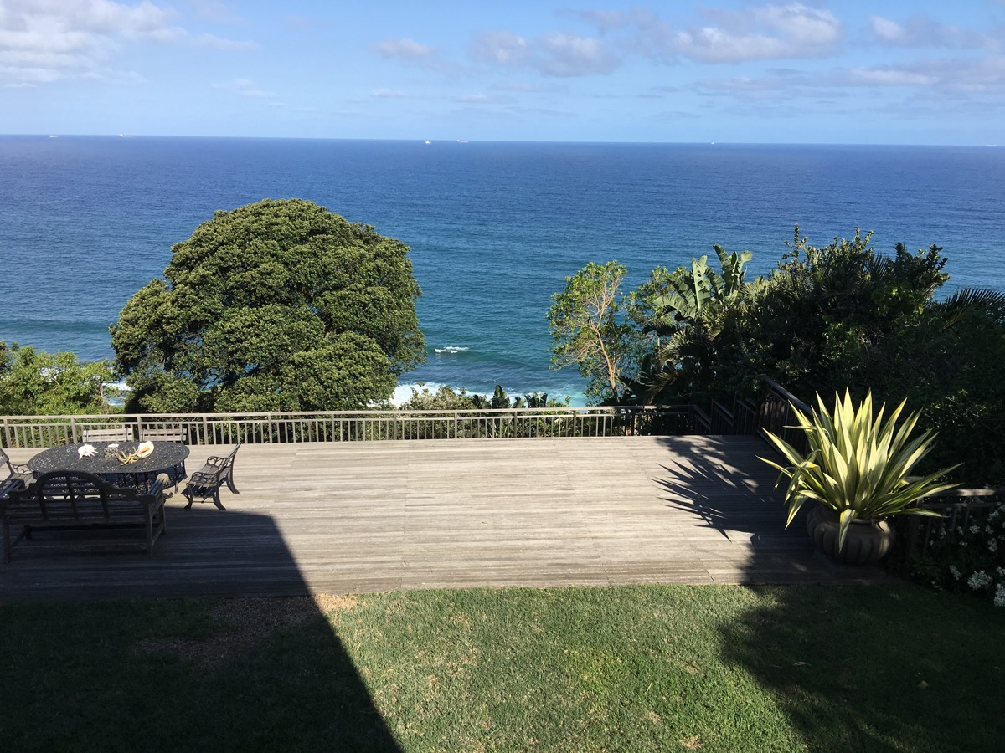
View of Indian Ocean from home of Joy & John Terry-Lloyd.

Durban Country Club (Beechwood)
Golf started at the Durban Country Club (Beachwood) which is on the Indian Ocean three miles north of Durban. This is a 1920s original designer by Percy Stiebel. The Durban Country Club took over the course in 1996 with Gary Player Design Group then did significant remodeling. It is rated #33 in SA. I played with Club Captain Sean Fenger who I had met at Diamante, Cabo San Lucas, Mexico in November 2012. The course is walkable with monkey sightings. Quiet surroundings with some holes near the Indian Ocean (cannot see water from the course, but can hear waves crashing). Some housing is on the border (mostly apartment buildings). Many elevated tees and many straight holes. Tight tee shots through tall trees and tall, thick bushes. Fairways bottleneck at 250-300 yards so longer hitters have to pay attention. A few water hazards (some mangroves); some out-of-bounds; thick rough; about 70 bunkers with excellent sand; medium sized greens with moderate contours and collections area on the sides.

Zimbali Country Club at Zimbali Coastal Resort & Estate
John then drove me to Zimbali Country Club at Zimbali Coastal Resort & Estate. This property is 15 miles north of Durban just past Westbrook overlooking the Indian Ocean. The course is a 1998 Tom Weiskopf design and rated #22 in SA. The Zimbali course is part of a mature “estate” (estate in SA means gated real estate development) with some houses close to the course. A Fairmont Hotel is part of the complex (substantial expansion under construction). A motorized cart is required because of the substantial elevation changes. A few glimpses of Indian Ocean are in the distance, many elevated tees, a few blind shots, uphill and downhill lies (a couple ski slope downhill), many water hazards, some forced carries, large greens - some angled, modest slopes, some steep fall offs. The club would like Weiskopf to come back to soften a couple of the holes.

Durban Country Club
The Durban Country Club (DCC) is just north of downtown Durban. The population of the Durban metropolitan area is 3.4 million (#3 in the country). The entire country has 53 million people (only 9% white). Durban has the busiest ship container port in Africa. The golf course is a 1920 design by Laurie Waters and George Waterman. Then Englishman Stafford Hotchkin (Woodhall Spa) did some revisions in 1928. Recently the club has had design advice from David McLay Kidd. In 2010 the greens were successfully converted from Paspalum grass to MiniVerdi Bermudagrass per USGA recommendation. The course maintenance was outsourced starting in 2012 to the Peter Matkovich Company. Peter is a well known course designer in SA.
DCC has ranked on the GOLF Magazine World Top 100 for many years and currently holds the #97 position. It is lovingly referred to as “The Grand Old Lady”.
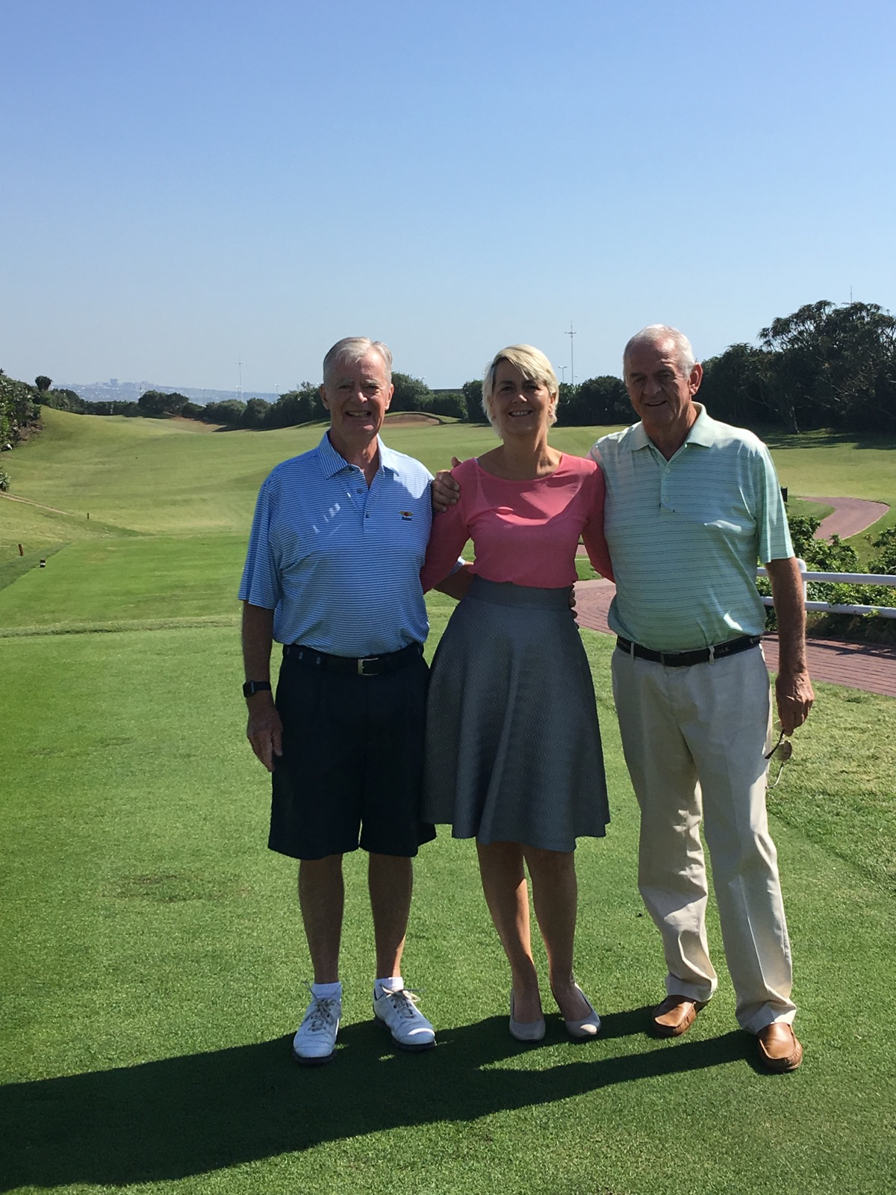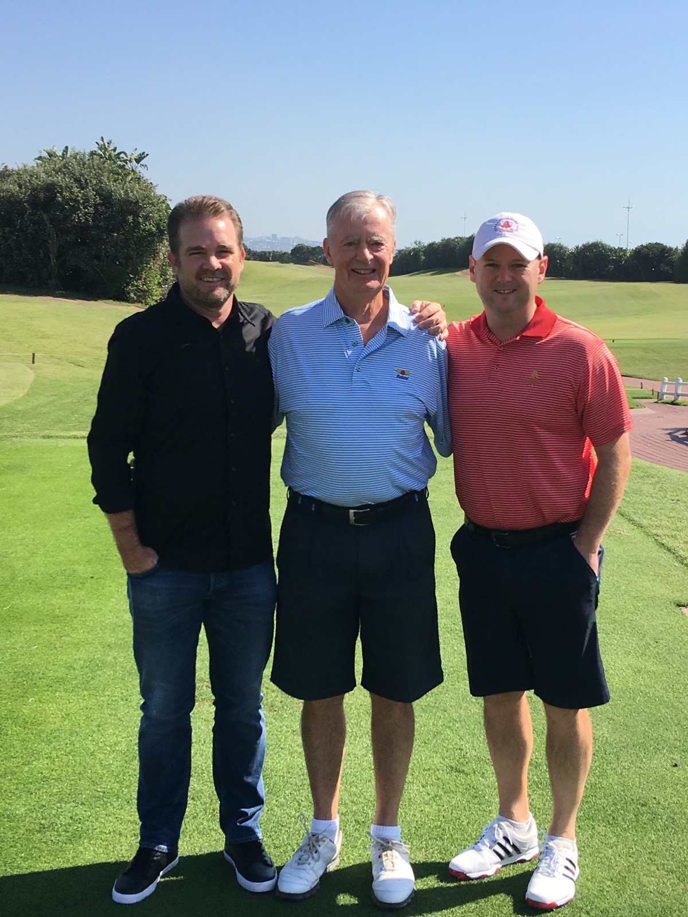
1st tee Durban Country Club. Picture on left with club CEO Pascale van Maris and John Terry-Lloyd.
Picture on right with Beechwood Club Captain Sean Fenger (on my right) & DCC Club Captain David Swanson.

I played DCC with Club Captain David Swanson. Several world-class holes are here on a walkable course (with caddy). The first five holes are on true rolling links dunes land that runs parallel to the Indian Ocean separated by a busy road. The second hole has a very elevated tee with a 360-degree view so you can see the Durban Harbor, downtown Durban, and the shore line for miles. Also visible is the nearby new soccer stadium built for the 2010 World Cup.

Starting with the 6th hole, the course transitions to more of a parkland setting. On the flat sixth fairway you can see a lot of flat land. However, in reality there are some hills interspersed to make for interesting holes such as par 5 #8 which parallels the third hole and has a very perched green sitting on a high dune.

My favorite hole is the short par 3 #12 at just 143 to 156 yards (#12 at Augusta National and #8 at Royal Troon-the Postage Stamp come to mind). These are the holes where you stand on the tee and think: if I do not hit a perfect short iron I am in deep trouble. From an elevated tee it is all carry over a deep fronting bunker to a perched green. The green is 34 yards deep, but only 20 yards wide. DO NOT MISS THIS GREEN as your ball will roll down a very steep and slippery slope so that you cannot see the flag on your next shot. Your lie will also be in some gnarly grass or on bare ground so it is more than possible to go from one side of the green and back again. Thus, this hole definitely has card wrecker potential. Maybe the best way to play the hole is to put your tee shot in the front bunker and settle for a probable four.

Tall trees and thick underbrush close to many fairways are the penalty at DCC. Water is not a factor (only on two holes) and there are only 48 bunkers. There are no bunkers at the elevated 1st and 3rd greens with steep sides producing sharp roll offs. Players cannot just blast away as they have to really pay attention about where not to miss. Recent tree and bush removal in out-of-play areas is a positive as vistas are opened up yielding a more natural look.

Humewood Golf Club
After golf and a nice lunch with John, Joy, Elaine, and David in the enlarged clubhouse with a nice view of the Indian Ocean, John took us to the airport. We then had a short flight southwest to Port Elizabeth where we picked up a rental car (driving on the left hand side of the road) and were met by Alma and Keith (Simmo) Simpson. The four of us then had a fun-filled dinner. Simmo is the former Captain and President of Humewood Golf Club as well as a fellow R & A member. I learned from others that he had just won the Jubilee Vase competition at the R&A Fall Meeting (this is a big deal with about 250 competitors doing individual match play starting on Monday and finishing Saturday).

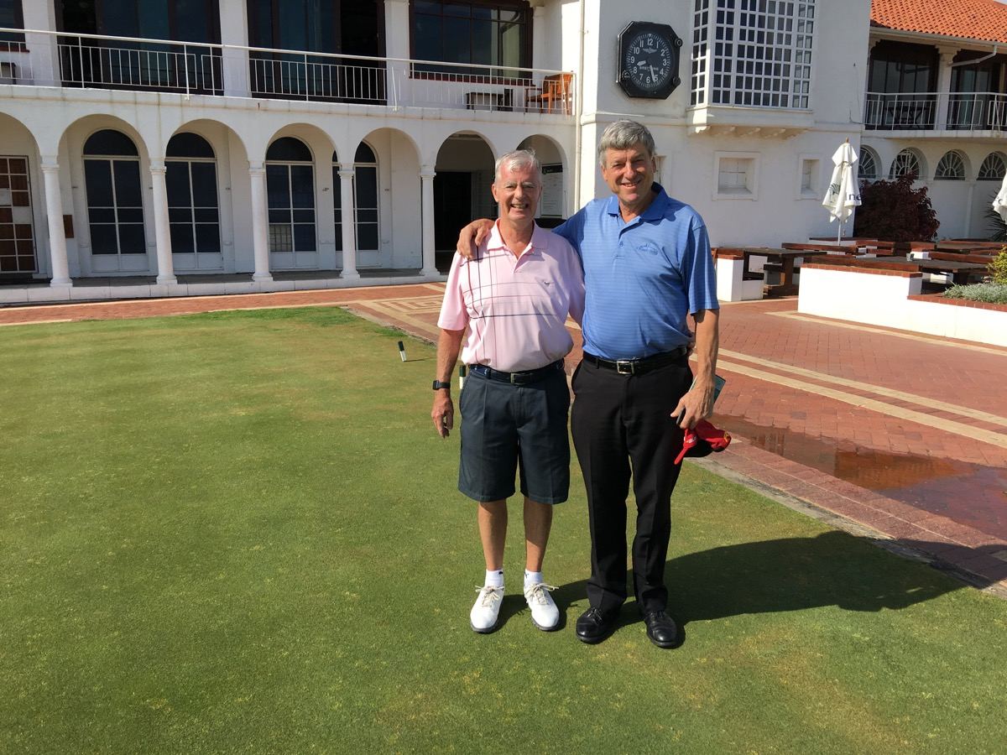
Humewood GC with member Keith Simpson.

The next morning, I played Humewood with Simmo while Alma took Elaine sightseeing. After golf we all had a nice lunch on the second floor of the clubhouse overlooking the Indian Ocean. The club is just south of Port Elizabeth (biggest deep water port in South Africa). This is the start of our “Garden Route” tour along the Indian Ocean from Port Elizabeth to Cape Town. The course was designed in 1929 by Englishman Stafford Hotchkin (Woodhall Spa) with another Englishman Donald Steel doing revisions in the 1980s. Then in 2009 Sean Quinn upgraded the green complexes. Humewood is rated #11 in SA (definitely way underrated; in my Top 5 in SA)

The course is in sandy dunes on Algoa Bay flowing into the Indian Ocean, but this water does not come into play, as the nearest hole lies about 300 yards from the shoreline. Humewood is the only true links course in Africa (two other courses on this trip have “Links” in their name, but they are really not links). The course has gorse bushes, fresh air and strong wind (Port Elizabeth is called “The Windy City”). I loved this course - firm and fast with newly rebuild creeping bent grass greens. It is walkable with caddy. There are gradual elevations changes, along with wide and sloping fairways that have many humps, hollows, and ridges. There are only 44 bunkers. Water is on only one hole, a stream in front of 17th green.

My friend Pat Ruddy (designer and owner of The European Club in Ireland) particularly treasured the "kickers" at the sides and fronts of greens at Humewood. According to Pat “…Kickers are little banks placed strategically near greens that send a slightly errant shot kicking forward or sideways unhelpfully. Something like today's run-offs except that they may send the ball onto the green but out of control. Hotchkin left quite a few of them at Humewood, but Pat is not quite sure if they were all intentional or just the by-product of the work of the day when the horse and man combo deemed enough was enough at such a stage”.

St. Francis Links
Back in the car it was a short 74-mile drive west through Humansdorp and on to St. Francis Bay. At St. Francis Links we were warmly greeted by the jovial Chief Executive Officer Jeff Clause. Elaine and I had a delightful dinner with Jeff and wife Liezl. Jeff is from Iowa, worked in Houston, and then came to SA 15 years ago to be at Fancourt. The course is a 2006 Jack Nicklaus design with associates Sean Quinn and Greg Letsche. It is rated #7 in SA. St. Francis is a partially built out estate. Customers come mainly from Europe (Sweden and Norway). There are guest rooms available in the large clubhouse or the Dune Ridge Country House back in a “bush” environment (where we stayed). St. Francis Bay is visible from the development which is a half mile from the water.

Jeff Clause and I played the next morning in overcast skies with rain threating. Unfortunately, the skies did open up on the back nine but we finished the key holes. The course is on a down-sloping sand ridge with some modestly high dunes. The routing basically moves up and down the ridge so there are several uphill and downhill shots. Walking is possible, but you must be in good shape as there are a few long walks between green and next tee. The back nine is on higher ground than the front nine. Each hole is framed by tall bushes and trees. There are water hazards on eight holes with a few forced carries. The 120 bunkers have excellent sand. Finally, there are modestly-contoured greens.
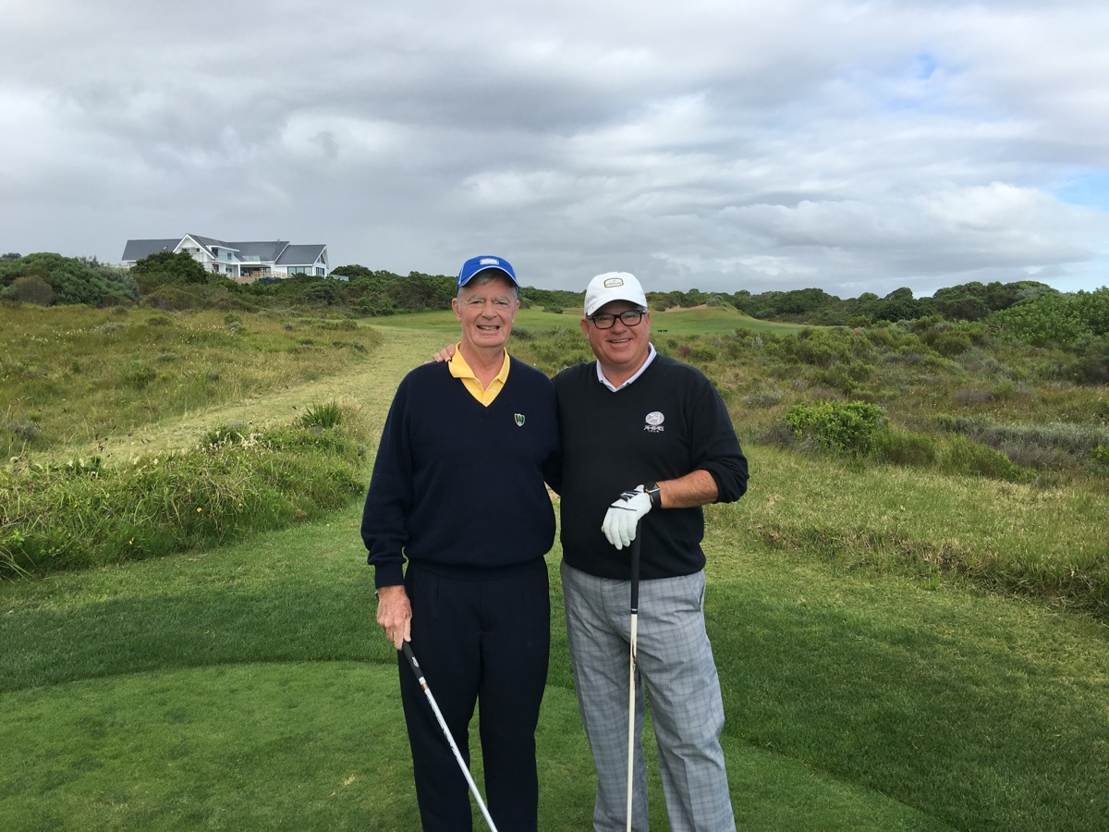
St. Francis Links with CEO Jeff Claus.

The large expanse of vacant land next to the estate is the site of a proposed nuclear power plant to generate electricity. It has been in the planning stage for 10 years. Current news is a possible purchase of Russian made reactors and steam turbines. With all the open discussion of rampant corruption in SA, starting with President Zuma, a deal with Russian companies is the perfect match for huge corruption.

Fancourt Hotel & Country Club Estate
From St. Francis we drove 171 miles west through pouring rain to the seaside town of George and then four miles west to the Fancourt Hotel & Country Club Estate. We were met by our host, Scotchman Lloyd Martindale, General Manager-Golf. Fancourt opened in the early 1990s. SAP computer software co-founder Hasso Plattner ($10 billion net worth and owns CordeValle resort and golf course in northern California) bought Fancourt in 1994 and has invested over $100 million in new facilities including converting the 34-bedroom Manor House to 18 beautiful suites. Other lodging options are a main hotel (133 rooms) and hundreds of self-catering lodges. Seasonal or permanent residents can purchase individual houses or town houses (lodges). We experienced excellent food and service during our 48-hour stay there.

Fancourt has three courses:
- The Links course: 2000 Gary Player design rated #1 in SA (constantly trades places at #1 with Gary Player’s designed Leopard Creek)
- The Montagu course: 1993 Gary Player design; 2004 David McLay Kidd remodel; rated #6 in SA.
- The Outenique course: 1995 Gary Player design rated #22 in SA (did not play).

At The Links course my host was Tyronne Farrell, PGA and Club Manager-Links. There was heavy rain the day before so the course, which is usually firm and fast, was soft and played long. 15 holes were built on a former runway (old airport for George) so tons of dirt were moved to create a world class course (best Gary Player design in the world in my opinion). Holes 1, 2, and 18 are on very sloping land with a large lake separating this part of the property from the former runway section. On the very elevated 10th green you can see almost the whole course. The course is walkable.

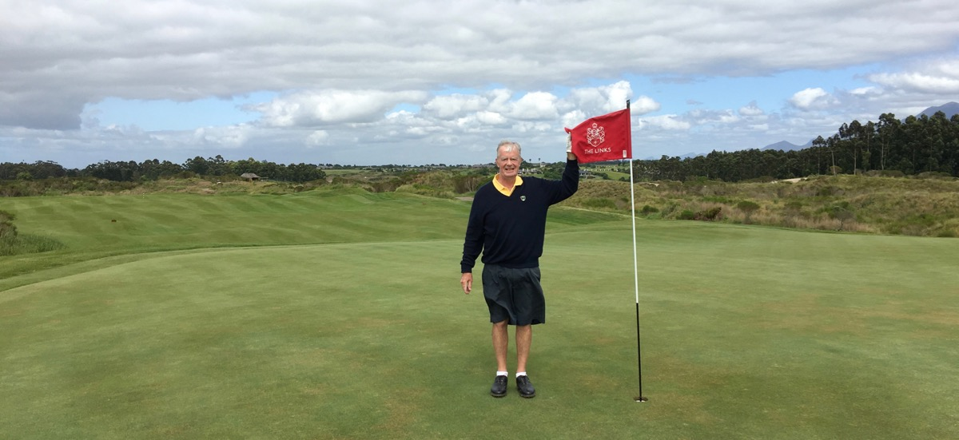
Fancourt Links par 4 #10 green.

There is a totally peaceful environment with no housing. Just you and nature with beautiful Quteniqua Mountains as a backdrop. There are almost no trees on the course, so the holes are exposed to strong wind. The course was in perfect condition with greens running at 11. The greens are large (starting with 52-yard deep 2nd green) with mostly subtle slopes and ridges, although the 18th is a wild finish. There are 12 straight holes and short forced carries over tall fescue grass in front of every tee. This is not a problem unless you hit a topped tee shot. The fairways are wide with brutal far rough (lose ball in thick bushes and tall grass). Fairways slope up, down, and sideways with humps, hollows, and ridges.

There are multiple hazards on almost every hole. A combination of: a few blind shots, water on 11 holes, and 97 bunkers. They are all over the place - in fairways on 8 holes including more than one on 3 of the 8 (so there are several pinched drives), in front of greens on 5 holes, pinched at front of greens on 7 holes. The bunkers are very penal with sharp edges and straight high lips. They play like traditional links riveted sod walls, but are actually hard rubber tubing running horizontal (I have never seen this before).

The Montagu course mostly twists through hundreds of lodges. A motorized cart is helpful, especially going from the 9th green to the 10th tee. This is a parkland course on sloping terrain with 67 bunker, water on 12 holes, and large sloping greens. Despite the housing there are some beautiful holes on both nines. I particularly liked the flavor of holes 12 through 14. First, there is a large lake with the 4th green to the right and then the The Links course on the other side of the lake. The next two holes have a river on the entire right side with a forest of very tall trees on the right side of the river. This is a peaceful place with a nice view of the Quteniqua Mountains.

Pinnacle Point Golf Club at Pinnacle Point Beach & Golf Estate
From Fancourt it is an easy 35-mile drive southwest of George to Mossel Bay and the Pinnacle Point Golf Club at Pinnacle Point Beach & Golf Estate. This is a 2006 Peter Matkovich-designed course rated #23 in SA. The course is set on a very steep cliffside with spectacular views overlooking Mossel Bay and the Indian Ocean. If there was ever a Jekyll and Hyde course this is it. Pinnacle Point is a combination of some really bad steeply sloping holes combined with some of the most scenic and challenging holes in the world. There are seven of these (three on the front side and four on the back). These holes have dramatic approach shots over steep rocky cliffs cascading down to a roaring surf. Unfortunately, the non-water holes leave a lot to be desired. A motorized cart is the only way to navigate the course. The sign on 1st tee says “beware of snakes”, but I never saw any. Self-catering apartments are available with full dining service all day at the golf clubhouse. There is a casino just before the property entrance if you are so inclined.

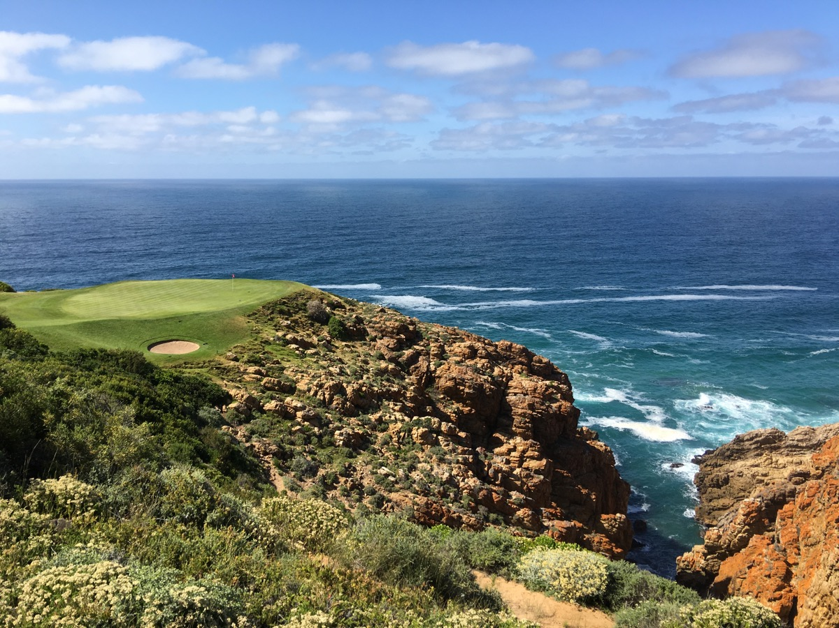
Pinnacle Point par 3 #7 at 121 yards overlooking Mossel Bay.

Arabella Golf Club at Arabella Country Estate, Hotel & Spa
From Pinnacle Point we drove 191 miles west for some ocean sightseeing in Hermanus. Then it was 16 miles northwest to Arabella Golf Club at Arabella Country Estate, Hotel & Spa. The course is a 1998 Peter Matkovich design rated #9 in SA. It is part of an almost fully built out estate along with a large modern hotel that incorporates the pro shop. At the northern edge of the property is a huge and scenic lagoon called Bot River and then expansive views of the tall Kogelberg Mountain Range. Many of the holes twist through the real estate development, but five holes have the lagoon coming into play with the mountains as a backdrop. This is my first golf course experience involving a large lagoon. Peter did a brilliant job of incorporating the lagoon into the design.
There are 79 bunkers with three being as long as any in the world. These would be 175 yards on #8, 165 yards on #9, and 220 yards on #18. (The 17th hole has one of just 55 yards long). On the outside of the bunkers there is tall vegetation. The combination of long bunkers and thick vegetation are to keep balls out of the lagoon. The par-5 8th hole is one of the most scenic in the world. It is ski slope downhill on the first two shots. As you walk down the fairway you come closer to the peninsula green with the lagoon on three sides and the mountain backdrop. The view is spectacular and peaceful.

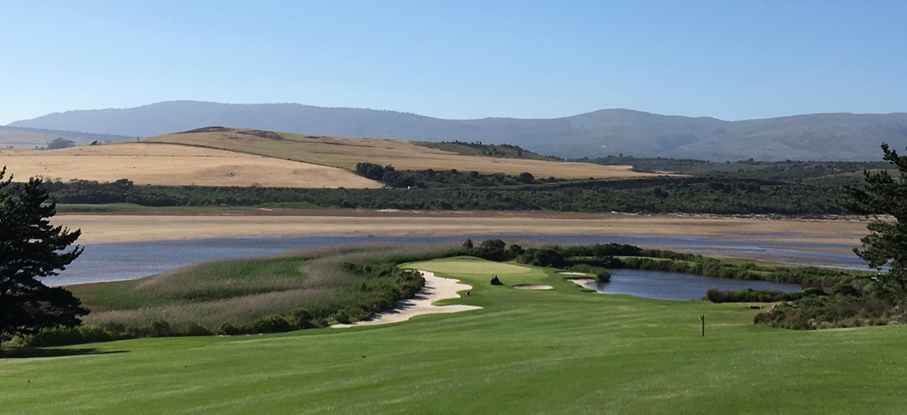
Arabella GC par 5 #8 with peninsula green in Bot River lagoon.

Pearl Valley Golf & Country Estate
From Arabella we drove 60 miles west and then north to Babylonstoren Farm Hotel & Vineyard with charming accommodations in Dutch-influenced cottages. The next day I was at Pearl Valley Golf & Country Estate which is 45 miles northeast of Cape Town. The development is in the Berg River Valley bordering on the Simonsberg Mountains with the Drakenstein Mountains in the distance. Nearby are the towns of Paarl, Franschhoek, and Stellenbosch that comprise a major winelands region. The course is a 2003 Jack Nicklaus design with Sean Quinn as associate. It is rated #8 in SA and is the best course in the Cape Town region.

You start out here at a large modern clubhouse. The sign on the 1st tee says “Beware of snakes” (none encountered). The course winds through high-density housing on dead flat ground. Unfortunately, there was no effort nor expense incurred to create any noticeable movement on the fairways. There is a little elevation change on some greens. The course is easy to walk. This might be one of the better Nicklaus design efforts given the restrictions of flat land and high density real estate. Water comes into play on seven holes and there are 86 bunkers (a few massive with one on #14, 100 yards long). Out-of-bounds is present, some trees come into play, and some of the greens are pinched with left and right bunkers in front. You know immediately that this is a Nicklaus design with a huge bunker smack in front of the 1st green requiring a high approach shot (although you can bail out both left and right to chipping areas).

Cape Town
After golf we drove 28 miles west to the Cape Town Airport to deposit the rental car. This was the end of “The Garden Route” tour. Then we took a taxi for 13 miles to the Cape Grace Hotel on the Cape Town waterfront and near the mammoth Victoria Wharf Shopping Center (built in the 1990s). Cape Grace turned out to be a terrific hotel for the next three days of being a tourist. I know long-time readers of The O cannot believe I would spend three full days of an overseas golf trip as a tourist with no golf. Actually, I loved ever minute of it.

Cape Town is in a lovely location and is a bustling community with much to do. The area population is 3.7 million (#2 in SA). The first full day we had a guide, Brian Kirsch (kirsch@oceanviewsp.co.za), who did everything for us. He drove us to the Cape of Good Hope and Cape Point, 40 miles (beautiful 90-minute drive) south of Cape Town. Many think this is where the Atlantic Ocean and Indian Ocean merge. Wrong! That point is Port Agulhas, which is 93 miles east-southeast of Cape Point as the crow flies (150-mile drive). It is a remote, windswept, tiny fishing village and difficult to get too. The only negative for the day was thick fog and mist so we did not get the full flavor of the Cape. At the end of the day Brian took us to two vineyards near Cape Town for wine tastings. One was Klein Constantia that dates back to 1685.

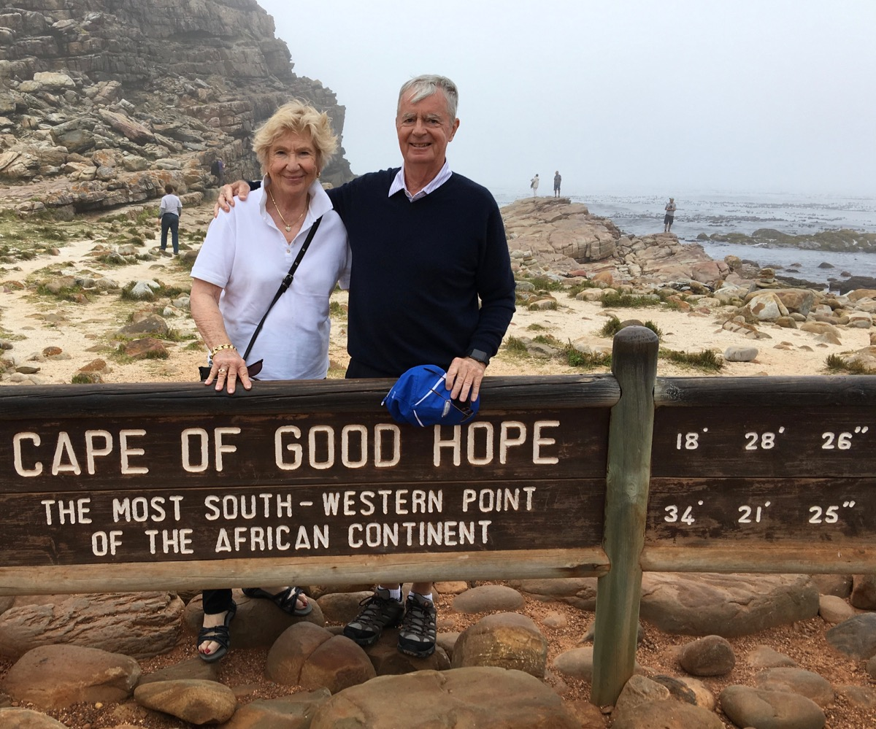

The next two days we did the Red and then the Blue open top bus tours. The highlight was taking the cable car to the top of famous Table Mountain, the prominent landmark overlooking Cape Town. This was an exciting and scenic 5-minute, almost totally vertical ride with the cable car floor rotating 360 degrees. The top is 3,500 feet above sea level in a mountain range stretching down to Cape Point.

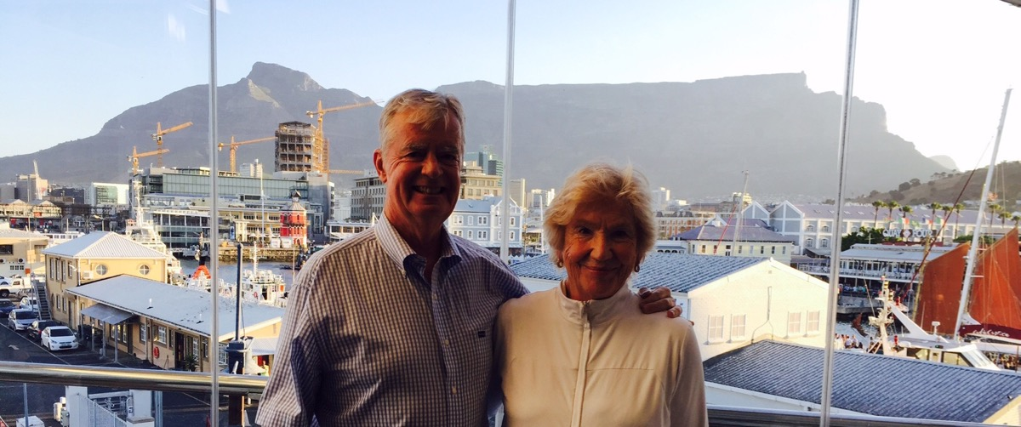
At Baia Seafood Restaurant with famous Table Mountain as backdrop.

While in Cape Town I had a long and interesting breakfast with Stuart McLean, editor of GOLF DIGEST-South Africa. We exchanged many thoughts about about golf courses in South Africa and all over the world. He and Keith Simpson (Humewood) are traveling partners and I was able to offer some golf course recommendations for their upcoming trip to Australia.

Safari
On Saturday morning we flew 937 miles northeast from Cape Town to Nelspruit (near Mozambique border). GAP Tours & Transfers had been hired to drive us between Nelspruit/Safari/Leopard Creek/Nelspruit. The last part of the 75-mile ride north northeast to the safari location was over bumpy dirt roads with no road signs. At this point we were glad to have an experienced local driver.

We arrived at Singita Sabi Sand Boulders safari resort and were greeted by a herd of elephants on the way in. When I first thought of a safari, I was thinking it would last about one week. Then I was told three days were just right for a first time effort. Singita came highly recommended as we were not interested in roughing it out in the bush under tent. So we did just the opposite with five-star accommodations, food, and service. It proved to be an expensive choice, but worth every penny. Elaine and I agreed this had been one of our life-time highlights.

Singita is a 22-year-old privately held company (Bailes family) that controls a million acres of land. They operate 12 lodges and camps in South Africa, Tanzania, and Zimbabwe. Their Sabi Sand property borders the Kruger National Park to the east. There is no fence between the public park and the private Sabi Sand property, so all the animals roam freely between the two. Kruger covers 4.8 million acres while Sabi Sand involves 45,000 acres. There are three different Sabi Sand facilities within this game reserve (Boulders & Ebony Lodges and Castleton House).

The routine is an automatic wakeup call at 5am with a knock on the door at 5:30am to be escorted to the main lodge for a continental breakfast. Then you board an open-top Range Rover for the morning excursion. These are called “drives” and we had six of them from 6 to 9:30am and 4:15 to 7:30pm. The bonus at the end of the late afternoon “drive” is a beautiful sunset. There is no point in being out looking for animals during the mid-day heat because they are resting. After the morning “drive” you return for a full breakfast. Then you lounge around before having a delicious lunch, followed by more lounging around until the afternoon “drive”. We spent some time in our luxurious bungalow’s infinity pool overlooking the Sand River with some animals passing by.

After the late day “drive” there was a gourmet meal served along with the best SA wines. The third night dinner was setup away from the lodge in relaxing open air surrounded by flaming torches. This was a big project by the staff as all the cooking equipment had to be brought from the lodge and the food prepared barbeque style. After dinner the staff put on an African dancing and singing show.

The success of a safari totally depends on the quality of your driver/guide and his partner, the tracker/spotter. The two most important qualities needed are an ability to find all the different species of animals and then to provide verbal background on the important traits of each animal. We got really lucky with two super guys. Our driver/guide was a really neat young man, Ricardo Careaga. He is from Mexico, has been at Boulders for five years, and is about to return to Mexico to start a jaguar game reserve. Our tracker/spotter was Peter, a native of the area. They were a perfect team.

Finding animals in a wild environment is not easy. Managers of game reserves want to avoid a zoo type atmosphere as much as possible. Thus, none of the animals have tracking bracelets so finding them is tricky with a lot of patience and luck needed. It is similar to looking for fish in open water, but without fish-finding equipment like sonar or echo meters. In addition to the people manning your vehicle, there is good communication between the other Boulders vehicles as well as the vehicles from the other two Sabi Sand facilities. The spotter/tracker does leave the vehicle for extensive foot searches in the bush, staying in communication with the driver/guide.

During our stay no more than 12 to 15 guests were present at the Boulders and were split-up between three Range Rovers. We got lucky with only one other couple in our vehicle and they left half way through our three-day stay. Thus, we had the Range Rover, Ricardo, and Peter all to ourselves for half the time.

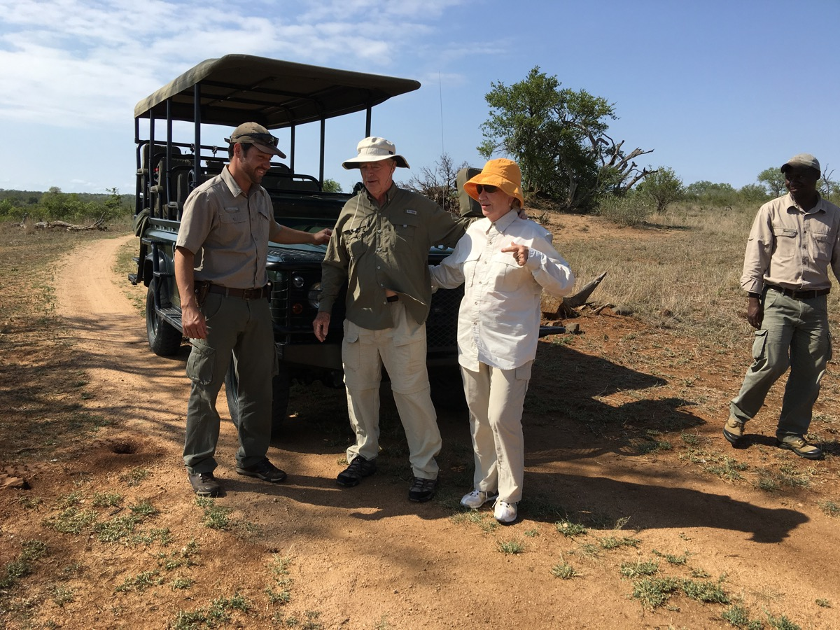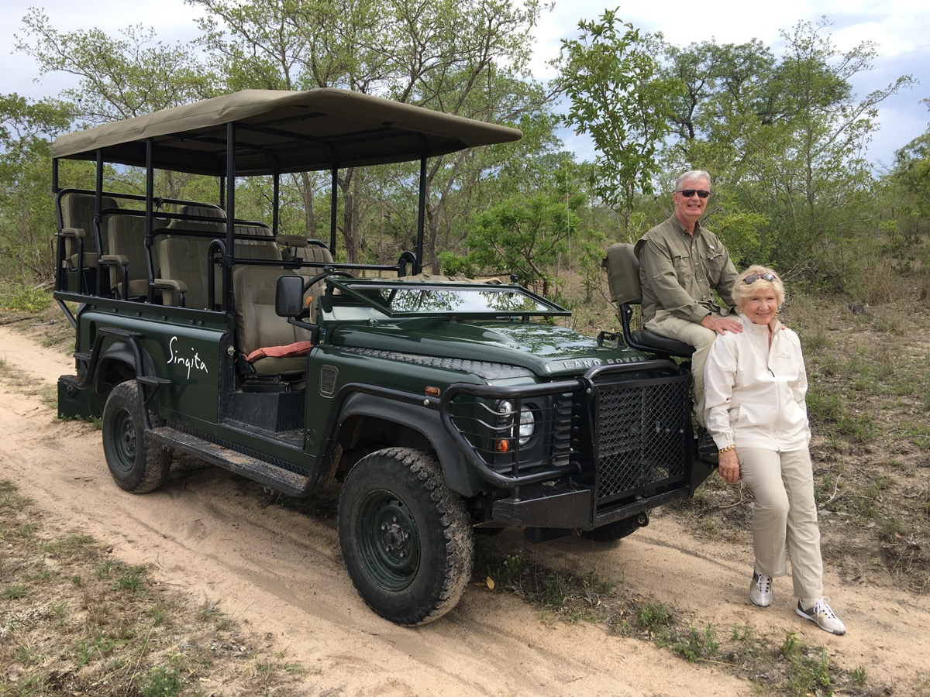
Driver/Guide Ricardo on left and tracker/spotter Peter on right. Picture on right I am in the tracker seat.

I thought of buying expensive camera equipment with telescopic lenses, but in the end settled on my trusty new iPhone 6+. We got so close to the animals that I was able to get all the good pictures I needed up close and personal. The only unnatural part of a safari is the animals do need to be trained to not fearing vehicles and people in the vehicles. This training process takes several years. To make this all work, the spectators need to remain still in the vehicle so as not to spook the nearby animals. When taking pictures, there is a temptation to standup for a better shot so you have to show restraint. The driver also has to balance trying to get as close as possible without tripping the animal’s chase instinct. There is a rifle in the vehicle for an emergency situation, but Ricardo said he never had to use it.

Over the three days we saw everything up close starting with the "Big Five" of lion, elephant, leopard, Cape buffalo, and rhinoceros. The term "Big Five" was coined by big-game hunters and refers to the five most difficult animals in Africa to hunt on foot. Equally as interesting, we also saw giraffe, zebra, impala (the main source of food for the predator animals), warthog, kudu, ostrich, cheetah, wildebeest, mongoose, and a variety of birds including vultures (necessary to avoid disease from spreading). We did not see an actual “kill” as 85 to 90% of that takes place at night. We did see a lion and lioness mate. After that Ricardo explained the total mating process which might last for two or three days every 15 minutes. We also learned about the fierce competition among male lions. Certainly a story of survival of the fittest. They do not die from old age. They seldom live longer than 10 to 14 years in the wild due to injuries sustained from continual fighting with rival males. The third morning we located a lion because we heard his extremely loud roar that can travel four miles or more.

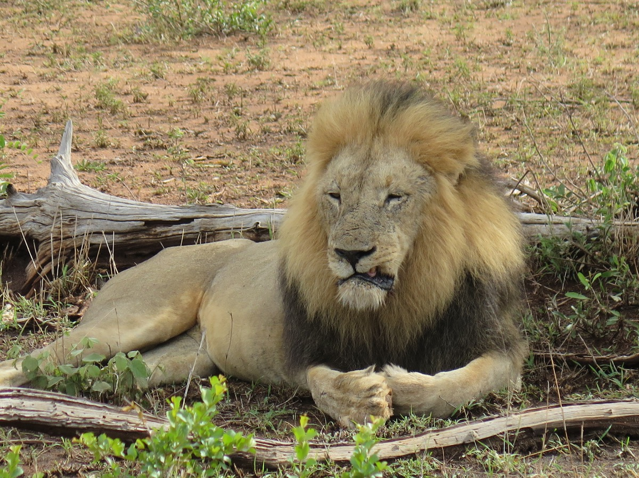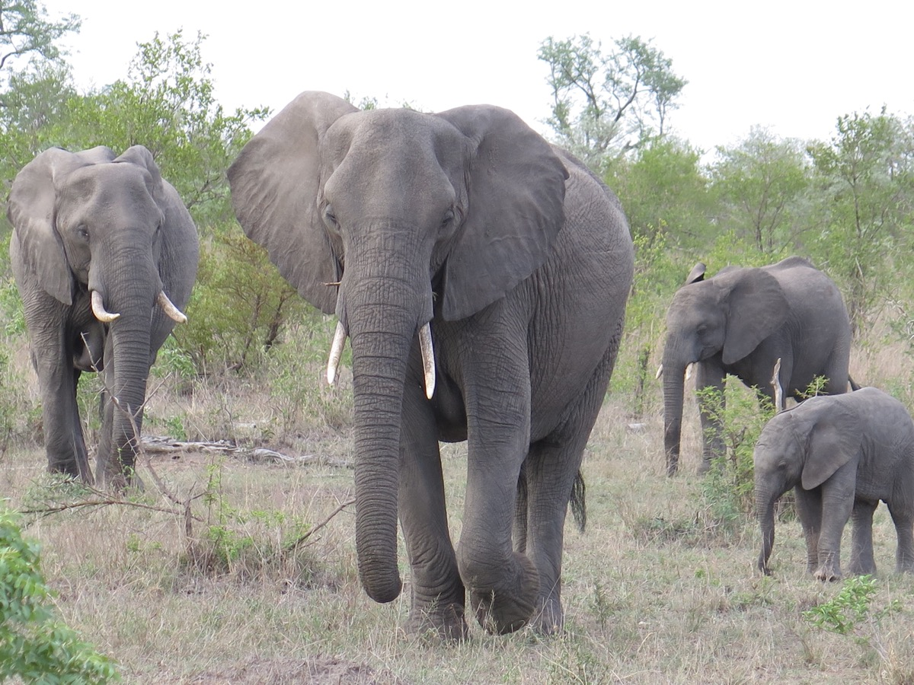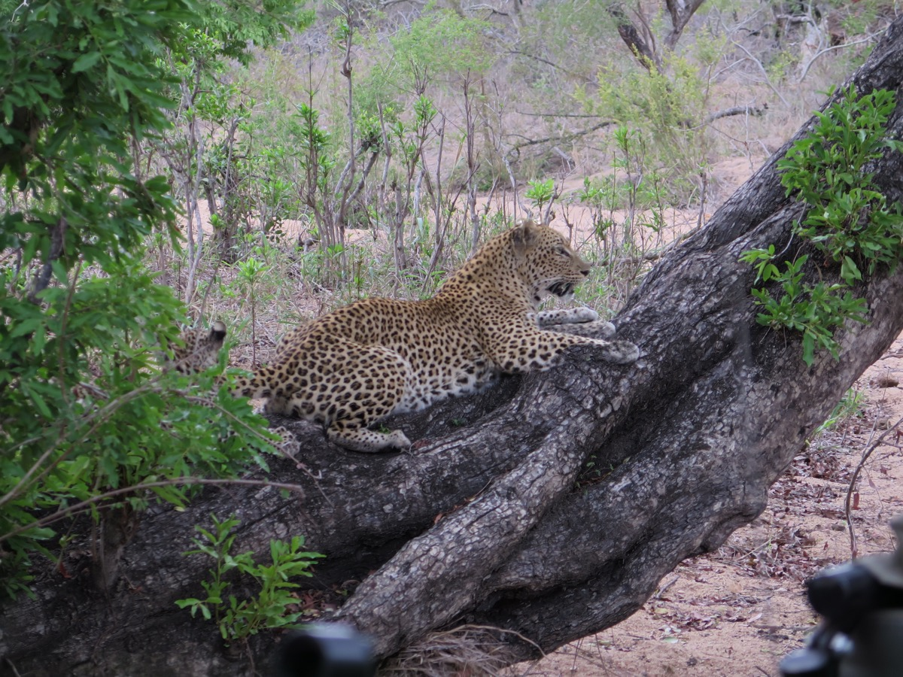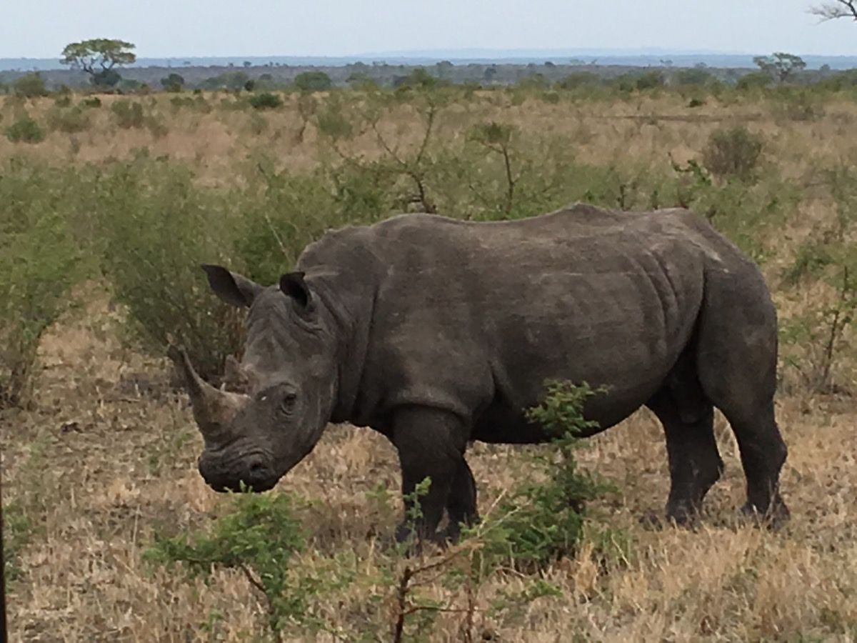

Leopard Creek Country Club & Estate
From Singita we were driven south 104 miles back near Nelspruit and then northeast to the farming town of Malalane (also called Malelane) in Mpumalanga Province. The last part of the trip is on the busy main highway between Johannesburg and the Mozambique border (28 miles from Malalane). Turning off the highway you are near the southeast gate to Kruger National Park and the entrance to Leopard Creek Country Club & Estate. The course is a 1996 Gary Player design rated #2 in SA (constantly changing positions 1 and 2 with Fancourt Links). We were immediately met by host was Johan Piek, Club Manager, a really nice young man who made sure our stay was comfortable and informative.

Leopard Creek is on land that was formerly the private reserve of Johann Rupert. The Rupert family wealth is $7.7 billion from owning luxury goods companies such as Cartier, Dunhill, Montblanc, and Peter Millar. Johann is a very popular supporter of golf in SA (both amateur and professional). He has turned the property into a low density, high-end estate along with a private golf course. There is an attractive large old-style clubhouse with excellent food and service. Six newly-build four bed room lodges are available for guests of members. All the housing is substantially set back from the course. There is almost none visible on the front side of the course and just a few come into view on the back nine.

Part of the property is on the banks of the Crocodile River, although the only course view of the river is on the 13th green. This hole has a stream running in front of the tee and then meanders down the entire left side of the severely down-sloping fairway to the green. The raised green is in a spectacular setting with the Kruger bush land clearly visible on the other side of the river and then a mountain backdrop. The river in about 40 feet below the back of the green (no crocs were visible in the shallow water). You can see for miles at this location.

Wild life was originally present on the course, but giraffes beat up the greens. I did see some elephants below the clubhouse. The whole course is quiet with birds chirping and the overall ambience is excellent. The course is fairly hilly so a motorized cart is helpful (actually there are no bunker rakes so you have to use the one on the cart). Most of the holes are tree lined on both sides. There are 87 bunkers and water comes into play on 11 holes (some hidden narrow streams in front of greens and some lake lakes). From the tee many driving areas look wide, but are actually pinched by bunkers and strategically placed trees. The greens are large (some massive) with steep edges and multiple chipping options.

I really liked the 9th and 18th holes as a combination. They run side-by-side separated by a stream on the same severely down-sloping terrain. The design challenge was how to differentiate the look and playability of the two holes. From the tees you see in the distance the Kruger Park landscape with a mountain range as backdrop. The 9th is a 476-yard par 4 and 18 is just a 541-yard par 5. The 18th fairway is tighter and curvier than the 9th. The real difference is the approach shot. The 9th has a peninsula green and the 18th is an island green, both sharing the same body of water (a large pond). The the view of the 9th and 18th greens plus the handsome clubhouse is attractive from both the course and then looking at the reverse view from the open air upper floor of the clubhouse.

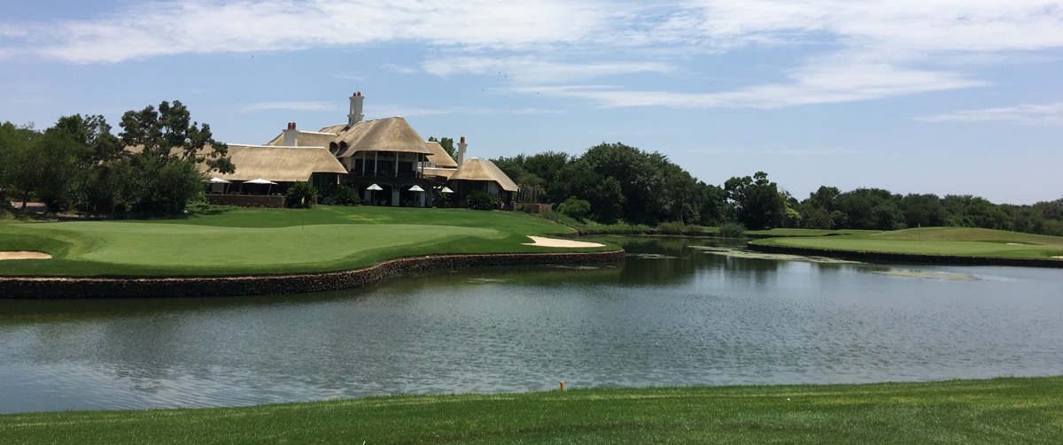
Leopard Creek #9 green right & #18 green left with clubhouse behind.

To accommodate the long hitting tour pros, the club is going through a major update. Currently under construction is a new massive range (comparable to Augusta National’s new range) along with a nine-hole par-3 course. In 2018 the whole course will be regrassed with Bermuda (original greens bent grass). Some greens will be refloated and some new back tees will be added to bring the bunkers back into play. More forward tees will also be created.

Johannesburg
We were driven 49 miles back to Nelspruit Airport for the short 195-mile flight west to Johannesburg (Joberg). We arrived at The Palazzo Montecasino hotel which is 15 miles north of downtown Joberg. In planning any trip in the Joberg area you have to make a strategic decision where to stay to minimizing having to dealing with brutal traffic at all times of the day and night. Joberg is the most populous area in SA with 4.4 million inhabitances.

After settling in at the hotel, Joan and Barry King came over to map out the logistics for the next few days. The King’s are close friends with the Terry Lloyds and I actually had dinner with the Kings in Durban during the 1997 100-day trip. Barry volunteered to take me to the golf courses. Joan and Elaine had a grand time shopping and sightseeing.

The Club at Steyn City
Barry drove five miles north to Midrand and the brand new huge development called Steyn City. The golf course is called The Club at Steyn City. This is a 2015 Nicklaus Design Co. project. Sean Quinn was the lead designer with no Jack Nicklaus involvement. The course is part of a 2,000 acre 10,000-resident program being developed by billionaire Douw Steyn (Auto & General Insurance Co. and was a very close friend of Nelson Mandela). Douw’s Tucson villa is the largest owner's mansion as part of a golf course property that I have ever seen and is the most expensive home in SA. Parts of holes 13, 14, and 15 bring you up close to the three structures. The clubhouse is also unique with a two-level underground parking garage along with grass and scrubs growing on the roof.

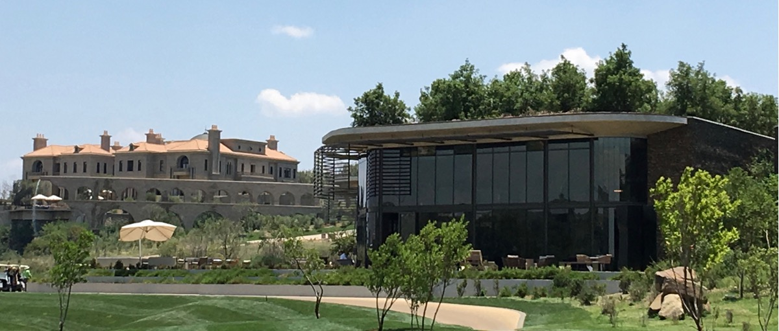
Steyn City clubhouse right & owner’s mansion left.

The course is on extremely hilly terrain so a motorized cart is necessary. The steep topography produces a couple of ski slope downhill shots. The Jukskei River bisects the property but only comes into play on the opening tee shot and the par-3 9th hole. However, water does come into play on 12 holes (13 distinct times with two separate large ponds on #18). Bunkers number 73 with some in the middle of fairways and at the direct front of greens. On the 15th hole one of the bunkers is wide and about 200 yards long. The brand new course has a wide open look. Some young trees have been planted (200,000 on the whole property) and real estate construction is just beginning. Ten years from now the look will be totally transformed with one million more trees to be planted over the next three years and dense housing surrounding almost every hole.

Glendower Golf Club
The next morning Barry drove me over to the private Glendower Golf Club in Edenvale next to N3 Eastern Bypass tollway and 8 miles northeast of Joberg city center. The course is a 1937 Englishman Charles Alison design. In 1985 tees, greens, bunkers and water hazards were updates. Then in 2008 the greens were modernized to USGA specifications with Sean Quinn as consultant. The course is rated #4 in SA (the highest rated member club). It is a walkable parkland suburban course surrounded by housing on the periphery. My playing partner was businessman and club president Yani Joannides. The European Tour SA Open would be played here in four weeks. It was here in 2015 and after this year (2016) will return in 2017 and 2018. After returning home, I viewed the 2016 event on American TV and thought the course was very well-presented. There were a couple of 65s (seven under par), but the winning total was only 14 under.

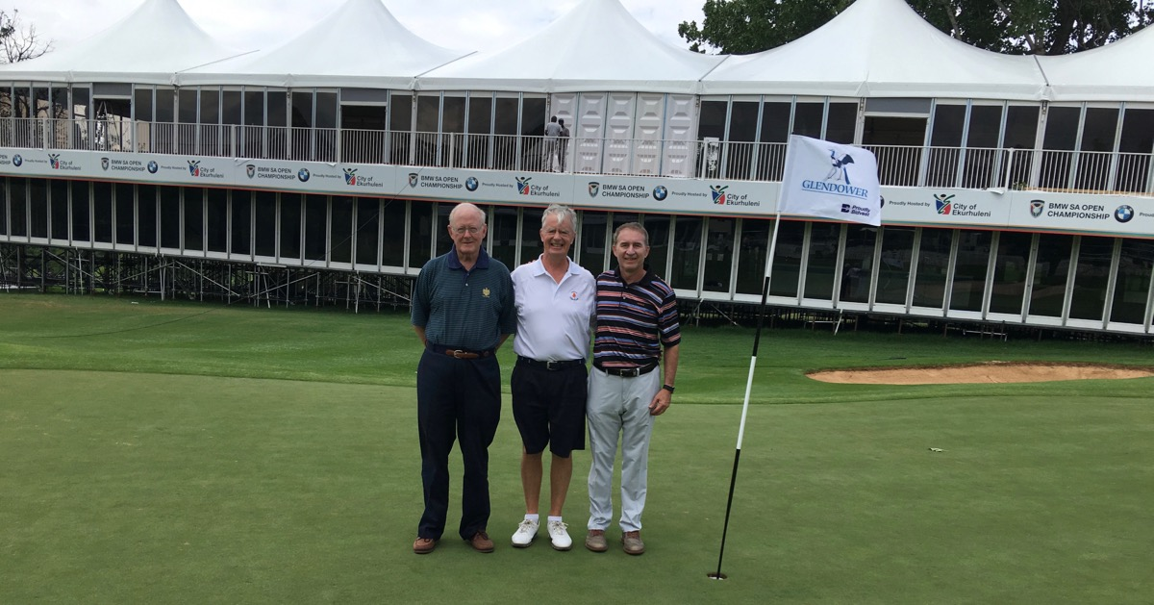
Glendower GC Barry King on my right & club president Yani Joannides on my left.

The course is on nicely rolling terrain with many tall mature trees (40 different species), water influencing play on 12 holes, and only 64 bunkers. It is a tight course with trees pinching drives, forced carries over water, a few out-of-bounds, water close to some greens, and some greens pinched by left and right fronting bunkers. You definitely cannot just blast away but have to really concentrate on your shots.

Glendower is a designated bird sanctuary and through 12 holes the nature-like ambience is reasonably quiet. Unfortunately, the 13th green and 14th tee are under a huge power line and hug a busy and overwhelmingly noisy tollway intersection. Things do calm down again after #14. My favorite hole was #7, a long par 4 dog leg left tight through trees. The drive must be on the right side of the fairway so the perched green can be see. The approach shot is over a stream short of the green with water creeping close to the green on the left. Trees really pinch the shot and then the false front green is really pinched by left and right bunkers. The green slopes severely downhill so your approach must be below the pin.

The River Club
The last course on the trip was the most exclusive golf club in SA. The River Club is eight miles north of downtown Joberg in the Sandton district. The course was designed in 1977 by Bob Grimsdell (SA’s leading golf architect from the 1930s to 1970s). It was upgraded in 1998 by Rob O’Friel. The club has recently decided not to be rated. The last rating in 2014 was #13 in SA, but I loved the course.

My host on Sunday morning was investment banker and member Peter Wharton-Hood. My long-time American friend Kevin Costello insisted I play the course and made the introduction to fellow R & A member Peter. The club has just 220 members and a once per year payment of expenses minus income is divided equally among the members. Unlike almost every other course in South Africa there is not much guest fee income because guests must absolutely play with a member.

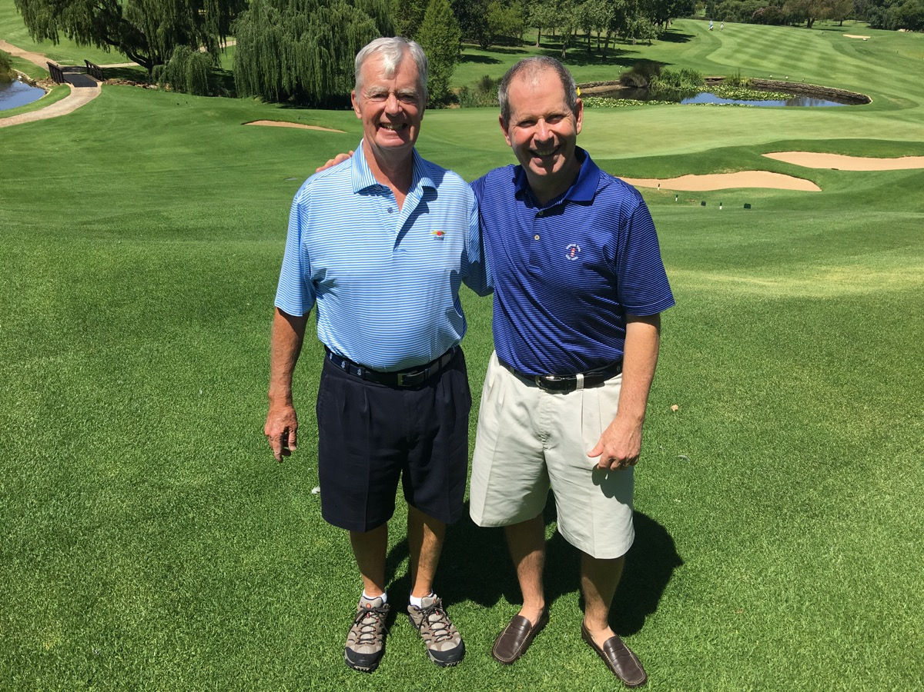
The River Club with member Peter Wharton-Hood.

The River Club is a compact (walkable with good caddies available) suburban parkland course surrounded by homes. The recently rebuilt clubhouse has an elegant feel. There is a quiet environment in the clubhouse and out on the course which is well-conditioned. With only 48 bunkers (not many in fairways), the many trees close to the fairways require accuracy off the tee. The terrain slopes gradually up, down, and to the sides so making approach shots a challenge. Water is a factor on nine holes with five holes having a fairly large pond just in front of the green. So the down-sloping stance makes the required high shot to clear the pond that much more difficult. This feature comes once on the front nine and three times on the back. The par 3 #17 , including the last three holes.

The moderately elevated greens are medium to large and have some severe fall-offs. Accuracy is the calling card here. The course is certainly not a pushover at 7,135 yards from the tips, but there is a soft, calm feeling about the place. Sort of the feeling one gets at Cypress Point, so it is in the category of wanting to be played on a regular basis. This round was the finale for the SA trip. A perfect ending to another great trip.

Website/Blog
I am pleased to say the website/blog “The Odyssey” (thegolfodyssey.com) continued to make progress in 2015. Kevin Larrabee is my IT guru, and he has patiently created what I hope is an excellent working site. To easily locate it just Google “golf odyssey mccoy”.

“The O” on a website gives everyone various options to read the material – computer, tablet, cell phone. My preference is tablet. In “the nothing is easy category” I found that my website provider WordPress has a glitch in their system. If you use an Apple product, minor amounts of the text and some pictures do not appear. Thus we have posted the following: Safari Users (iOS/OSX): The Odyssey's content is best viewed by using the "Download" option at the bottom of each page. Actually, no matter what browser used, the “Download” routine is the best way to view any of the documents.

The real challenges in 2015 was reducing the memory size of each picture. Thanks to the iPhone I am now able to take pictures on the course without interrupting play. Thinking that some pictures would add to your reading enjoyment, I first started inserting pictures in the 2014 Odyssey. Unfortunately, when I went to email the full document, it hit the internet capacity wall because just a few pictures were taking up too much memory. The total size was 110 megabytes and I sadly learned that the maximum size for emails is 31.5 megabytes. Each picture was taking up 2 to 3 megabytes of memory. So I had to strip out the pictures in order to email the text for the 2014 Odyssey. The original document, including pictures, was also too big to be posted on the website. So the pictures were put in a separate section of the website, but that was an unsatisfactory solution.

Thankfully, Kevin has come up with a solution that does not sacrifice picture quality. I am now able to shrink the memory size of each picture from 2 to 3 megabytes to about 800 kilobytes. This reduced the 2014 Odyssey to 4 megabytes so you can now see the text and the inserted pictures in one place on the website. The same is true for the 2015 Odyssey.

I welcome your visit and would appreciate any comments and/or suggestions you may have about the format and/or content.

Moving Northern Home From The Boston Area To Boothbay, Maine
At the beginning of 2015, Elaine and I had no thought of moving anywhere. Then I heard about some interesting developments in Boothbay (56 miles northeast of Portland) and Boothbay Harbor, Maine. A 63-year-old businessman sold his liquor business in 2012 to Beam, Inc. (Jim Beam Bourbon) for $605 million. Already having a home on Southport (next to Boothbay Harbor), he has decided to invest tens of millions of his dollars to upgrade the area with the desire of it becoming another Kennebunkport, Bar Harbor, or Camden. He bought the Boothbay Harbor Country Club (BHCC) out of bankruptcy in 2013 for $1.4 million. The golf course is two miles north of the harbor in hills and woods.

Bruce Hepner (former Tom Doak and Ron Force associate) was hired to totally redesign and rebuild the golf course and add a driving range for $8 million. To open in May 2016 is a new 32,000-square-foot clubhouse for $23 million. Plans are almost finalized on a second phase building for fitness, pools, spa, tennis, and pickle ball (not sure what that is).

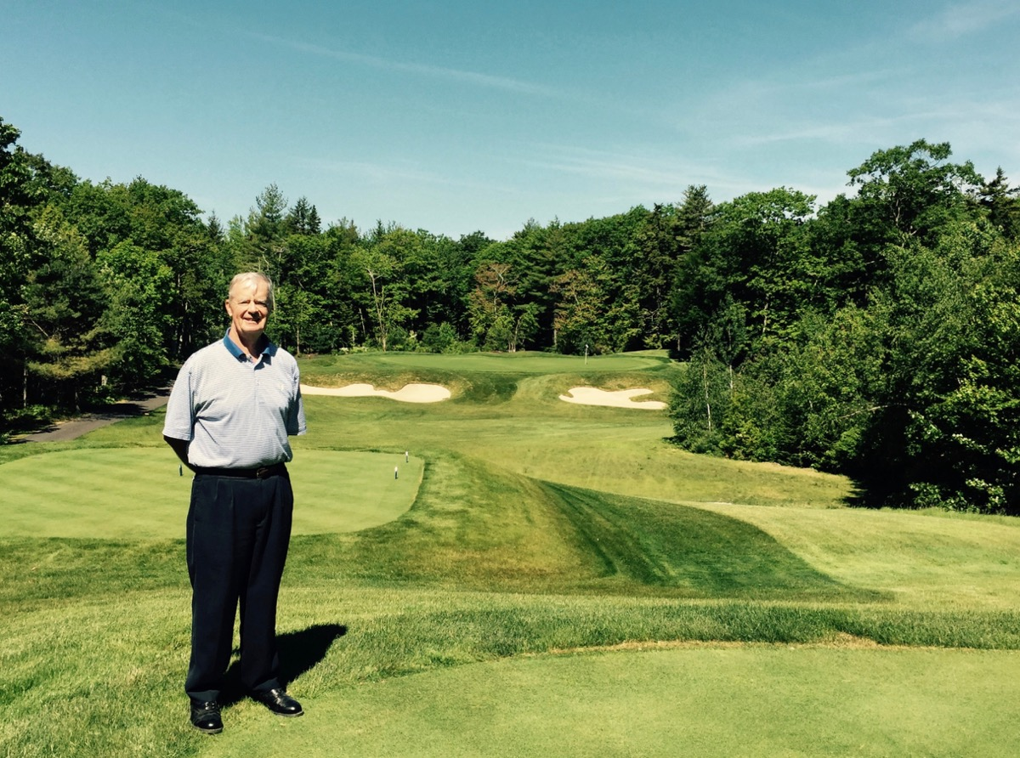
Boothbay Harbor CC par 3 #15 at 150 yards.

Elaine and I went up there in mid-June. I played the course and liked it so we then spent some time with local realtor Bruce Tindal. Almost immediately, we bought a lot with a 1965 vintage cottage along with a barn on Hodgdon Island. The attractions are a multi-mile north view of the tidal Back River, 1.5 acres of peninsula land, and two miles from the golf course.

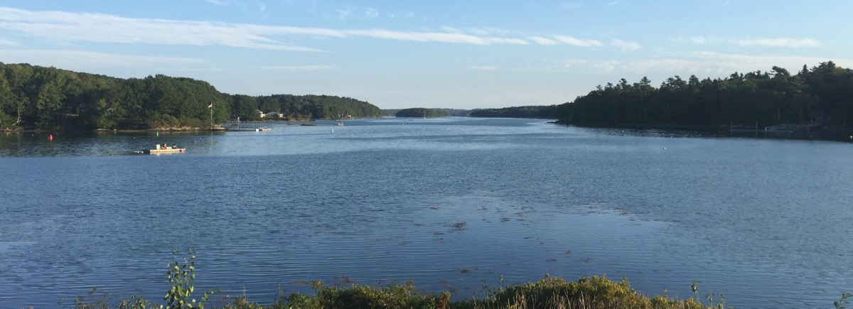
View of Back River from front porch of our new home.

We are using the local Knickerbocker Group (same firm doing the BHCC clubhouse) to build a modest home. After the cottage was demolished, construction started toward the end of the year with completion promised June 2016. A dock has been approved, so a small boat is contemplated. I have been told fishing in the lake is not great, but it does contain hundreds of thousands of lobsters. Apparently, I can acquire a license to catch five lobsters per day so maybe I will become a Maine lobsterman (without the distinctive Down East Maine accent). Elaine is over-the-moon happy and has spent almost every waking hour in planning everything down to the smallest detail. I am looking forward to a quiet and relaxing place to take care of business discussed in the next section of this document.

The Book
Again, for almost the whole of 2015 and not surprising, nothing was accomplished on A Golf Odyssey with The Real McCoy. Then in the lead-up to the South African trip, John Terry-Lloyd called to ask if I would be willing to give a speech at the Durban Country Club “Champions Dinner” (110 members honoring the club champion and others who won important events). The Brits call this “singing for your supper” and I was happy to accept the challenge. Creating the speech was actually getting the ball rolling on the book. I went through the old Odysseys and picked out some good stuff about the life and times of a golf course rater. I also put in writing, for
the first time, experiences from 1979 that were not in the computer. Here is the link to the speech:

http://thegolfodyssey.com/book/odyssey-1979-1987-1988-speech-2015-2/

The intention this summer is to sit in my new study, with the peaceful view of the gorgeous river, pounding away on the computer. I will be whipping all previous “Odysseys” into a continuous flow and then add material from pre-1985. Completed sections will be posted on the website.

Miscellaneous
I continue to be a fan of Facebook. I like to see what my family and friends are up to. I try to keep my activity to a minimum, but do like to post something when I am at a course for the first time. If you are interested, please “friend” me at “Bob McCoy Naples Florida.”

The monkey is finally off my back. Over the past few years some “friends” kept asking: “When are you going to shoot your age?" Well it happened and even one better: after turning 76 years young in March, I shot 75 at Naples Grande in April. Another bucket list item checked-off.

No sooner did one bucket list get checked-off, another one popped up – playing golf in all 50 states. During the year someone asked in how many states have I played golf. I had never given this subject a thought, so did some counting. The total was 45. Why not go for all 50 which means going to Alaska, Utah, North Dakota, Iowa, and Louisiana. Stay tuned!

How would you like to hit a 95 mph heater from the big guy on my left? In September I was asked to host baseball pitching great Roger Clemens at Baltusrol. Others in the foursome were Brett Bossung (NYC based private equity) and Roger’s close friend Ken Jowdy (developer of Diamante). The “Rocket” pitched major league baseball for 24 years and had 354 wins (#9 all time). He is a strong 6 handicap – 280/300 yard drives (50% in fairway), towering and accurate irons, approach putting little shaky but never 3 putted (locked in on five footers like it was the World Series because he had an intense match with Ken). It was a fun and interesting day. Roger paid everyone’s caddie fee including generous tip.

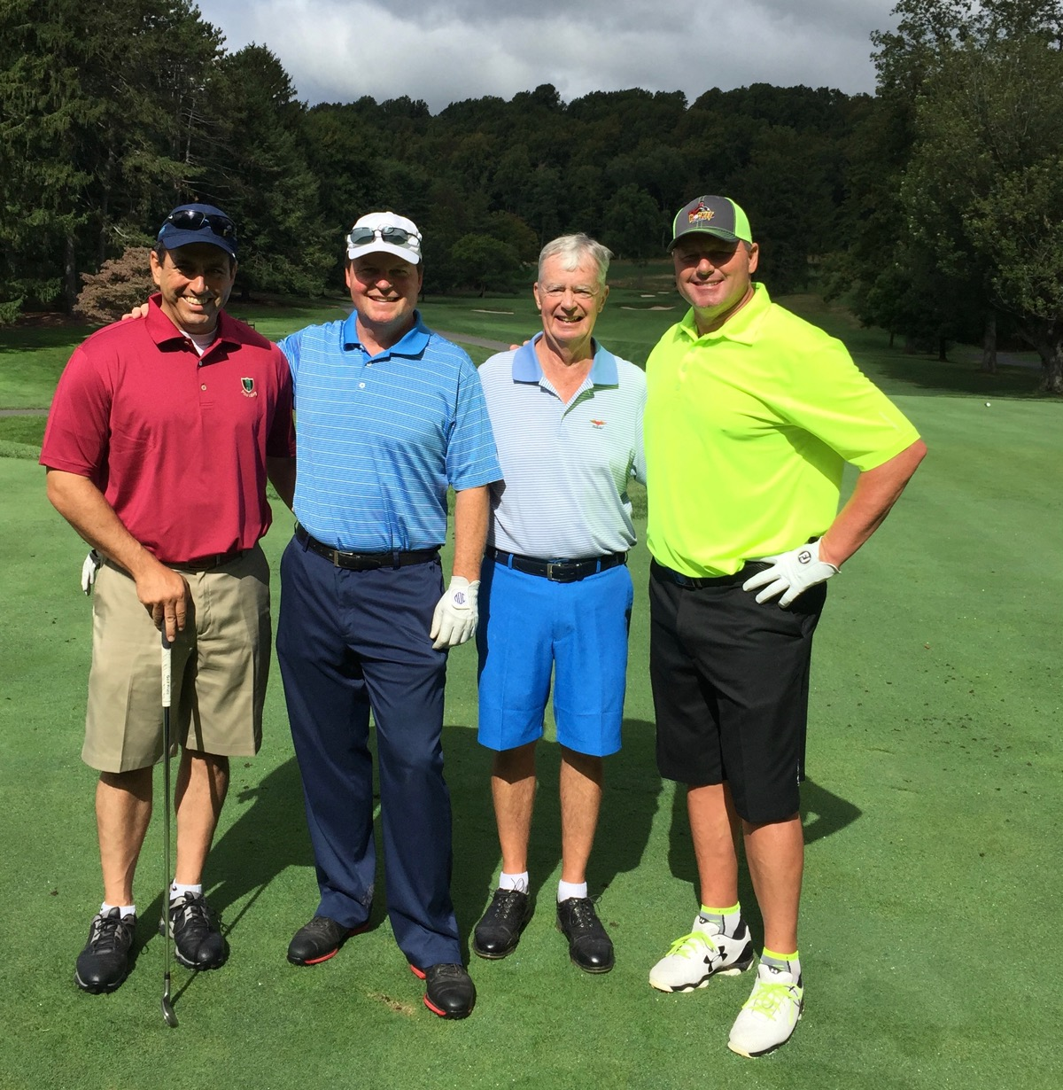
Baltusrol GC par 4 #14 Upper. R/L Roger Clemens, a high school baseball player, Brett Bossung, Ken Jowdy.

Conclusion
I thank everyone who helped make the 2015 events possible. There is no way I could do any of what has happened in 2015, or for that matter all the other years of golf travel, without the help of so many people. As far as this “O” is concerned, special thanks goes to long-time friend Tony Maramarco for his editing expertise.

Wishing all the readers of the “O” good health and enjoyable golf in 2016.

Bob McCoy

Ps Please note new email address: rmccoyjr62@gmail.com.

