2012 Odyssey Part 1

To all my golf friends,
The 2012 Odyssey is about to lift-off on the first of three big trips this year.
The 17-day itinerary covers seven states and 19 different golf courses.
Will be visiting the Teton and Yellowstone areas of Wyoming for the first time.
To make the trip work will be driving from Jackson Hole, Wyoming to Portland, Oregon.

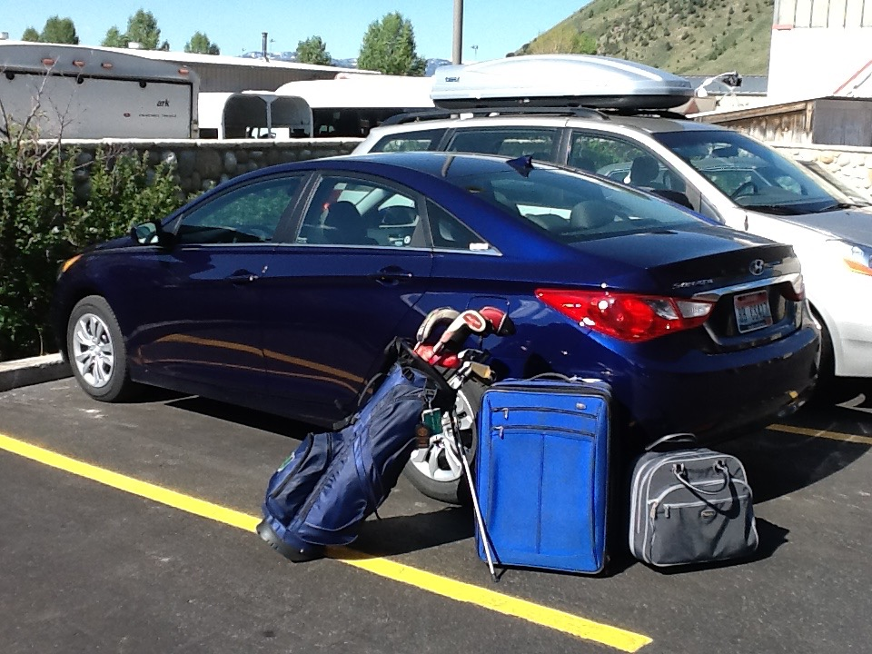
Jackson Hole, Wyoming

The coast-to-coast trip involves 2,300 road miles and 4,800 air miles.
Wed | 30-May | Fly Boston/Detroit | Delta 2883 7:08am-9:19am | 613
 |  | Drive to Roscommon, MI | Northwest of Detroit | 210
 |  | Stay Forest Dunes
Thurs | 31-May | Play Forest Dunes GC 7:33 am | Donny Fisher, PGA Head Golf Professional
 |  | Drive to Detroit airport |  | 210
 |  | Stay Holiday Inn
Fri | 1-Jun | Fly Detroit/Chicago | AA 4355 7:20am-7:40am | 239
 |  | Fly Chicago/Wichita | AA 4253 8:20am-10:10am | 590
 |  | Drive to Andover, KS | East of Wichita | 19
 |  | Play Flint Hills National GC 1pm | Max Moss (Member)
 |  |  | Tom Devlin(Developer)/Dave Henson PGA
 |  | Drive to Wichita airport |  | 19
 |  | Stay Holiday Inn Express
Sat | 2-Jun | Fly Wichita/Denver | United 658 8:30am-9:02am | 437
 |  | Fly Denver/Jackson Hole, Wyoming | United 762 11:29am-12:55pm | 393
 |  | Rental Car Hertz | Return Portland Oregon Airport
 |  | Stay Wyoming Inn in Jackson |  | 10
Sun | 3-Jun | Play 3 Creek Ranch 8am | Greg Glover, PGA Head Golf Professional | 2
 |  | Drive to Teton Village | Northwest of Jackson | 11
 |  | Play Shooting Star GC 1:30pm | Matt Morman, PGA Director of Golf
 |  | Drive Driggs, Idaho | West of Teton Village | 34
 |  | Stay Huntsman Springs
Mon | 4-Jun | Play Huntsman Springs 8:30am | Tony Snoey, PGA General Manager
 |  | Drive to Bozeman, Montana | North of Driggs | 184
 |  | Stay Hilton Garden Inn
Tues | 5-Jun | Play Black Bull 8:30am | David Baucom, PGA, General Manager
 |  | Drive to Eureka, Montana | Northwest of Bozeman near Canadian Border | 361
 |  | Stay Lodge at Wilderness Club | Debbie Garrison
Wed | 6-Jun | Play Wilderness Club 8am | Bob Veroulis, PGA Director of Golf
 |  | Drive to Coeur d'Alene, Idaho | Southwest of Eureka | 196
 |  | Stay Coeur d'Alene Resort
Thurs | 7-Jun | Play Gozzer Ranch 8am | Matt Baine, PGA Head Golf Professional
 |  | Play Coeur d'Alene Resort 2pm | Andy Mackimmie, PGA Head Golf Professional
 |  | Stay Coeur d'Alene Resort
Fri | 8-Jun | Play GC at Black Rock 8am | Trevor Fox, PGA Director of Golf | 19
 |  | Drive to Walla Walla, WA | Southwest of Coeur d'Alene | 169
 |  | Stay Holiday Inn Express
Sat | 9-Jun | Play Wine Valley GC 7am | John Thorsnes, PGA Director of Golf
 |  | Drive to Sisters, OR(Black Butte Ranch) | Southwest of Walla Walla | 274
 |  | Stay with Trina & Dean Alpine | Black Butte Ranch
Sun | 10-Jun | Drive to Bend |  | 37
 |  | Play Pronghorn(Nicklaus) 8:50am | Austin Kingsley, PGA Golf Professional
 |  | Play Pronghorn(Fazio) 1:08pm
 |  | Stay with Trina & Dean Alpine | Black Butte Ranch
Mon | 11-Jun | Play Black Butte Ranch(Big Meadow) 8:33am | Jeff Fought, PGA Director of Golf
 |  | Play Black Butte Ranch(Glaze Meadow) 1:39pm
 |  | Stay with Trina & Dean Alpine | Black Butte Ranch
Tues | 12-Jun | Drive to Bend |  | 38
 |  | Play GC at Tetherow 9:40am | Caleb Anderson, PGA Head Golf Professional
 |  | Drive to Bandon, OR | Southwest of Bend on Pacific Ocean | 265
 |  | Stay Bandon Dunes Golf Resort-The Inn
Wed | 13-Jun | Play Old Macdonald 8:50am | B.R. Koehnemann, Dir Marketing & PR
 |  | Play Bandon Preserve 3pm
 |  | Drive to Portland (Wilsonville), OR | Northeast of Bandon | 228
 |  | Stay Holiday Inn
Thurs | 14-Jun | Play Waverley CC 8am with John Strawn | John Wells, PGA Head Golf Professional | 15
 |  | Fly Portland/Boston | Jet Blue 96 11:25pm | 2540
Fri | 15-Jun | Arrive 7:47am

Odyssey 2012 Trilogy Part 2

Before the trip notes from Odyssey 2012 Trilogy Part 1 which took place in May-June are completed and sent to you, it is already time for Trilogy Part 2. The focus over the past two months has been detailed planning for Parts 2 and 3. Suffice to say, Part 1 was successful.

As you can see from the itinerary below, Part 2 is split between Denmark, England (Royal St. George’s), and Scotland. In 2010 I played Royal Copenhagen so this trip is to experience all the other leading courses in Denmark.

At Royal St. George’s Elaine and I will be renewing old friendships at this beautiful links club which we love to visit every September. I will also be defending a win from last year in the Club Handicap Championship. In the Club Foursomes Handicap Championship David Kulick and I won two years ago and lost on a match of cards last year. Not bad for two Americans employing long putters and not regular alternate shot players.

The final leg in Scotland includes our yearly visit to St. Andrews for various R&A competitions. But before that comes the new Donald Trump course just north of Aberdeen. The Donald has purportedly spent $60 million to design and build a seaside links course. It officially opened in June of this year and early reports from friends and the press have been very favorable. Blairgowrie, Montrose, and Panmure are fairly near Aberdeen and my thought is that they, along with Trump, can be part of a compact package of courses in the northeast region of Scotland including Carnoustie, Royal Aberdeen, Murcar, and Cruden Bay.

As a senior citizen I’m taking baby steps in the social networking era so dabbled with Facebook during the May-June trip. It was my maiden voyage in trying for a daily update with a picture and brief progress report. Because the pictures were taken with a smartphone I also had to type the text from the phone’s keyboard in order to post everything on Facebook. What I immediately found out is typing anything on the TINY keyboard is difficult and time consuming. I’m a 36 handicap in this area. In any event, I’ll give it another try on this trip. So here we go.

Mon | 27-Aug | Fly Boston/London | BA 212 7:10pm 6 hrs 15 min 3,268 miles
Tues | 28-Aug | Arrive London(Heathrow) | 6:25 am
 |  | Fly London(Heathrow)/Copenhagen | BA 814 9:55am-12:50pm 1 hr 55 min 609 miles
On island of Zealand
Rental Car Europcar
 |  | Drive to Jutland-peninsula connected to Germany  Drive to Esbjerg | 188 miles(304 km) 3 hrs
 |  | Stay Hjerting Badehotel
Wed | 29-Aug | Play Esbjerg GC(Marbaek)-8am 4 miles(8 km) | Hans Christian Warrer, GM
 |  | Drive to Vemb | 65 miles(106km) 2 hrs
 |  | Play Holstebro GC(Forest)-4pm | Play with Knud Andersen group
 |  | Stay Hotel Norre Vosborg | 4 miles(8 km)
Thurs | 30-Aug | Drive to Nimtofte | 99 miles(160 km) 3 hrs
 |  | Stay Lubker Golf Resort
Fri | 31-Aug | Play Lubker(Sky, Sand, Forest) 8am 27 holes | Jonas Nygaard Nielsen, Golf Mgr
 |  | Drive to Silkeborg | 52 miles(85 km) 1 1/2 hrs
 |  | Stay Radisson BLU | Jan Frandsen Rosenbaek, Dir Sales
Sat | 1-Sep | Play Silkeborg GC-7am 4 miles(7 km) | Mads Rugholm, Manager
 |  | Drive to Lyngbygaardsvej | 18 miles(30km) 30 min
 |  | Play Lyngbygaard Golf-1pm | Thomas Christensen, Sekretaer
 |  |  | Play with Jacob Arnkvist, Head Greenkeeper
 |  | Leave Jutland-drive to Zealand  Drive to Skjoldenaesvej | 158 miles(255km) 3 hrs
 |  | Stay Skjoldenaesvej Hotel | Gitte Tofte Thomsen
Sun | 2-Sep | Play Skjoldenaesholm Golf Center(RTJ) 8:50am | Thomas Nancke
 |  | Drive to Farum | 42 miles(69 km) 1 hr
 |  | Stay The Scandinavian Golf Club | Frank Undall
Mon | 3-Sep | Play The Scandinavian GC(Old)-8am
 |  | Play The Scandinavian GC(New)-1pm
 |  | Elaine Tour Copenhagen
 |  | Drive to Rungsted Kyst | 12 miles(20 km) 30 min
 |  | Stay Sophienberg Slot
Tues | 4-Sep | Play Rungsted GC-8am 1 mile(3 km) | Jens Holm Boye, Club Manager
 |  |  | Play with Members Stig Backen &
 |  |  | Hans Christian Colov
 |  | Drive to Copenhagen Airport | 31 miles(51km) 40 min
 |  | Fly Copenhagen/London(Heathrow) | BA 819 6:05pm-7:05pm 2 hrs 609 miles
 |  | Rental Car Enterprise
 |  | Stay Ramada Heathrow
Wed | 5-Sep | Drive to Sandwich | 114 miles 2 hrs 15 min
 |  | Stay at The Salutation thru Sept 9 | Dominic D.H. Parker
 |  | Play Royal St. George's -2pm | Match with Honorable Artillery Company (HAC)
 |  | Club Dinner with HAC | Robert Prestige, Match Manager
Thurs | 6-Sep | Play Royal St. George's - 9:10am | Match with Honorable Artillery Company
 |  | Play Royal St. George's - 3pm | 9 holes with Elaine
 |  | Dinner Griffen's Head 7pm
Fri | 7-Sep | Play Royal St. George's 9:30am | David Kulick
 |  | Play Royal St. George's 2pm | Home vs Overseas Members Match
 |  | Dinner King's Arms 6:30pm Fresh Dover Sole | David Kulick, Libby & Graham Findlay
Sat | 8-Sep | Play Royal St. George's am | Club Handicap Championship
 |  | Play Royal St. George's - 3pm | 9 holes with Elaine
 |  | Dinner St. Crispin Inn 6pm
Sun | 9-Sep | Play Royal St. George's | Club Foursomes Championship--Dave Kulick Partner
 |  | Drive to Gatwick
 |  | Fly London(Gatwick)/Edinburgh | BA 2944 4:50pm-6:10pm 354 miles
 |  | Rental Car Enterprise
 |  | Drive to Blairgowrie | 57 miles 1 1/4 hrs
 |  | Stay Altamount House Hotel | June Ramsey
Mon | 10-Sep | Play Blairgowrie GC(Lansdowne) 8am 2 miles | Lizzy Harding
 |  | Drive to Balmedie | 79 miles 2 hrs
 |  | Stay Whitehorse Inn
Tues | 11-Sep | Play Trump Intl Golf Links 9am 3 miles | Sarah Malone, GM; Jonas Hedberg Golf Development
 |  | Drive to Montrose | 50 miles 1 1/2 hrs
 |  | Stay Park Hotel
Wed | 12-Sep | Play Montrose Golf Links(Medal) 7am 1/2 mile | Claire Penman, Company Secretary
 |  | Drive to Barnhill | 27 miles 50 min
 |  | Stay Best Western Woodlands Hotel
Thurs | 13-Sep | Play Panmure GC 8am 5 miles | Play with Gordon Adam(member)
 |  | Drive to St. Andrews | 22 miles 40 min
 |  | Stay at Scores Hotel thru Sept 17
Fri | 14-Sep | Play St. Andrews(Old) | Bing Crosby Tournament
Sat | 15-Sep | Play St. Andrews(Old) | Town Match with Bobby Simpson as partner
 |  | Play St. Andrews(Strathtyrum) pm | With Elaine
Sun | 16-Sep | Play St. Andrews(New) 8am
 |  | Play St. Andrews(Strathtyrum) 2pm | With Elaine
Mon | 17-Sep | Play St. Andrews(Old) 1pm | R&A Medal-L.A. Draper, M.R. Johnston
 |  | Drive to Edinburgh Airport | 53 miles 1 1/2 hrs
 |  | Stay at Hilton Edinburgh Airport
Tues | 18-Sep | Fly Edinburgh/London(Heathrow) | BA 1441 10:05am-11:50am 330 miles
 |  | Fly London(Heathrow)/Boston | BA 215 5:40pm-7:45pm 7 hrs 5 min 3,268 miles

Elaine and I came back from the 23-day August/September Denmark/England/Scotland trip bloodied but unbowed. It was the wildest trip we have ever experienced. However, the positives far outweighed the negatives.

The good news is that we really enjoyed the people, golf and food in Denmark. We saw many old friends at Royal St. George’s in Sandwich in sparkling weather. I did play the spectacular new Trump course in Scotland (a must play but expensive) as well as every other scheduled course except one.

The challenges were:
- On the fifth day in peaceful Denmark a car break-in while playing golf in a remote part of the country with the loss of about 50% of our travel gear.
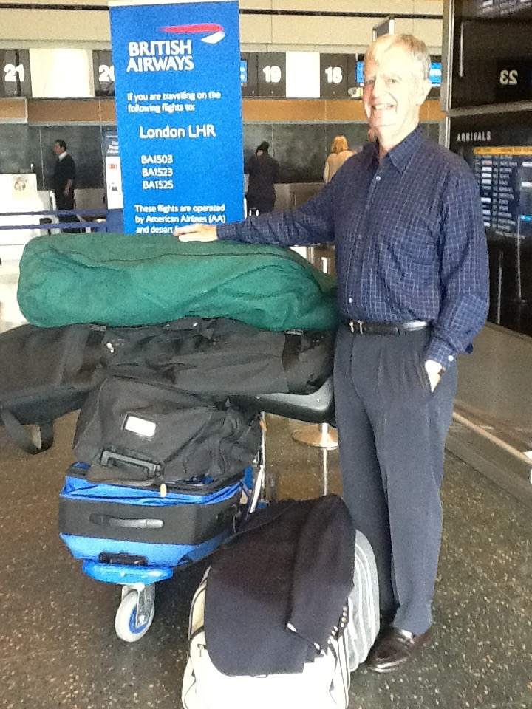

At Boston Logan Airport. 50% stolen at Lyngbygaard Golf in Denmark.

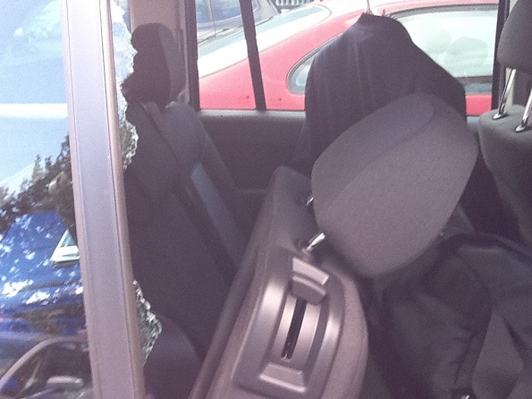
Car Break-in at Lyngbygaard Golf.

- Real trouble renting cars without my driver’s license which went in the robbery. Losing this key item is totally my fault for being lulled into not even contemplating a possible disappearance.
- Elaine coming down with vertigo sickness in England (medication for that taken during car break-in).
- Stuck hotel shower producing hot steam which set-off an ear splitting hotel alarm system (an alarm in each room) at 6:30 am while shaving and then trying to explain to groggy and half garbed neighbors it was only a false alarm.
- Banging the top of my head in St. Andrews on a poorly designed Vauxhall car trunk 30 minutes before a competition tee time on The Old Course resulting in a concussion and much blood gusting through my golf cap and streaming down my face.

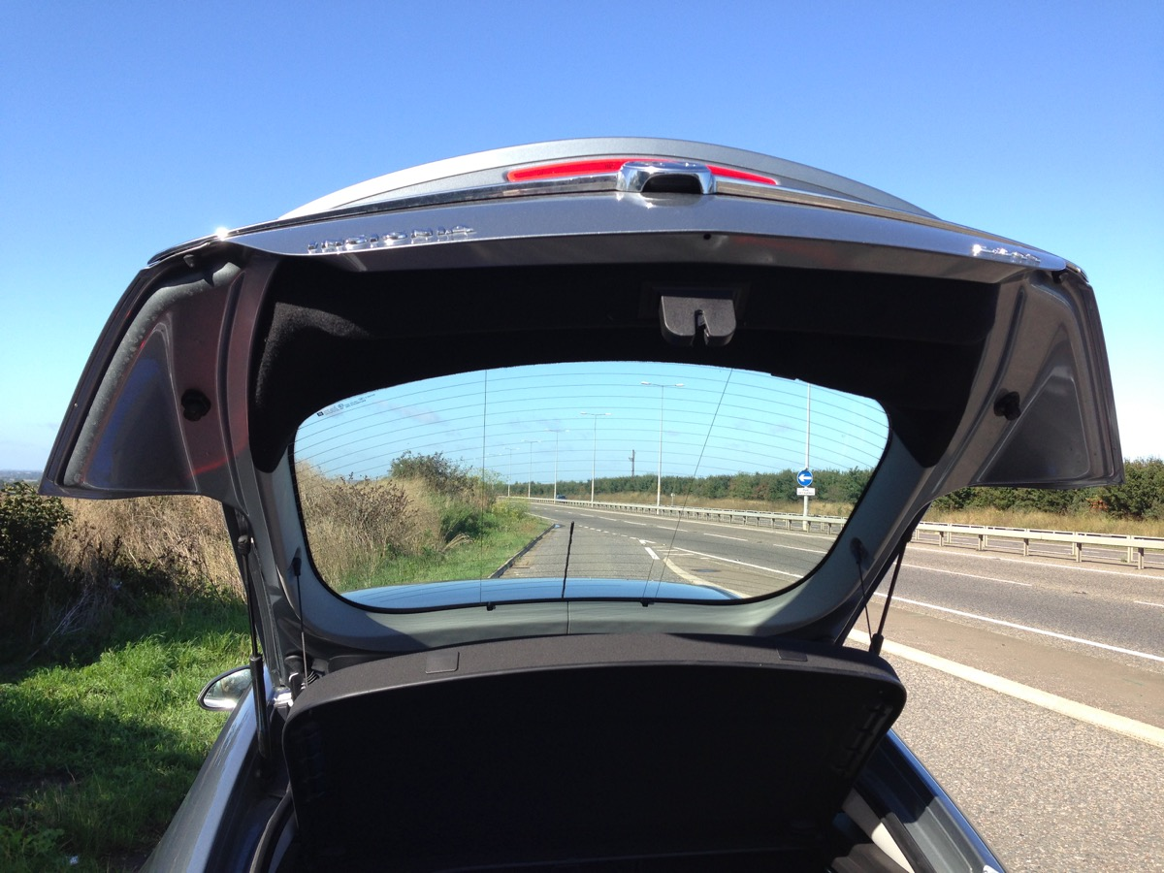
Vauxhall trunk with very dangerous wings.

- Then battling 60 mph winds during said competition on the same day the British Ladies Open was cancelled due to the same high winds.
We did survive all the craziness and some of it now seems funny. You could not make this stuff up.

Much thanks go to our new friends at The Scandinavian Golf Club in Farum, Denmark (14 miles northwest of Copenhagen). Managing Director Lars Peter Wilhelmsen along with Tuula and Frank Undall were our next stop after the car break-in and they were so helpful in the regrouping stage. The two courses there (Old & New designed by RTJ II company) are outstanding. The names are somewhat misleading as the “Old” opened in 2010 and the “New” in 2011. My preference was the New because of a smoother flow of holes with good variety and subtle challenges. It is the number one course in Denmark in my opinion. Both courses are well conditioned and extremely difficulty so bring your A-game or plenty of balls. In the attractive modern clubhouse there is excellent food and service.

Odyssey 2012 Trilogy Part 3

Turning to Part 3 of the 2012 Odyssey, one goal at the start of the year was to becoming current again in playing all courses on the GOLF Magazine 2011 World 100 list (first achieved in 1988). The number was three and in June I played Old Macdonald (#74 on the list Tom Doak/Jim Urbina design)) in Bandon, Oregon. In late October it will be Diamante (#58 on the list Davis Love III design) in Cabo San Lucas, Mexico and finally in November Barnbougle Lost Farm (#82 on the list Bill Coore design) in Tasmania, Australia. So if I’m going to these distant locations the schedule needs to be filled out with more highly regarded courses to visit for the first time to evaluate.

Gordon Dalgleish of PerryGolf suggested a Circle Pacific program which offers a substantially reduced air fare if your itinerary fits the program’s requirements. After some maneuvering a 38-day schedule (27 courses) and Boston/LA/Hong Kong/Melbourne/LA/Boston flight schedule (24,950 miles) came together. Other plane tickets were purchased separately (5,887 miles).

The last time I played LA North and Riviera was 1997. LA North has gone through a recent substantial renovation by Gil Hanse and there has been some massaging at Riviera over the past few years.

There is much new golf course construction going on in China. In May 2011 when visiting the Kunming area for the first time, two interesting courses where under construction – Stoneforest C Course (Schmidt-Curley Design Company) and Yunling (a Rees Jones/Greg Muirhead design). Kunming is the capital of Yunnan Province which is in the mountainous southwest part of China bordering Myanmar, Laos and Vietnam. The climate in the Kunming area is consistently warm year around (60-75 degrees) so perfect for golf. The golf ball also goes a long way as the elevation in the area is more than a mile high.

Visiting China requires a visa. In 2011 I only had to complete a simple form. However, as of August 1, 2012 the central government changed the rules and every applicant has to provide proof of reservations to enter and leave the country as well as proof of every hotel reservation. So if you are going to China be prepared for much more paper work.

Getting from one place to another on a golf trip in China is easy. Westerners absolutely do not drive as you need a Chinese license and this is not easy to obtain. Every hotel and golf course has access to a government subsidized taxi system (Buick seems to be the most popular). Because of Chinese wages, the cost of the driver is quite low.
As in my first visit, the base of operation will be Singapore-owned Spring City Golf & Lake Resort (30 miles east of Kunming City) where I will again play the best course in China (Lake Course-RT Jones Jr design opened 1998) as well the very good Mountain Course (Nicklaus design opened 1996). Not only is Spring City a large resort, but it is also a successful real estate development with several hundred units.

During the 2011 trip I did play the first two courses at Stoneforest and rode around the third course. Stone Forest is a world famous tourist attraction with 270-million-year old limestone formations of sheer tall rocks (up to 100 feet) coming out of the ground looking like petrified trees and giving the illusion of a forest of stone. The challenge for the Schmidt-Curley design team was to find green and tee sites among the thousands of stones without being permitted to move any of the larger ones. The Leader’s Peak course has the most stones on the property and thus is located in a dramatic and very unique setting.

Mission Hills is the largest golf complex in the world at three in-land locations: Dongguan (5 courses) and Shenzhen (7 courses) both just north of Hong Kong with Haikou (10 courses) on Hainan Island. All the courses are named after famous golfers who acted as design consultants, but most of the work was done by Schmidt-Curley Design.

Hainan Island (dubbed “China’s Hawaii”) is the southernmost province of China located in the South China Sea and 300 miles southwest of Hong Kong. The capital city is Haikou at the northern tip of the island with Sanya at the southern tip. The central government in Beijing has designated Hainan Island as a major international tourist location so there has been much infrastructure spending on transportation as well as easily granting permits for the construction of hotels and golf courses. Much of this is taking place on the beautiful sandy shores stretching on the east coast of the island between Haikou and Sanya.

From Mission Hills Haikou I will work down the coast to Shanqin Bay (Coore + Crenshaw design),

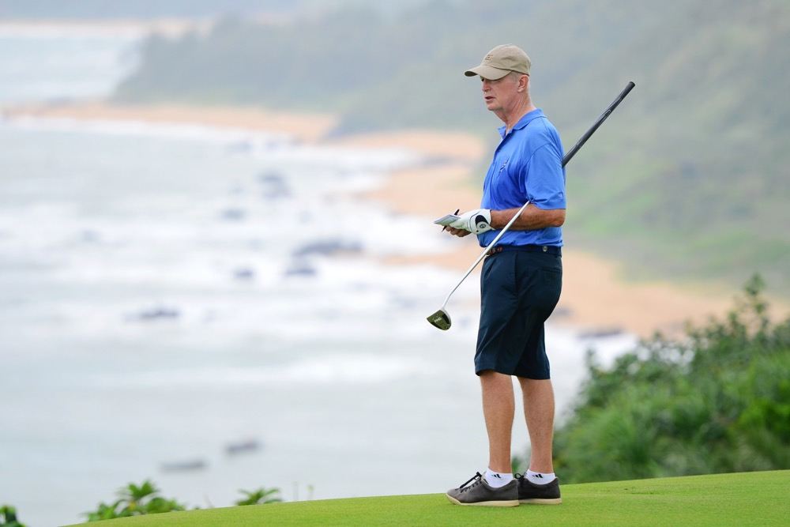
Taking notes at Shanqin Bay.
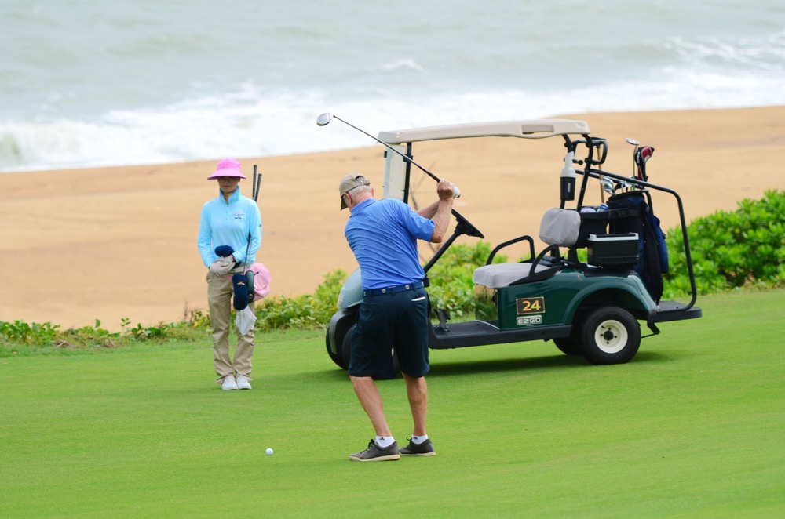
Playing at Shanqin Bay

The Dunes at Shenzhou Peninsula (Weiskopf design), and then Jian Lake Blue Bay (JMP-Mark Hollinger design). At the end of golf there was no direct flight to Hong Kong from Sanya that fit my schedule so a flight to Shenzhen was booked with the thought of taking a two hour bus ride to Hong Kong. Thanks to Google I found a 40 minute ferry service directly from Shenzhen Airport to Hong Kong Airport.

My guess that a return trip to Hainan Island is in the cards within two years as more high profile courses will be opening. For instance, Tom Doak has two projects under way. While on Hainan during the current trip I hope to learn about all the new developments.

The best way to Tasmania and Barnbougle is through Melbourne. So if you are in Melbourne one has to play Royal Melbourne, Kingston Heath and the Woodlands. The East Course at RM has received some recent attention from Tom Doak. Trying to work out the full Melbourne schedule with conflicting events at KH (Australian Masters) and corporate outings at RM required a “double dip” visit to the area.

Now for Facebook. I had every intention of posting several updates during the August/September trip but after the car break-in the spirit for this vanished along with my iPad. The first thing I did upon returning home was to go to the local Apple store for a new iPad. I had visions of a difficult restart, but was blown away by the Apple startup department. In what seemed like two seconds an associate retrieved everything that was on the stolen iPad including pictures taken in Denmark the day before the robbery. But I digress. On the upcoming trip I hope to do at least a few Facebook updates, but don’t hold your breath.

Day | Date | Course/Transportation/Hotel | Contact Person/Flight #
Wed | 24-Oct | Fly Boston/Los Angeles 737-800 2,600 miles | American AA 25 6:45am-10:05am 6:20 hours
 |  | Car Rental Hertz
 |  | Stay Luxe Sunset Boulevard Hotel 14 miles
 |  | Dinner Samm & Norman Klaparda 6 miles
Thurs | 25-Oct | Play The Los Angeles CC(North) 11:30am 4 miles | Play with Mitch Milias (Member)
 |  | Dinner Samm & Norman Klaparda
 |  | Stay Luxe Sunset Boulevard Hotel
Fri | 26-Oct | Play The Riviera CC 10am 3 miles | Play with Norman Klaparda (member)
 |  | Drive to Pasadena 26 miles
 |  | Stay The Langham Huntington
 |  | The Athenaeum at Caltech 6:30pm | Diana & Tim Clark Golden Wedding Anniversary
Sat | 27-Oct | Drive to Moorpark 52 miles
 |  | Play Rustic Canyon GC am | Rodney Scott, PGA Head Professional
 |  | Drive to LA Airport 48 miles
 |  | Stay Holiday Inn Express at LA Airport
Sun | 28-Oct | Fly LA/Cabo San Lucas Los Cabos 737-800 913 miles | American AA 237 10:35am-12:55pm
 |  | To Diamante/World Club Championship (spectator) 33 miles | David Smith, Marcia Robbins
Mon | 29-Oct | Play Diamante GC(Dunes) 11am | Ken Jowdy, CEO
Tues | 30-Oct | Play Diamante GC(Dunes) 10am
Wed | 31-Oct | Play Puerto Los Cabos GC(Mission 9/Marina 9) am 33 miles
Thurs | 1-Nov | Play Cabo Del Sol(Ocean) 8am 20 miles
Fri | 2-Nov | Watch Finals World Club Championship
Sat | 3-Nov | Fly Cabo San Lucas Los Cabos/LA 737-800 913 miles | American AA 425 1:55pm-4:25pm
 |  | Fly LA/Hong Kong 777-300ER 7,230 miles | Cathay Pacific CX 883 11:15 pm 15:40 hours
Sun | 4-Nov | In Air
Mon | 5-Nov | Arrive Hong Kong | 5:55am
 |  | Fly Hong Kong/Kunming A320-200 747 miles | Dragonaire KA 760 11:55am-2:30pm
 |  | Stay Spring City Golf & Lake Resort to Nov 9 35 miles | Lau Tong Chye, GM Operation
Tues | 6-Nov | Play Spring City(Lake) am
Wed | 7-Nov | Play Stoneforest Intl CC(Leader's Peak) am 25 miles | Ms. S.F. Rain
Thurs | 8-Nov | Play Yunling Golf & Spa Resort am 4 miles | Ms. Sherry Shang
Fri | 9-Nov | Play Spring City(Mountain) am
 |  | To airport 35 miles
 |  | Fly Kunming/Shenzhen 737 726 miles | Shenzhen Air 3331 5:50pm-8:05pm
 |  | To Mission Hills Dongguan 29 miles | Peggy Liong, Exec Dir.; Mona Li
 |  | Stay Mission Hills Dongguan
Sat | 10-Nov | Play Mission Hills(Norman) am
 |  | Stay Mission Hills Dongguan
Sun | 11-Nov | Play Mission Hills(Olazabal) am
 |  | To Mission Hills Shenzhen 10 miles | Sundi Shi
 |  | Stay Mission Hills Shenzhen
Mon | 12-Nov | Play Mission Hills(Nicklaus) am
 |  | Play Mission Hills(Faldo) pm
 |  | To Shenzhen Bao'an Airport 22 miles
 |  | Fly Shenzhen/Haikou A320 209 miles | China Southern 3955 9pm-10pm
 |  | To Mission Hills Haikou 12 miles | Icy Xia
 |  | Stay Mission Hills Haikou
Tues | 13-Nov | Play Mission Hills(Blackstone) am
 |  | Play Mission Hills(Shadow Dunes) pm
 |  | Stay Mission Hills Haikou
Wed | 14-Nov | Play Mission Hills(Lava Fields) am
 |  | To Bo'aozhen, Qionghai 68 miles
 |  | Stay Boao State Guesthouse
Thurs | 15-Nov | Play Shanqin Bay Golf Club 8am Bo'ao | Joey Garon, General Manager
 |  | To Shenzhou Peninsula-Wanning Area 45 miles
 |  | Stay Sheraton Shenzhou Peninsula Resort
Fri | 16-Nov | Play The Dunes at Shenzhou Peninsula(West) am 3 miles | Jimmy Luk, General Manager
 |  | Play The Dunes at Shenzhou Peninsula(East) pm
 |  | To Xiangshuiwan Bay (Perfume Bay) 40 miles
 |  | Stay Narada Resort & Spa Perfume Bay
Sat | 17-Nov | To Xicun Town, Lingshui County 15 miles
 |  | Play Jian Lake Blue Bay am | Malcolm Chia, Ass't GM
 |  | To Sanya 20 miles
 |  | Stay Narada Resort & Spa Sanya
Sun | 18-Nov | To Sanya Airport 10 miles
 |  | Fly Sanya/Shenzhen A320 384 miles | China Southern 3977 7:40am-9am
 |  | Fuyong Ferry Terminal/Sky Pier Hong Kong Airport 11am 40 min | Chu Kong Ferry Service
 |  | Fly Hong Kong/Melbourne A330-300 4,600 miles | Cathay Pacific CX 135 7:10pm 9:15 hours
Mon | 19-Nov | Arrive Melbourne | 7:25am
 |  | Rent Car Hertz
 |  | Drive to Metropolitan GC 28 miles | Pick-up Doug Mitchell
 |  | Play Woodlands GC 2pm 7 miles | Play with Graeme Grant (member)
 |  | Stay Quest Cheltenham 4 miles
 |  | Dinner at John Cornish & Kay-Aussie Barbie 7pm 5 miles
Tues | 20-Nov | Play Royal Melbourne (West) 8am 2 miles | Play with Gary Lisbon (member)
 |  | Play Royal Melbourne (East) 1pm
 |  | Drive to airport 27 miles
 |  | Stay Best Western Airport Motel in Attwood
Wed | 21-Nov | Fly Melbourne/Launceston, Tasmania 296 miles | Virgin Australia DJ 1362 8:15am-9:20am
 |  | Rent Car Hertz
 |  | Drive to Bridport 58 miles
 |  | Stay Lost Farms Lodge (maybe play late pm) | Elizabeth Sattler
Thurs | 22-Nov | Play Barnbougle Dunes Golf Links 7am
 |  | Stay Lost Farms Lodge
Fri | 23-Nov | Play Barnbougle Lost Farm 7am
 |  | Stay Lost Farms Lodge
Sat | 24-Nov | Play Barnbougle Dunes Golf Links 7:20am
 |  | Drive to near Launceston Airport/Evandale 58 miles
 |  | Ingleside Bakery Cafe in Evandale | Meet Ruth & Mike Cooper
 |  | Fly Launceston/Melbourne 296 miles | Virgin Australia DJ 1377 6:05pm-7:10pm
 |  | Rent Car Hertz
 |  | Stay Quest Cheltenham 28 miles
Sun | 25-Nov | Play Kingston Heath 7:30am & 1pm 3 miles | Play with John Cornish (member),
 |  | Drive to Airport 31 miles
 |  | Stay Parkroyal Melbourne Airport
Mon | 26-Nov | Fly Melbourne/Los Angeles A380-800 7,920 miles | Qantas OF93 11:20am-6:45am 14:25 hours
 |  | Fly LA/Boston Boeing 757 2,600 miles | AA 202 12:50pm-9:15pm 5:25 hours

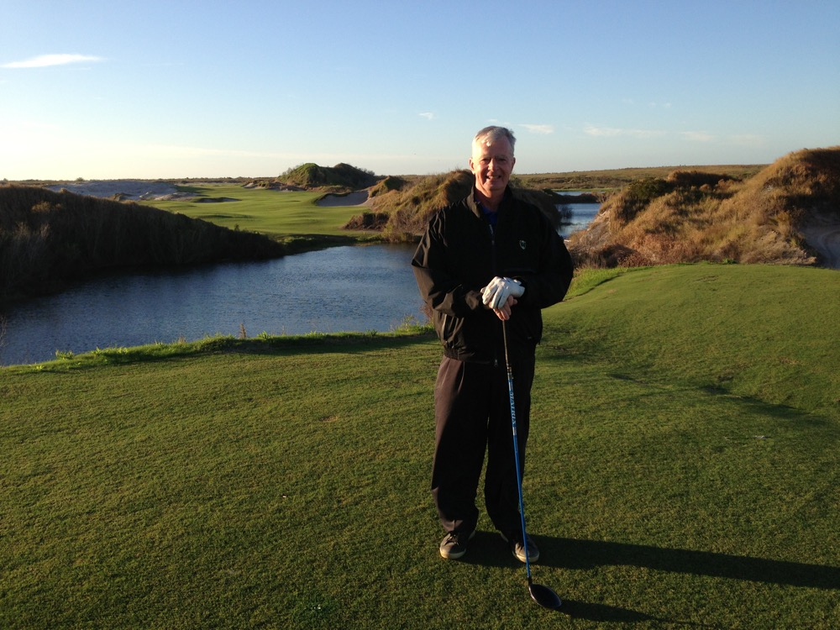
Streamsong (Red) 1st tee in December. First day of official opening.

