2014 Odyssey

Saluti a tutti i miei amici di golf,

2014 was another interesting and enjoyable year. The highlights:

Trips:
• Miami, Florida – early-February – Trump National Doral – Blue Course (Gil Hanse remodel)
• Southern Indiana & Columbus – mid-May – Pete Dye French Lick (my 99th course played on 2013 GOLF DIGEST USA Top 100) and Scioto
• Scotland – late-May to early-June – Royal Aberdeen, Royal Dornoch (4 rounds featuring 7th hole-in- one), Brora, Golspie, Tain, Fraserburgh
• Switzerland, northern Italy, England – late-August to mid-September – 21 days with seven courses in Switzerland, nine courses in northern Italy, and Royal St. George’s in England
• Morgantown, West Virginia – early-October – Pikewood National – Again became current on GOLF DIGEST USA Top 100
• Going South – mid-October – yearly fall trip from Massachusetts summer home to Florida winter home:
Trump Golf Links Ferry Point (Jack Nicklaus design), Bronx, NY
Philadelphia Cricket Club (Wissahickon) (Keith Foster restoration), Flourtown, Pennsylvania
Old Town Club (Coore + Crenshaw restoration), Winston-Salem, North Carolina
Tobacco Road Golf Club (Mike Strantz design), Sanford, North Carolina
Mid-Pines Golf Club (Kyle Franz restoration), Southern Pines, North Carolina
Other Items:
• Meeting Rory McIlroy (briefly) – mid-March
• Mickelson Family – late-June
• Baltusrol Seniors – late-September
• Website/Blog “The Odyssey” “thegolfodyssey.com” actually in operation. More content to be added.
• Writing of book A Golf Odyssey with The Real McCoy going slowly.
Future Plans:
• 2015
Mexico - May
El Cardonal (Tiger Woods design), Diamante, Cabo San Lucas, Baja California Sur
Dunes (Davis Love III design), Diamante, Cabo San Lucas, Baja California Sur
Quivira (Jack Nicklaus design), Cabo San Lucas, Baja California Sur
South Korea – May
Nine Bridges (David Dale design), Jeju Island
Anyang CC (Robert Trent Jones, Jr. redesign), Gyeonggi-do
Canada - Cabot Cliffs (Coore + Crenshaw design), Inverness, Cape Britton Island, Nova Scotia
South Africa – November/December
• 2016
Australia/New Zealand – November/December
Ocean Dunes (Graeme Grant design), King Island, Tasmania, Australia
Cape Wickham (Mike DeVries design), King Island, Tasmania, Australia
Tara-iti (Tom Doak design), Te Arai Beach, North Island, New Zealand
- Trump National Doral (Blue Monster Course) -

Kicking off the year in early February, I drove from Naples to the crowded commercial and apartment-laden western suburbs of Miami (16 miles west of downtown) and met GOLF DIGEST panelist Mitch Hantman, with whom I’ve rated many courses since the mid-1990s. Today it’s the newly-remodeled Trump National Doral Blue Monster Course. I first played the course in November 1971 when it was rated in the top 30 in the country. It continued in the USA Top 100 through the 1989 list and then permanently fell off.

Having played the Blue Monster several times since 1971 (last time 2010), I was anxious to see the Gil Hanse redo. Donald Trump bought the resort in early 2012 and for $150 million obtained an 800-acre resort complex including four golf courses, 700 hotel rooms across ten lodges, more than 86,000 square feet of meeting space (including a 25,000-square-foot ballroom), a 50,000-square-foot spa with 33 treatment rooms, six food and beverage outlets, extensive retail space, and a private members' clubhouse. He has subsequently pumped $300 million into renovating everything, including $30 million on the Blue Course, a Dick Wilson original design that had become dated and uninspiring over the years. Previous owners had hired Raymond Floyd in 1996 and then Jim McLean in 2000 to do major renovations, but neither remodel did the trick. Say what you want about the boastful Trump, he puts his money where his mouth is. Today will be my sixth Trump course played, and even though none are as good as he says they are, in my opinion they are all worth playing more than once.

The terrain at Doral is pancake flat and overhead is the approach to the busy Miami International Airport. Planes fly so close to the ground that you can count the rivets on the undercarriage of a 747. Needless to say, the jet engine noise can be distracting. We hit a few practice balls on the much-expanded range (in both width and depth and from six to fourteen acres), which has LED floodlights for night use.

On the first tee it is 70 degrees with wind at only 5-10 mph. Later in the round it would be a humid 80 degrees with wind at a more normal 15-20 mph. A forecaddie is mandatory, and we have energetic George driving the cart with our clubs on the back. Carts were not allowed on the fairways in 2014, and the cart paths are way off the fairways. George kidded that he is so far away on the cart path that we need to text him or use hand signals from the middle of the fairway to tell him what club to bring.

We basically have the course to ourselves as the green fee is around $400 and the resort is almost empty due to construction on almost every square inch of the hotel part of the property. The 600 members can play today on one of the other courses. Close by the putting green and first tee are at least 100 construction workers along with cement trucks. The resort is working frantically to finish all projects before the World Golf Championship (WCC) to be played here in early March.

It is amazing to know that the physical work on the golf course started last March, immediately after the 2013 WCC, and the course was opened for play in mid-December. Today the fairway lies are perfect and the smooth TifEagle grass on the greens is stimping between 9 and 10. After eliminating hundreds of ficus and pepper trees, more than 1,000 expensive new royal palms were planted. The eliminated trees have opened up views across the course and to the hotel.

Original lakes have been expanded and new ones built. This project created about 500,000 cubic yards of fill, but most of it was used to cap the lakes and build spectator mounds. Very little was used in recontouring fairways, which remain basically flat. If any major recontouring had been done to the fairways it would have forced the course to close for 12 months to let the new grass grow in. That would have meant the loss of too much green fee income and the shifting of the 2014 WCC to another course.

Every green except 18 is new. Each of the others is larger and more contoured than before. The number of bunkers has been reduced from 101 to 95, but they have been moved much closer to the greens, are deeper, and have higher lips. The water (increased from six to fourteen holes) is also now much closer to the greens. Steep banks off the sides of the greens bring the hazards much more into play. Many of the greens are pinched in front by nests of bunkers, so the challenge is flying approach shots with strong winds present.

My assessment is that Gil Hanse did a brilliant job, given the flatness of the land and the time constraint. The new Blue is one of the top three recently remodeled courses in the country that I have played. The first is Coore & Crenshaw’s Pinehurst #2 followed by Gil’s Los Angeles Country Club North Course.
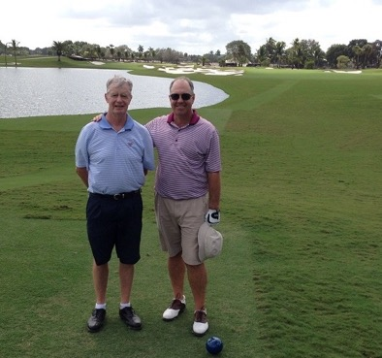
16th Hole Drivable Par 4 (290-yard carry over
water above my head) with Mitch Hantman

- Southern Indiana and Columbus -

The Pete Dye Course at French Lick Resort

In mid-May I took a slight detour on my semi-annual commute between homes in Florida and Massachusetts to play The Pete Dye Course at French Lick Resort in Indiana. This small town where Larry Bird was raised (population 1,807) is in south-central Indiana, 75 miles west and then north of Louisville, Kentucky and 100 miles south of Indianapolis. I was supposed to play on Wednesday, May 14, but on the drive in on Tuesday morning the weather forecast for Wednesday was awful. After reaching Louisville I called host Sean O’Daniel, Golf Group Sales Manager for the resort, and he said it would be OK to play that afternoon.

The Pete Dye Course opened in 2009 and entered the 2013 GOLF DIGEST USA Top 100 at #93. You may remember that of the six new additions to the 2013 list this course was one of two I had to play to stay current in playing all 100 beginning with the 1983 list.

At 3:30pm I’m on the first tee in a cart with Whitey, the caddie. It is 80 humid degrees with overcast skies and wind at 15-20 mph. We have the course to ourselves. It’s in outstanding condition despite recent heavy rains – excellent fairway lies along with smooth greens running between 9 and 10. The tees, fairways, and greens are bentgrass, which is unusual this far south (St. Louis is due west). The $350 green fee keeps total yearly rounds in the 4,000 area, which certainly helps keep conditioning at a high level.

The course is built on a mountaintop 900 feet above sea level. Pete spent between $30 and $40 million cutting down most of the trees above 750 feet and moving 2 million cubic yards of dirt. None of the remaining trees comes into play. Due to the lack of trees on the course, many holes can be seen at the same time, so there is certainly a feeling of expansiveness. There are “infinity” holes where the only thing you see behind a green may be five miles away. Panoramic views of the countryside stretch for 25 miles in many locations to 50 miles standing on the 10th tee. The course is totally bordered by forests of tall trees, which produce beautiful fall foliage (mid-October).

Men’s tees range in length from 6,115 to a ridiculous 8,102 yards. The Big Ten men’s championship was recently held here and even the young guns played from the next tees at 7,254 yards.

The severely-sloping terrain produces downhill and uphill shots, some from hanging lies if you miss a fairway. There are also steep falloffs around many greens, some of which are perched. Most are moderate in size except #13 at 51 yards deep and #18 at 54 yards deep. The greens have a lot of movement but nothing extreme, nothing over the top.

Water comes into play on only three holes (1, 15, and 16). Bunkers are the main theme here: 156 of them, with eight being anywhere between 100 and 210 yards long. I had seen pictures of Pete’s artificial-looking volcano- style bunkers and thought I would not like the course. One of the criticisms I have of Pete is that he takes a theme and beats it to death. During the round I was pleasantly surprised that the volcano feature neither overwhelmed the look nor distracted from playing characteristics. Pete showed uncharacteristic restraint with only holes 1, 2, and 7 being truly volcano-looking.
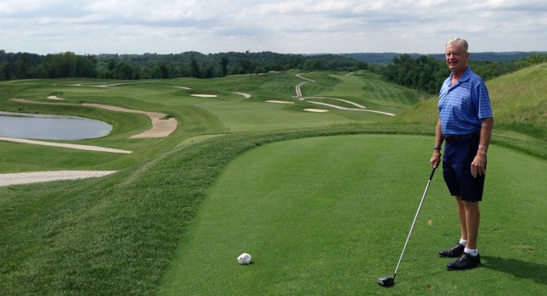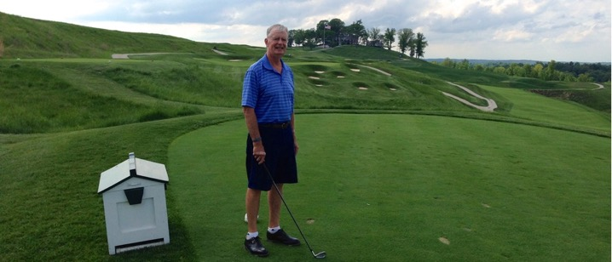
1st Tee 9th Tee

Finally, the round was as peaceful and quiet as any in the world. The course is totally isolated so it is just you, the holes, and the views.

The round finished at 6:30pm just as the skies opened up with lightning, thunder, and heavy rain, conditions that continued for the next 24 hours. Playing a day early was a fortuitous decision.

After golf I went to the West Baden Springs Hotel, which is part of the resort. Crooked Stick ( in Indianapolis) friend Tom Reilly had recommended this old hotel, which is one of a kind with one of the largest freestanding domes in the world.
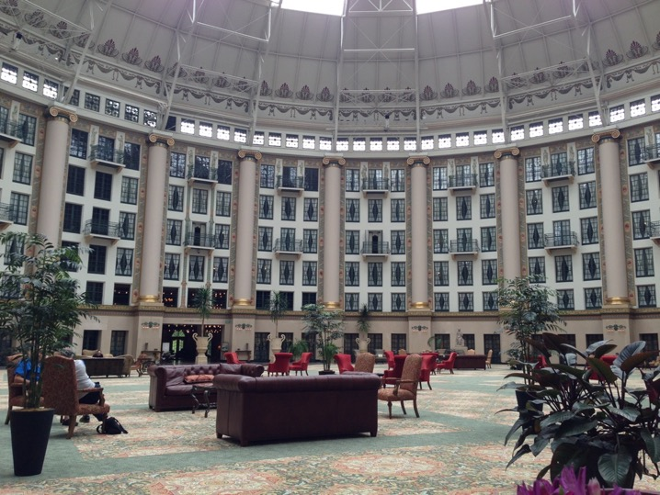
West Baden Springs Hotel Domed Atrium

One of the reasons why I have a desire to play so many good courses around the world is to see new parts of the world and learn about the stories surrounding the creation of those golf courses. The Pete Dye Course was the final piece of a $600 million investment to build a resort casino and revitalize the French Lick/West Baden economy. In the 1920s this area was Las Vegas before Las Vegas. Al Capone and friends would come down here to some of the thirteen illegal casinos.

Self-made, multi-billionaire Bill Cook of nearby Bloomington, Indiana provided all the funding. He founded the medical equipment manufacturer Cook Group in 1963. The key invention was guidewires for catheter angiography (procedure that uses a special dye and x-rays to see how blood flows through the arteries in the heart). I had never heard of Bill Cook and his company. His is the type of U.S. success story I love to hear. I should also mention that I met this Cook Industries product up close and personal twice within the past year. I’m the proud owner of two stents successfully inserted through a catheter by Lahey Health Systems (Burlington, MA) September 2013 and July 2014.

The French Lick tour ended with an early Thursday morning round at the resort’s Donald Ross Course, which was built in 1917 and hosted the 1924 PGA Championship won by Walter Hagen. At 7:40 I’m on the first tee by myself with clubs on a cart. The temperature is a raw 40 degrees (I can barely feel my finger tips), wind a strong 10-15 mph, and mist (I could have been in Scotland). The course is almost under water from the recent heavy rains so it’s cart paths only.

The busy 7,030-yard public access Donald Ross Course is rated #6 in Indiana. The terrain is hilly with a lot of uphill approach shots to steeply sloping elevated greens. Under normal conditions you would want to avoid downhill putts at all costs. There are 77 bunkers, and water is not a factor. With a par of 70, sloping lies and steep greens produce a challenge to score well here.

Scioto

From French Lick it was a leisurely drive east to Worthington (a suburb of Columbus), Ohio and the home of Marty and John Jacob. John and I have successfully teamed together in various American and Southern Senior events. He is a long-time member of Scioto (#52 in USA) and insisted on me stopping here on my way home from Indiana.

Before golf, John took me on a tour of the expansive Ohio State University (OSU) campus. John has been on the school’s Board of Trustees with a continuing benefit of a preferred parking space next to the 105,000-seat stadium for all home football games. Another feature of the campus tour was the Jack Nicklaus museum. This is May and who would have dreamed that by January OSU would win the national football championship (and no less with a third string quarterback).
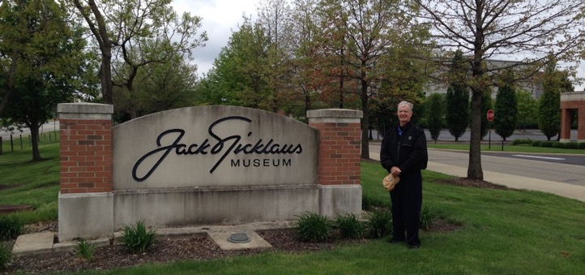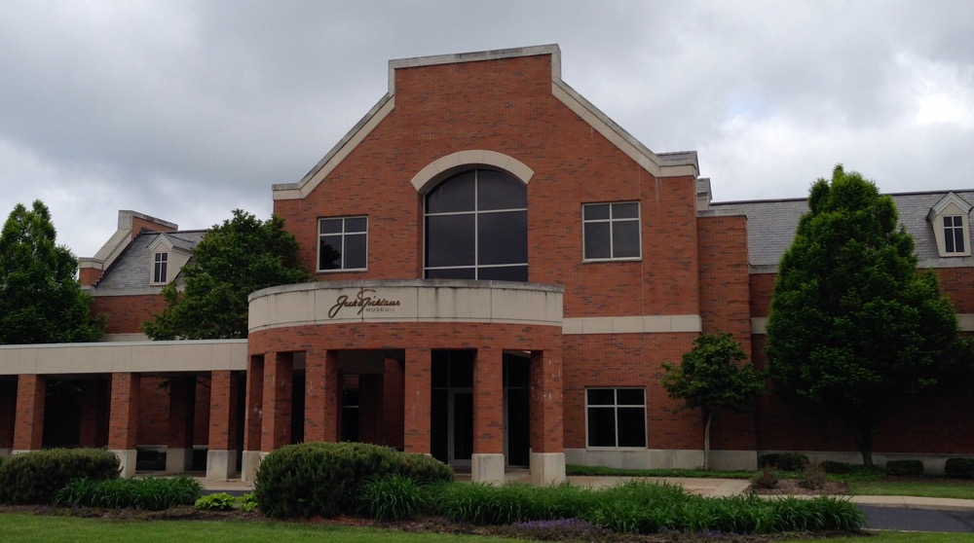
Jack Nicklaus Museum (football stadium in background)

At 11am I’m on the first tee at Scioto Country Club with John, Joe Ray III, and Jack Saeger. Joe is a long-time family friend and was helpful in organizing some Ohio courses for the 1997 Top 100 trip. Jack’s claim to fame is being Jack Nicklaus’s school classmate and more specifically starting in the same Jack Grout Scioto junior program with Nicklaus. Asked why his game did not have the same path as Nicklaus’, his response is “nothing that hitting 20,000 practice balls would not have solved” as a kid.
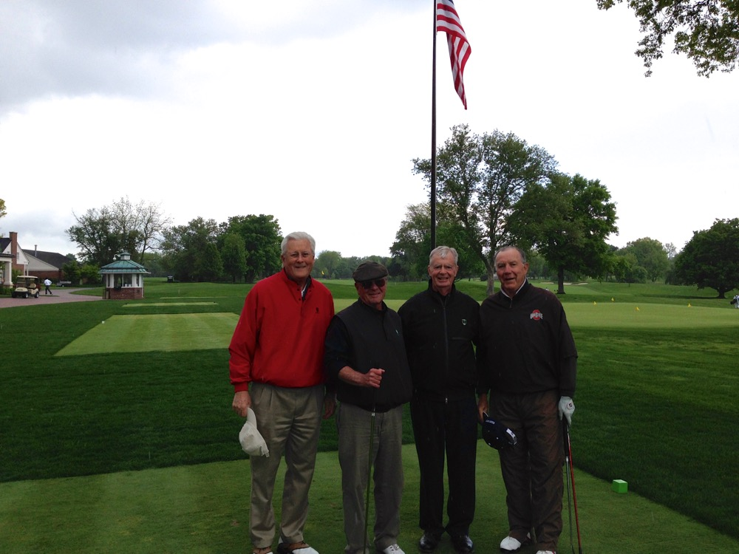
L/R Joe Ray, Jack Saeger, author, John Jacob

The weather is in the 50-degree area with light rain. During the round the skies opened up and the lightning alarm went off so we headed to the clubhouse. Fortunately it was only an hour delay and we were able to finish the round. During the clubhouse wait there was the feeling of how busy the club is on a daily basis.

Scioto is in Upper Arlington and is five miles northwest of downtown Columbus. The course was designed by Donald Ross and opened in 1916. Dick Wilson did a renovation in the early 1960s and then in 2008 Jack Nicklaus and Dr. Michael Hurdzan completed another renovation.

The course is on nicely-rolling terrain so there is much variety in up- and down-sloping shots to mostly well-guarded medium-sized raised greens with some slope and some falloffs. The holes are tree lined and water is a factor on a few holes. The suburban course is surrounded by nice homes across the streets that surround the property.

Scioto is one of four world-class courses in Columbus, the others being Muirfield Village (Jack Nicklaus design), The Golf Club (Pete Dye design), and Double Eagle (Tom Weiskopf design). You can debate all day about which is #1 in the area. I do know that you would make Jack Nicklaus really mad if you told him Muirfield Village is considered one of the best courses in the world, but in Columbus only tied for second with The Golf Club. My Columbus preference is Scioto by a hair.

- Scotland -

At the beginning of the year Boston-area friend Doug Mitchell suggested a late-May/early-June trip to his Scottish Highlands course, Royal Dornoch. Another friend, Jim Bunker, made it a traveling threesome. Doug spends three weeks at Dornoch each spring, so he was already in-country when Jim and I arrived at the Aberdeen airport.

The nearest major city to the remote seaside resort town of Dornoch (population about 1,000) in northeast Scotland is Inverness. Unfortunately, commercial service from Heathrow to Inverness has been reduced to a trickle over the past few years, so Aberdeen is the closest alternative. Doug did all the driving on this ten-day trip. The road map between Aberdeen and Dornoch looks straightforward at only 145 miles, but a good part of the trip goes through several small towns making for a somewhat exhausting three-hour drive. Doug did the Aberdeen/Dornoch round trip three times during his three week stay in Scotland.

Royal Aberdeen

Before traveling to Dornoch we played Royal Aberdeen Golf Club (Balgownie Links), where the Scottish Open would be played in early July. I had played the course once before, in August 1992. Today we learned that golf tourism has increased here because of the opening of Trump International Golf Links just 10 miles away. Within 155 miles going north from Royal Aberdeen courses worth playing are: Murcar (3 miles), Trump (7 miles), Cruden Bay (14 miles), Fraserburgh (25 miles), then west to Moray in Lossiemouth (67 miles), Nairn (27 miles), and Castle Stuart (12 miles).

It’s Monday, but the course is crowded due to a bank holiday, so we are lucky to be able to play starting at 11am. The weather is cloudy, foggy, and 55 degrees, with a light 5-10 mph breeze. During the first part of the round, the fog thickened and I learned from Doug that this condition in Scotland is called “haar.” I have been going to Scotland since 1979 and cannot believe this is the first time I have heard the term “haar.” Wikipedia notes:

“In meteorology, haar is a coastal fog. Haar is typically formed over the sea and is brought to land by wind advection. This commonly occurs when warmer moist air moves over the relatively cooler North Sea causing the moisture in the air to condense, forming haar. Sea breezes and easterly winds then bring the haar into the east coast of Scotland and North-East England where it can continue for several miles inland. This can be common in summer when heating of the land creates a sea breeze, bringing haar in from the sea and as a result can significantly reduce temperatures compared to those just a few miles inland.”

Another local knowledge item I learned from Doug was the references to all the heavy change you accumulate in your pockets in the UK. It is called shrapnel, grummets, or bits.

On the ninth hole the sun broke through, and we were suddenly down to golf shirts in 70 degrees. The rest of the round was in glorious sunshine and refreshing clean air.

The first tee is just in front of clubhouse windows so your driver action is prominent for all to see from the bar and restaurant area. The hole runs downhill with the North Sea as a backdrop behind the green. The next eight holes swing north up the coastline with the fairways and greens at the base of massive dunes that shield the course from the adjacent North Sea. You do not, therefore, see much of the water except from back tees on a few of the holes, where you can also hear the waves crashing on to the sandy beach (no swimmers visible). The course reverses direction at number ten. Now away from the tall dunes and on higher ground, the views of the North Sea and up and down the coastline are noteworthy.

The course has a few blind shots, humpy fairways that produce uneven stances, an ample number of fairway and greenside bunkers (exactly 100 in total), and large and deep greens with some slope. Royal Aberdeen had a lot of rain in the spring, so the fairways were lush with not much roll. In total, a pleasant and challenging true links experience and a satisfying start to the trip.

In the “small world” category, at lunch Art Dunkley, owner of Kingsbarns, stopped by to say hello. Fourteen years ago Elaine and I had been with Art and his then Kingsbarns partner, Mark Parsinen, in Mark’s apartment overlooking the 18th green of the Old Course at St. Andrews. I remember a delightful two hours discussing golf course architecture and the development of Kingsbarns with these two knowledgeable men.

Royal Dornoch

The next four days were spent playing Royal Dornoch Golf Club. I first was here in September 1986 when playing 54 holes in one day pulling a trolley. I came back in July 1992 and again in June 1997 during the 100-day trip.

Doug Mitchell, Jim Bunker, and Doug’s English Dornoch member friend Roger Bradbury played the Championship Course with me all four days. This course is currently rated 14th in the world by GOLF Magazine. I also ventured out on the club’s Struie Course (8 holes one day with Doug and 10 holes the next with Jim). The Struie is basically flat and meant for a mixture of higher handicap players in either the younger or older categories and also for family play. An eight-hole loop is possible with the 4th green running into the 15th tee and then playing on through to the 18th green and the nearby car park and clubhouse.
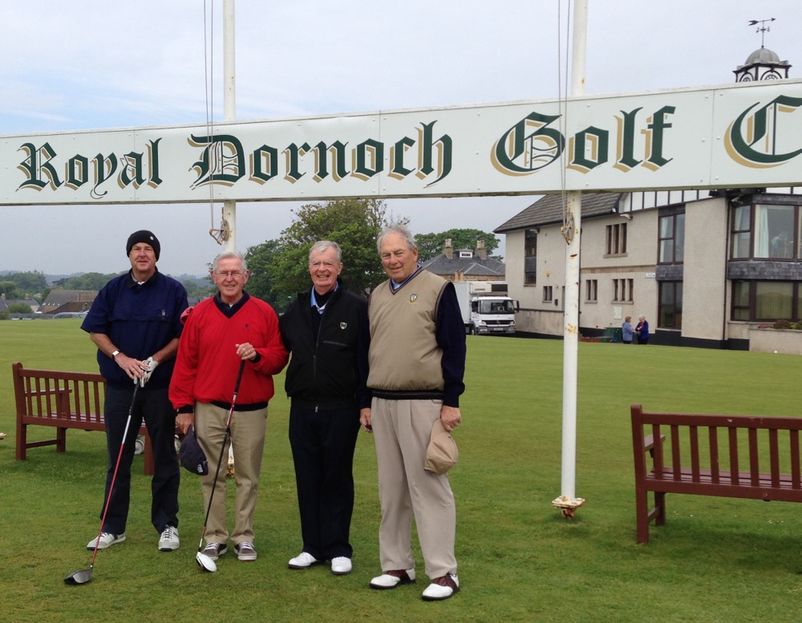
L/R Roger Bradbury, Jim Bunker, author, Doug Mitchell

Playing the Struie caused me to think about the current routing of the Championship course. I’m always intrigued about how the great courses developed into greatness. The original Dornoch course was designed by Old Tom Morris in 1886 and then modified by John Sutherland over his 50-year involvement with the club including Club Secretary.

After WWII John Duncan turned Dornoch into a masterpiece. Holes 13-18 near the clubhouse became part of a “relief” nine hole course (now part of the 18-hole Struie course). At the far end of the property Duncan built new holes seven through eleven as well as thirteen. He also built a new 6th green. Throwing out the old, and adding the new, transformed the main course at Dornoch into world-class status. The new holes greatly enhanced the viewing experience and provided a much better variety of golf challenges.

Weather-wise we were really lucky. Our six days in the Dornoch area were rain-free. The day we were playing Royal Aberdeen it rained so hard at Dornoch the course was closed. Then after we left the area there was another day of torrential rain and course closure. We learned that the 2014 spring was the wettest ever in the UK. Our weather varied from 50 degrees, cloudy, wind 15-20 mph (gusts up to 30 mph) from the east (not normal) to 70 degrees and sun.

Before the first round at Dornoch I had a nice chat with club General Manager Neil Hampton. A very engaging young man as well as a scratch golfer, Neil runs an active club that serves superb lunches and dinners with friendly service. Did I forget to mention the thirst quenching smooth Belhaven Best draft beer?

The course commences on high ground with a fairly benign par 4 followed by the difficult par 3 2nd hole. Then there is a sheltered walk through ten-foot tall gorse bushes followed by an explosive view of the majority of the holes and Dornoch Firth running out to the North Sea. You can see and hear the waves crashing. Breathing the Highlands fresh air, the exhilaration is delightful. As you walk up the steep path to the 7th tee, there is another great view looking back over many holes (see below).

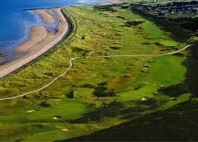
Far End Plateau Looking Back Toward Clubhouse

The 9th tee is next to Dornoch Firth and starts a stretch of eight consecutive holes running along the Firth. Dornoch might have more continuous holes adjacent to a body of water than any links course in the UK. Dunes do shield some of the water views, however. Then at the finish the back of the 18th tee offers up a final view of almost every hole. In terms of beautiful links courses, Royal Dornoch and Royal County Down are at the top of the list.

The only blemish is a bunch of large new houses on the left-hand ridge built over the past ten years and overlooking holes three through six. They just seem out of place in this remote part of the world. The other small annoyance is the occasional Royal Air Force fighter jets roaring down the Firth and interrupting the otherwise tranquil setting.

The playing highlight at Royal Dornoch was my seventh hole-in-one on the 13th hole. The tee is slightly elevated and the shot is all carry over five fronting bunkers (only four visible in the picture below). My yardage was 135 but the strong right to left wind allowed me to hit 9-iron.
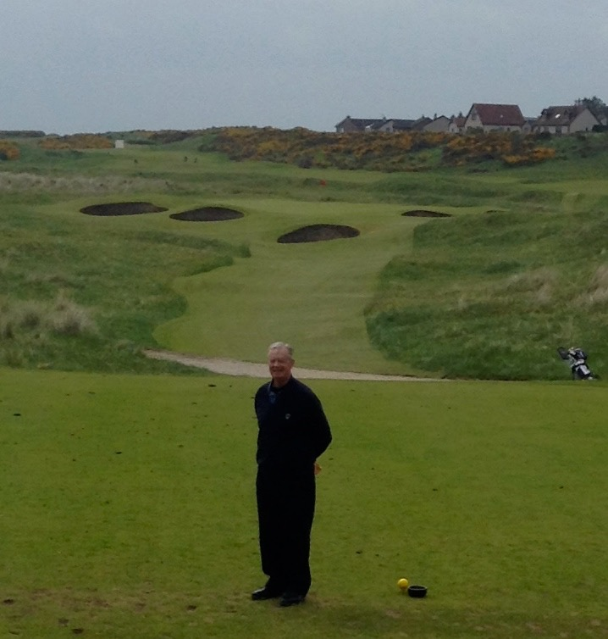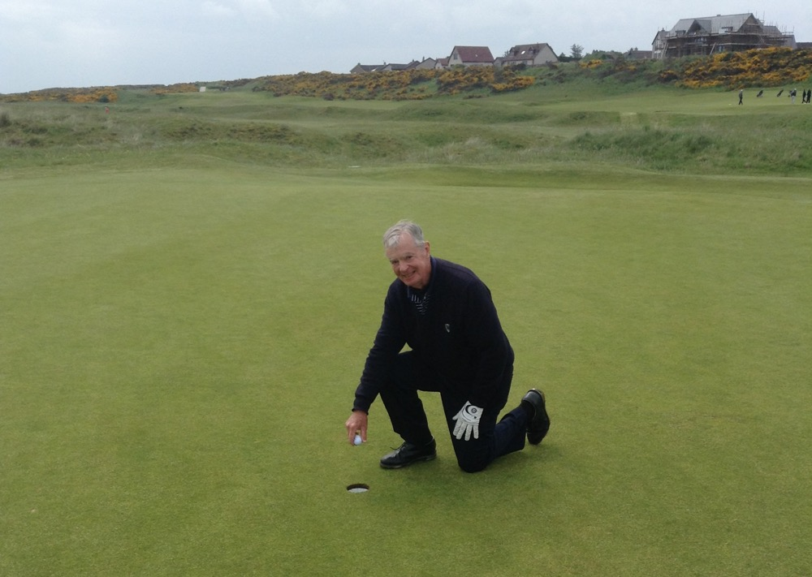
13th Hole 7th Hole-In-One

Brora, Golspie, Tain

One of my goals for this trip was to play some of the 3rd-tier courses in the area. Everyone knows the top-tier courses in the UK and Ireland, those venues where The Open Championship is held or Top 100-rated courses such as Royal Dornoch and Castle Stuart. The second tier of courses in northern Scotland includes the likes of Nairn and Royal Aberdeen. What I have learned over the years in the UK and Ireland is that there is another category of courses that are worth playing if you have a little extra time. These “3rd-tier” courses usually have a mixture of several good holes along with a few prosaic or even dull ones. The good definitely overshadow the less good in your total golf experience. The added advantages on weekdays are much lower green fees, significant flexibility in starting times, and less-crowded courses that produce a reasonable pace of play.

Within easy driving distance from Dornoch are Brora (17 miles north), Golspie (11 miles north), and Tain (10 miles south). We thought about Fortrose & Rosemarkie (45 miles south), but by the time we got there from Tain mid-Sunday afternoon we were too tired to play and the course was busy.

Saturday Doug, Jim, and I are on the first tee at Bora Golf Club at 9:10am with cloudy skies, 55 degrees, and 10 mph wind, which picked up as the sun came out during the round. The course runs north/south with the North Sea on your right (east) near many of the front nine holes. There are no high dunes between the holes and the sea as exist at Dornoch and Aberdeen, so the coastline water views are excellent along with some nice mountain backdrops.

We basically had the course to ourselves as the Saturday activity was coming out later in the morning. The routing starts on high ground, works downhill to the far end at the 9th green. Then the course turns back 180 degrees on fairly level ground.

The final holes sweep uphill and culminate at a severely-ascending 200-yard par 3 that features a huge dip in front of the green followed by a severe false front. The uphill adds the need for one extra club and today’s 20 mph headwind required another two clubs. The common occurrence on this hole is a tee shot hitting the green with the ball rolling back down the false front and then further down into the bottom of the big dip. All too often, a following delicate pitch doesn’t quite make it over the false front and the ball returns to its original position at your feet. After golf we had lunch in the clubhouse, whose large picture window overlooks said 18th green. As each group played the hole at least two players experienced the ball-rolling-back-to-their-feet trick.

Walking down the first hole we were greeted by about fifteen grazing cows smack in the middle of the fairway. Then, starting on the seventh hole onward, we had small flocks of sheep at our heels. It turned out that all the greens were surrounded by thin protective wire to keep the animals off the greens.

While playing I had the feeling of old world golf as if I were stepping back in time. Bora is 6,200-yard par 70 designed in 1923 by James Braid (five-time Open Champion).

That afternoon we drove seven miles back toward Dornoch to Golspie Golf Club where we met member David Tepper, who has been running Tepper Capital Management in San Francisco for many years, has an apartment in Dornoch, and is a member of Royal Dornoch. David had gotten hold of one of the early Xeroxed copies of my Odyssey and wrote me a letter about it. So it was nice to finally meet him – and in Dornoch no less.

At 2:45pm it is a sunny 65 degrees with wind at 10-15 mph on a busy, fairly flat course with a few tall dunes appearing late in the round. Holes three through five touch the North Sea on your left with nice water views similar to Brora.

The backs of the sixth and seventh tees are near the water, at which point the course shifts from links to parkland, winding through a forest of pine trees, gorse, and heather (blooms in August). The finish is back on links terrain with the 16th and 17th greens on top of challenging dunes.

The par 4 last hole at 443 yards is straight and flat, but there is a huge dune (about 25 feet high) right in the middle of the fairway starting at 280 yards from the tee. To clear the entire dune requires a 300-yard carry (good luck with that one). Even a 250-yard drive leaves the player with a blind 193-yard shot involving an exceptionally high trajectory. This was certainly too tough a combination for me to hit the green in two, but David assured me that it is no problem for the low-handicap players. I remain skeptical about that.

Golspie was almost bankrupt 20 years ago and was close to being taken over by Royal Dornoch, but the Golspie members rallied and the club remains independent. The heavy clubhouse activity we experienced after the round is a healthy sign for the club.

Sunday morning Doug drove us 10 miles south to the Tain Golf Club. Our Dornoch partner, Roger Bradbury, who is also a Tain member, joined us. It is a cloudy 60 degrees with a light breeze and the course is not busy at all.

The terrain at Tain is basically flat. The soil is sandy, but the course feels and plays like parkland. Most of the holes are surrounded by miles of flat farms, cows, and hundreds of sheep on three sides with some self-contained holes bordered by forests of trees. Dornoch Firth is on the fourth side, but most of the holes are away from it so one is limited to mostly a few distant water views. The best viewing spot is the 12th tee, where you see the nearby Glenmorangie single malt Scotch whiskey distillery looking left and then the spire of the Dornoch Cathedral looking right.

There is quite a bit of gorse along with thick rough. The setting is peaceful except for the fighter jets briefly roaring down the Firth on Mondays through Friday.

Fraserburgh

Monday was our last full day for golf. We left Dornoch and went south and then east for 140 miles to the town of Fraserburgh (population 12,600), which is 42 miles north of Aberdeen and the biggest shellfish port in Europe. It is also a major white fish port with a busy commercial harbor.

Our threesome is off at 12:30pm at Fraserburgh Golf Club (Corbie Hill course) with clouds overhead, 55-60 degrees, and a strong 20-25 mph wind with gusts up to 40 mph. Redesigned by James Braid in 1922, the present course sits next to Fraserburgh Bay, which flows into Moray Firth and the North Sea. Beautiful high coastline dunes covered by tall and attractive marran grass hide the possibility of water views except from the highest points on the course, the 2nd green and 3rd tee. These are the same raw dunes Donald Trump first saw at Balmedie 31 miles south and which became part of the successful Trump International Golf Links.
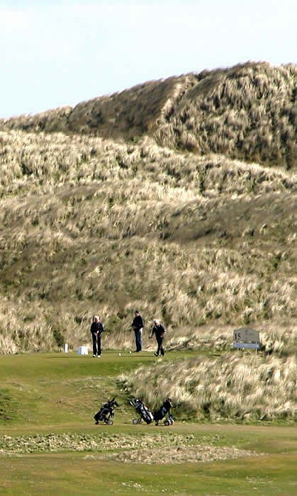
Dunes Behind 15th Tee

The first and 18th holes are side-by-side on dead flat terrain so the first thought is why are we here? Looking past the first green is Corbie Hill. From a distance it looks like a mini-mountain. At the finish of pulling a trolley up the ski slope fairway to the very perched green, and then a steep uphill trudge to the 3rd tee, you are definitely out-of-breath and think you have climbed Mount Everest! On a calm day the walk would be formidable, but today’s very strong 30 mph headwind puts the old legs to a real test.

But the effort is rewarded, as you now see most of the holes spread out on rolling land with the magnificent dunes to the left. The best part of the course comes toward the end of the round on holes 13 through 17. Thirteen has the tall dunes as a dramatic backdrop and then fourteen through seventeen run close to and through the dunes.

I was intrigued by the actual height of Corbie “Hill” because I thought it was the unique feature on the course. I also want to give the readers of “The O” a feeling of what it is like to actually be at a course. “Hill” means to me modest height and what is at Fraserburgh is more than modest. In researching the issue I could not find any height number anywhere. I even e-mailed the club and they do not know. My estimate is 80 to 90 feet high.

Trip Wrap-up

Wonderful ten days with two great guys along with new friends along the way. Jim and I thank Doug for his yeoman effort in arranging the entire itinerary and then driving us all over hither and yon. All the courses were worth playing and left indelible memories.

- Switzerland, Northern Italy, England -

In late August, Elaine and I lifted off on a 21- day trip to Switzerland (seven courses), northern Italy (eight courses), and England (Royal St. George’s). Please see our itinerary at end of this document.

Itineraries

When you see an Odyssey final itinerary it is all tied together in a neat package and appears as if I have done all the work myself. The reality is that many days and months have gone into the planning with help from one or more people in the key countries. I have several ways to determine a few of the leading courses to play in each country, but filling out a complete list and determining the route of travel and then gaining access to the courses takes local knowledge. I have been lucky enough to be able to call on old friends and also to develop new contacts to greatly facilitate these trips.

For Switzerland I first asked fellow GOLF Magazine panelist Philippe Hermann for a brief rundown of the leading courses in his country. Then I used the Internet to locate Francesco Andina, whom I had known many years ago in the New York City area. I found his money management firm in Zurich, sent an e-mail, and within five minutes Francesco was calling from Switzerland. He has been helpful with identifying and contacting the Swiss courses and then establishing the ideal driving route. Fortunately, he also accompanied us on most of the trip so getting lost was eliminated from the equation. The real luxury was his ability to speak five languages, which covered our Swiss (German and French) and Italian needs. We also stayed in his lovely apartment in Ascona.

For Italy, I did have an idea of some of the top courses and was thinking they were probably spread out all over the country. Thanks to Google Maps I was amazed to learn that they were bunched together in northwestern Italy between Turin and Milan, so they dovetailed nicely with the Swiss courses, making Zurich a convenient entry and exit point for the trip.

Now the hard part for Italy: How was I going to communicate with Italian courses where language might be an obstacle? While pondering this dilemma I happened to be reading GOLF COURSE ARCHITECTURE, a UK- based magazine edited by Adam Lawrence and important reading for news on golf course developments throughout the world. In the November, 2013 issue there was one paragraph about a Dana Fry- designed course at Royal Park in Rotta Cerbiatta, Italy.

Royal Park was already on my target list, and I’ve known Dana since he designed the highly-regarded Calusa Pine course in Naples, Florida in 2001. The last time I saw Dana was in the Shenzhen China airport at 8pm on a Friday night in November 2012. I was traveling from Mission Hills Shenzhen to Mission Hills Haikou on Hainan Island, and Dana was off to his Batu Bay Golf Club project in Inner Mongolia, a must-play when finished, he told me. (Recently, I had lunch with Dana and he said everything is set for construction to start at Batu Bay, but China’s central government has clamped down on all new golf course construction except on Hainan Island. In fact, the government has forced some already-built courses to be plowed up and irrigation systems removed.)

I sent an e-mail to Dana to ask for a contact at Royal Park. He immediately replied with Mr. Romy Gai, “MR. everything at the club.” Romy sent me a welcoming email and then asked his Sports Secretary, Andrea Faldella, to help with the other Italian courses. Andrea performed above and beyond the call of duty as many e-mails flew back and forth for the next several weeks.

For the 2013 trip to Austria, I received invaluable trip-planning help from Dieter Usner (fellow R&A member, located in Salzburg, and European Golf Association Honorary President) and Stephan Guertler (Managing Editor, EXTRAGOLF in Vienna). I had met Dieter by accident in the R&A clubhouse in September, 2012 and we talked about golf in Austria. Then in January 2013 I met Stephan at Tom Doak’s Renaissance Cup at Streamsong in Florida. I’m always amazed at how tightly knit this world golf community can be, especially when some help is needed.

Driving, Directions, Speeding Tickets

Driving on the Continent is easier than in the UK because you are on the right hand side of the road. As for directions, the Hertz rental car we rented in Austria in 2013 had an easy-to-use factory-installed “Never Lost” GPS system, which I do not totally trust because some golf courses are in remote locations. I therefore also bring along hard copy Google Maps as a backup, a wise decision as the GPS twice led me to isolated farms several miles from the intended golf course. When I returned the car I asked for a definition of “Never Lost” because the system had twice failed. I was pleased to hear that a full refund for the GPS was due without any questions or arguments.

As for driving fast, do not be misled about how fast you can go based on the many cars that roar by you in the UK and the Continent. There are speed cameras all over the place and almost all are totally hidden. I am a fairly cautious driver, but have received three so-called speeding tickets over the years for minor violations. Only one (Switzerland) was on a main highway. The one in Austria was going from a highway (70 mph) to suddenly entering a village (30 mph) with the speed limit sign half-hidden by trees. However, what took the cake was the letter from the Walton-on-Thames (England) police saying I was “observed” going 45 mph in a 40 mph zone and that will cost you £75. You cannot avoid paying the fine because all the documentation comes through the rental car company and they put a surcharge on your credit card every time they handle paperwork from the police.

Switzerland

In Switzerland the order of playing the courses and availability of tee times because of many club events required great flexibility and a number of adjustments. It turns out that late-August is a busy time for golf in Switzerland. Fortunately, all the clubs were totally cooperative and fit me into some tight time slots.

When one thinks of Switzerland, images of long views down lovely lakes and of snow-capped towering Alps Mountains come to mind. Elaine and I did experience both on our eleven days in the country but mostly not from the golf courses. In order of first seen were Lake Lucerne, Lake Zurich, Lake Geneva, Lake Como, and Lake Maggiore. The best lake golf view was Lake Geneva from the clubhouse at Domaine Imperial. Of the 162 holes I played in Switzerland, none play on or near these famous lakes.

As for mountains, we did have the occasional spectacular views. The best leading course in Switzerland for mountain views is Golf Club Crans-sur-Sierre. Sadly, we missed this course because the European Tour’s Omega European Masters was being held during our time in country.

The most spectacular mountain view that we have ever seen was snow-capped Mont Blanc on the French Italian border but clearly visible from Switzerland. We saw Mont Blanc on three different occasions. The first was unexpected, while having an outside dinner in Morges looking out over Lake Geneva. In early evening sunshine with a crystal clear sky, we experienced sunset shadows highlighting the tallest (15,780 feet) mountain in the Alps and the second-highest peak in Europe. The next day it was visible again from Golf Club du Domaine Imperial in the morning and again in the afternoon as we drove right through the mountain on the way to Italy using the Mont Blanc Tunnel.
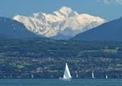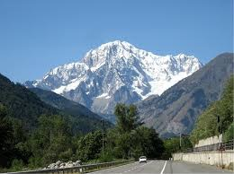
Mont Blanc From Restaurant Mont Blanc from Tunnel Road to Italy
in Morges Switzerland

Switzerland has 100 courses and about 50,000 golfers. What I found were busy courses with full tee sheets. All the courses played except one were private with outside guest play possible on weekdays.

After arriving at the Zurich airport on Wednesday and picking up our rental car, we headed 40 miles southwest to Lucerne. This beautiful lakeside city was most convenient to the four courses I was going to play in the Zurich area. We would be staying at a Four Star hotel away from, but overlooking, Lake Lucerne.

Not knowing anything about restaurants in Lucerne we opted for the one in our hotel. Now, we are not gourmet diners, but do desire a reasonably tasty meal. Opening the menu and looking at the prices was a “welcome to Switzerland” moment. We were not prepared for the sky-high restaurant prices throughout the country. They are at least double what you pay in the US.

Kicking off the golf schedule on Thursday, I was up way before sunrise and drove in total darkness 25 miles northeast through the Swiss countryside on narrow roads. I prayed the car’s GPS would do its thing because I could not read the printed Google directions in the dark while driving. Fortunately, the system worked and I arrived early at Golf & Country Club Schoenenberg, 15 miles south of Zurich. At 7:20am I’m off by myself pulling a trolley. It is 55 degrees, cloudy, with a light breeze. The course opened in 1969 and was designed by Donald Harradine, an Englishman who has designed several courses in Europe and has also remodeled some of the courses on this trip – Geneva, Lausanne, and Zumikon.

The course is mainly in a valley with some gradual up and down slopes. I immediately realized that the fairways were very soggy and later learned that the Zurich area had the wettest summer on record. The pleasant parkland course winds around the River Krebs. The theme is water hazards, with ponds and streams coming into play on thirteen holes. There are also areas called “Biotop” with “Do not enter” signs. In the USA these would be called “habitat” or environmentally-sensitive areas. At the end of the round I talked to Peter Aeschbach, the manager of the club, and thanked him for getting my trip off to a flying start.

After golf it was back in the car for a 20-mile drive north to Zurich and then out to Golf & Country Club Zurich in the small town of Zumikon, 5 miles southeast of Zurich. The club is often referred to as Zumikon, similar to the practice in the UK, where, for example, Royal St. George’s is called Sandwich. Zumikon is the most prestigious club in the Zurich area with 500 members, but only 200 play golf. The course opened in 1930 (designer unknown). In 1936 Englishman Tom Simpson made some improvements and in 1978/79 Donald Harradine redesigned the course. The club has been working with Thomas Himmel (located near Munich, Germany) for the past several years on a master plan with implementation expected shortly.

Club Secretary Robert Snoddon met me. After lunch I was introduced to playing partners Christian Hausamann and Karl Svensson. Travelling companion Francesco Andina is a long-time member here, but he had a previous tournament playing commitment, so he paired me up with two of his friends. At 2pm we were out on the course. It is 70 degrees, part sun, and 5-8 mph breeze.

The property has basically two segments of terrain. Nearer to the clubhouse the land severely slopes with holes 9-11 and 15-18 running back and forth along the slope. After a downhill opening hole, holes two through eight weave through a valley on slightly undulating terrain. Holes 12-14 come back to the valley portion. The course is mostly tree-lined, with some water (ponds and streams) and out-of-bounds, and 50 bunkers.

After golf we enjoyed a refreshment on the clubhouse patio, which overlooks part of the course and the Swiss countryside. Same relaxing spot where I had lunch and just a lovely way to wrap up a full day of golf.

Friday I was again up early and drove 12 miles north to Hildisrieden and the Woodside Course at Golf Sempachersee, which was designed by Kurt Rossknecht (Lindau, Germany) in the mid-1990s. He also designed the second course (Lakeside) here in the mid-2000s. The better of the two is Woodside, and the club is open to the public.

Tee times start here at 7am, but I’m off alone and pulling a trolley at 6:30am because the course is holding a tournament with a shotgun start at 11am. The course begins on a high plateau above Lake Sempacher, which is smallish by Swiss standards and totally visible four miles away, with a backdrop of the Santis Mountain (8,210 feet high) to the Bernese Alps mountain range.

It is 60 degrees, cloudy, no wind. A little rain would fall on the back nine and the sun broke through on the 18th green. I had the course to myself on the front nine, but a twosome appeared out of the blue and slowed down play on the back. The first holes work steeply downhill and you do not return to the clubhouse area until the steep walk up the 18th fairway. Overall, the terrain rolls along with a few ups and downs mixed in with some flat holes. There was a long and confusing walk through a forest from the 14th green to the 15th tee. I took a wrong turn and actually ended up at the back of the driving range. At this point I was wondering how the heck I got here!

The number-one design feature is eight large ponds coming into play on fourteen holes. Combined with some mean rough, controlled shots are required on this 7,260-yard course. The ambience is a mixture of holes in the peaceful forest and holes out in the open with road traffic noise, electric power lines, and houses nearby.

Saturday morning I was again up early and drove 1 mile east to Lucerne Golf Club, which is private and busy every Saturday with club tournaments. In arranging to play I got lucky by being introduced through friends Luke Reese and Angus Moir to member Didi Serena. Between Didi and helpful club manager, Bettina Fopp, a 6:30am tee time was arranged. Didi is a low-handicap golfer and a successful businessman. He is President/CEO of LK International, a fashion and sports company, which markets products under the KJUS brand (innovative, premium sportswear for ski and golf). He is still a real athlete. In his earlier years he was a semi-pro ice hockey player but nowadays is a skier and serious cyclist (how about riding Seattle to San Francisco in 8 days, 1,120 miles, 5,840 foot elevation climb, longest day 137 miles).

The club is walking only on an extremely hilly course. No carts are available for visitors, and there are only four carts for members with health issues. Didi showed up with his wife’s battery powered pull cart, so I was grateful to Didi for being here at the crack of dawn and for providing equipment to make play less stressful. The course was extremely soggy because of heavy rain (with loud thunder) the previous afternoon. During the storm we could not see Lake Luzern from our hotel room.

Lucerne Golf Club was established in 1903 (third oldest in Switzerland), and the current course was built in 1925. Many changes have been made over the years with no person identified with either the original design or the revisions. The course is on a mountaintop in an area called Dietschiberg, which is about one mile above Lake Lucerne. There are a couple of distant lake views plus views of the Rigi Mountain range.

We started out in 55 degrees, cloudy skies, and no wind. During the round low-level mist appeared with humidity increasing by the end of the round. Most of the holes are parallel to each other and thus straight. Forests border most of the holes with open areas on the far side of the property, which contains holes six through eight and #13. In these open areas are cornfields and a view of the municipality of Risch-Rotkreuz and on to Lake of Zug.

The steepness of the terrain and the tight tree-lined fairways are the design features. How steep is the terrain? Even with the motorized trolley, I was almost out-of-breath a couple of times. There are many severe uphill, downhill, and side hill lies. You need decent length off many tees or the approach shot is blind. This was a particular challenge today because of the waterlogged fairways. The atmosphere is peaceful with an occasional horse and rider cantering by.

Sunday morning Elaine and I drove 167 miles west and then south through Geneva. Once past the bumper-to-bumper city traffic, we went around the southern tip of Lake Geneva to the Golf Club de Geneve (three miles northeast of city center and about one-half mile from the lake), where Francesco joined us. Logistically, this should have been the last course to play in Switzerland, as it is our closest course to the Italian border. However, playing it at the end would have meant doing two courses on Tuesday (course closed on Mondays) and then a four-hour drive through steep mountains at night to get to Italy.

As you walk from the large parking lot up a long gravel path, an impressive large and handsome clubhouse greets you. Out on the course players come near the clubhouse on tees 1, 3, 10, 16, and greens 1, 15, and 18. The finish to both nines brings you up a steep slope to a massive double green with the clubhouse as a backdrop. Sometimes this feature can be distracting, but here it all nicely blends together.
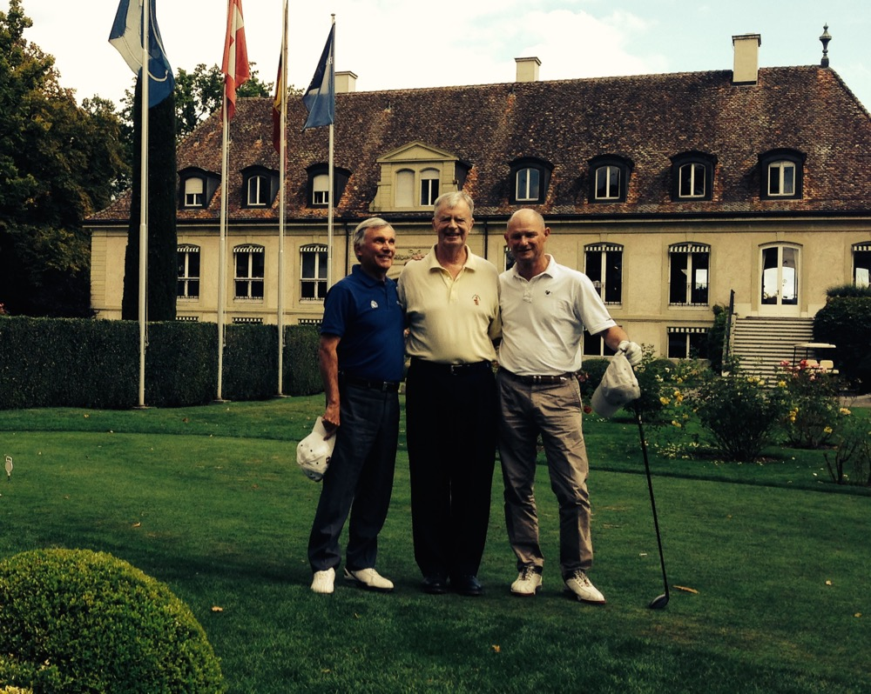
Club Manager Francois Lautens (my right) and Francesco Andina

The club was established in 1921 and the current Robert Trent Jones, Sr.-designed course opened in 1973. There is a possibility that Robert Trent Jones, Jr. might be hired to perform a redo of the greens in the near future.

This Sunday the course was booked solid, but Club Manager Francois Lautens squeezed us in at 2:08pm. This would be my first round on the trip with Francesco, who would be with us for the rest of the trip. It is 70-75 degrees, partly cloudy, with a 5-15 mph wind. We are a twosome pulling trolleys on rolling terrain. The first thing I noticed was the firm fairways. The Geneva area did not experience the huge quantity of rain that Zurich did this summer. Past the first green there is a nice view of Lake Geneva and distant mountains.

The course is laid out on a tight piece of property bordered by tall trees and some houses scattered about. There are many dogleg holes (even a double dogleg hole, #5). Several parallel holes are bunched together (a feeling of Firestone North in Akron, Ohio). Strategically-placed trees dictate shot direction. On the 560-yard par 5 15th hole the tee shot must maneuver around a 35-foot high and wide tree smack in the middle of the fairway with a bunker to the left of the tree. The hole then doglegs right, and the second shot must thread a needle through wide goal post trees on both sides of the fairway.

There is only one water hazard (large pond) affecting holes 8, 16, and 17. There are 80 bunkers. Eight greens require high approach shots to clear either a fronting bunker or water, and another eight holes have bunkers on both sides of greens that pinch approach shots.

After golf and some refreshments in the attractive and very active clubhouse filled with well-dressed and friendly members, we retraced part of the morning trip 34 miles northeast to Morges. We are in a 3-Star hotel directly on Lake Geneva and just west of Lausanne.

Monday morning Francesco and I drove 14 miles north and east to Golf Club de Lausanne. The club is six miles north of Lake Geneva in some foothills. Tall, mature trees dominate the entire course. Combining the distance from the lake with tall trees means basically no water views.

The course opened in 1931 and was designed by Hermann Narbel along with Donald Harradine. In the mid- 1990s Jeremy Pern (born in Great Britain but works out of France) did some major renovation work, mainly on the greens but also tees, fairways, and the only two ponds on the course that come into play in front of the 15th green.

At 7:30am we have motorized trolleys and the weather is cold (45 degrees) and windy (10-20 mph). During the round bright sun gradually warmed us, and by the end it was a beautiful 70 degrees. Lausanne has fifteen really good holes on nicely rolling terrain. There is a mixture of straight, curved, and doglegs. Beautiful chestnut, birch, and fir trees border most holes and can be ball-eating at times. The greens are elevated with interesting contours.

The problem: holes 11, 12, and 13 are located on a confining piece of land separate from the main part of the property. You cross a road to enter and exit this three-hole loop. Part of the terrain is different (very hilly) and the hole designs are unlike the rest of the course. Awkward comes to mind, especially the 471-yard par 5 #13 with a blind tee shot, two island fairways, and a very perched small green with the putting surface not visible from either fairway. You hit your second shot from an extreme downhill stance and your third so uphill you are almost falling backward. Unfortunately, to rectify the situation would take moving a tremendous amount of dirt, and I doubt the club would want to spend the money nor would the strong environmentalist group in the country let it happen.

Tuesday we left the hotel and drove 18 miles southwest to Gland and Golf Club du Domaine Imperial (18 miles north of Geneva). There, member and Francesco’s friend Ivan Couturier met us. The lineage of the property dates to the 17th and 18th centuries and involves a baron and then the Napoleon Bonaparte family. The handsome clubhouse is the former home of a Bonaparte mistress. The course opened in 1987 with Pete Dye as architect.

At 7:30am we are a threesome in carts. It is cloudy, 45-50 degrees, and wind about 20 mph. During the round the clouds disappeared and bright sun brought much warmer temperatures. The small tip of the property touches Lake Geneva, but all the holes work away from the lake so the only lake view is from the clubhouse. Mont Blanc comes into view on holes 9, 11, and 17.

The course has two distinct spirits. Members refer to the forest front side and “links” back side. Forest is correct for the front, but semi-open parkland is a more accurate description of the back. Holes two through eight are buried in a forest of tall trees, which border both sides of every hole. A long walk through the forest takes you from the first green to the second tee, which sets off holes two through eight. You can imagine how colorful it must be with fall foliage. An added feature is a beautiful wide-flowing stream that snakes along the far side of the property and comes nicely into play on holes three through seven.

Another long walk from the eighth green to the ninth tee brings you to the more open rest of the course. There is a large pond on holes 14 and 16. The terrain on all the holes is fairly level, although enough soil has been moved to provide some modest slopes.

Domaine is a calm Pete Dye design. There are only 64 sand bunkers along with many grass bunkers. Some of the bunkers are long and deep with high sides. The length of some bunkers measure between 65 yards and 110 yards. A few have ladders of five and six steps to enter and exit. Most of the greens have modest slopes with only #11 semi-wild. Green conditions were excellent – smooth and about 10 on the stimpmeter. Pete Dye railroad ties supported the sixteenth with a large pond fronting the front left side.

I love being surprised by seeing new things on golf courses. At Domaine it was “Toblerone” tank barriers hidden in the woods starting on the walk from 13 green to 14 tee. They then line the right side of the entire sixteenth hole. In the 1930s, the Swiss Army built a defensive line of 2,700 9-ton concrete blocks along the western edge of Gland to stop German tank invasions from the west. The blocks are the same shape as the famous Toblerone chocolate bar. During construction Pete Dye had to deal with severe environmental restrictions imposed by the Swiss Army. Pete built a tall burn between holes 14 and 16. The Army made him take it down because it blocked their line of shooting sight to a nearby main road.
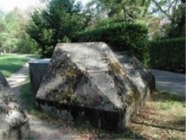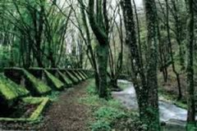
Toblerone Tank Barriers

After play, the golfers and Elaine enjoyed a lovely lunch on the clubhouse patio directly on Lake Geneva contemplating the gorgeous view and reflecting on playing the best course in Switzerland.
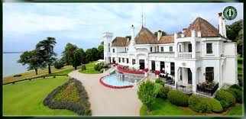
Domaine Imperial Clubhouse on Lake Geneva
Italy

As previously stated, my golf in Italy could not have been scheduled without the help of American golf course architect Dana Fry, who introduced me to Royal Park I Roveri Golf Club General Manager Romy Gai, who then transferred me to his Directeur Sportif Andrea Faldella. Andrea was my intermediary using the Italian language with the rest of the clubs on the itinerary.

After playing Domaine Imperial on Tuesday, we drove 180 miles south over and through the Alps to Italy and San Francesco Al Campo, a small town (comune in Italy) 13 miles northwest of Torino (Turin). At the beginning of trip planning I had no idea of the leading courses in Italy. Once I got a better feel for the lineup, I was pleased to see that the top four were in northwest Italy between Turin and Milan (just 89 miles apart). Not only was this a small part of a big country, but it also dovetailed nicely going out and then back into Switzerland.

For our stay near Turin, Andrea recommended Romantik Hotel Furno, which turned out to be a small country inn with buildings constructed in the eighteenth century. The food, service, and quiet accommodations were excellent (very relaxing). We are in the Piedmont Region at the foot of the Italian Alps.

Italy has about 270 golf courses (only about 130 are 18 holes) serving approximately 100,000 golfers. With a total population of about 60 million this small number would suggest empty courses and easily-accessible tee times. This is not what we found. All the courses we played were very busy and in one case we were only partially successful in getting what we wanted. As far as I could see, golf is alive and popular in Italy. All the courses played on this trip were private, but arrangements can be made in advance to play during the week.

On Wednesday morning we drove 8 miles west to Royal Park I Roveri Golf Club. There are two courses here – Robert Trent Jones Sr. Course built in 1976 and Pramerica designed by Dana Fry in 2013. The courses are in a regional park called Parco Reale La Mandria. Despite the Agnelli family (controlling shareowner of Fiat) involvement, securing the environmental permits for the second course was a herculean challenge.

La Mandria is the largest enclosed park in Europe. It was once the property and favorite hunting grounds of King Victor Emanuel. We arrived at the south guard gate at 7:15am. The guard would not let us proceed to the course until 8am, at which time he escorted us one mile to the clubhouse. There, the sole person around the pro shop gave us a buggy. This scene of no activity near the clubhouse at 8am was replaced at 10am with at least 100 golfers swarming all over the place as we left the 9th green.

In bright sunshine we had the whole course to ourselves. It is 50 degrees with no wind. During the round bright sun would raise the temperature to a lovely 75 degrees.

I immediately fell in love with the course. I was expecting a typical Robert Trent Jones, Sr. design with large-to-huge greens guarded by many fronting bunkers. It turns out I Roveri had some of the smallest greens I have seen anywhere. Tiny comes to mind. The average depth is 27 yards with some being 18 yards, 21 yards, and 24 yards. Some are wide, but some are narrow (how about 9 yards wide on the front part of the par 4 5th green with water just in front of the green).

The holes weave nicely through tall, mature trees that border both sides of all fairways. Some of the trees are strategically placed, overhanging some fairways or acting as goalposts on either side of the fairway.

The terrain slopes gradually up and down providing a pleasant look. Water in the form of beautiful clear, loud, fast-running streams comes into play on nine holes with dual ponds at the 9th and 18th greens. Usually I would rebel against the repetition of water in front of so many greens, but the setting of each had enough variety to sustain my interest. The streams are of varying widths and shapes, some straight and others serpentine, and a number run into small ponds.

The Jones, Sr. design team used great imagination here to produce a variety of features in proportions that fit smoothly and blend nicely. The frosting on the cake is several holes framed by the Italian Alps in the distance. Of the six Italian courses played on this trip the Jones, Sr. Course at I Roveri would turn out to be my favorite.

After the round I met Andrea Faldella, Directeur Sportif and thanked him profusely for all his help with the other Italian courses on this trip. I was hoping to meet General Manager Romy Gai, but he was not there on this day.

In the afternoon, starting at 12:30pm, we tried to play the new Pramerica course. Unfortunately, we were at the tail end of a packed tournament of 90 players starting out in foursomes on the 1st and 10th tees. The group in front of us was so slow it took us one hour to play only three holes. I am a dedicated golf course rater and grateful to Dana Fry for his help with planning this trip, but a potential six-hour round on a secondary course was above and beyond the call of duty. So we packed it in and headed back to the relaxing Hotel Furno.

Thursday morning we drove nine miles west to Circolo Golf Torino (Blue Course) – La Mandria, which is officially located in Fiano. Actually, we went the same way as the day before, but at the fence line of Parco Reale La Mandria we turned north for the last bit of the trip. It turns out it is just a two-minute walk through the woods from Golf Torino to I Roveri.

Englishman John Morrison designed the Blue in 1956. Over time nine holes were added (John Harris design) and then another nine came along (Marco Croze design). At this point the Blue and Yellow designations came into being. Canada-based architect Graham Cooke did some major renovations to the Blue prior to the 1999 Italian Open. The Blue occupies the interior land while the Yellow is basically on the exterior of the property.

Speaking of the Italian Open (part of the European Tour), I did not realize that the 2014 version ended here on Sunday, August 31 and we are here Thursday, September 4. It turned out the front nine of the Blue was closed for recovery maintenance on our playing day. Fortunately Sports Secretary Tiziana Panizzolo gave us permission to play the front nine. As we were strolling down the first fairway a member of the ground staff came zooming up with hands waving for us to get off that part of the course. We told him permission had been given so he said …”Oh, the golf writers from Rome….” With this problem resolved it then dawned on us that all the other players would be going off the back nine so we had better do that first to avoid the crowd.

Starting out at 8:15am in a cart it is a cloudy 50 degrees and no wind. During the first part of play we had our only rain on the trip – just drizzle at first and then a heavy 20-minute downpour. By the end of the round it was a humid 80 degrees.

Even though Golf Torino is adjacent to I Roveri, the terrain here is almost dead flat on this compact course. To jazz things up Graham Cooke created many mounding areas and added several bunkers to increase the total to 91. A slight negative is almost all the greens have the same feature of being pinched in front by bunkers hugging both sides.

Compared to I Roveri, the greens here are large to huge. For instance, the very first hole is 49 yards deep along with an approach shot over a wide stream. Four other greens have fronting streams. Tall trees border all holes and there are many narrow tee shots. The rough was particularly brutal on the front nine (left over from last week’s pro tournament). It was a good reminder of what tour golfers deal with on a weekly basis. Senior golfer swing “speed” has no chance in these conditions.

The rough swing speed issue reminded me of being at Pebble Beach three weeks before the 1992 U.S. Open. I was in the right rough on the 18th hole and could barely nudge the ball back to the fairway despite a full swing. On the first day of play in the Open, Phil Mickelson was in the exact same place and his pitching wedge went right through that thick grass like a sickle, his ball finishing 10 feet from the hole. But I digress.

After a full meal at noon in the Golf Torino clubhouse dining room it was off 48 miles northeast to Golf Club Biella “Le Betulle” (The Birches). The club is 11 miles southwest of the town of Biella and just outside the village of Magnano. The drive in from the south goes from a flat plain to steep mountains with several hairpin turns on a narrow country road. Once there you are 1,936 feet above sea level. We are in the foothills of the Alps in the Bo mountain range. The next morning on the course we had a lovely long-distance view of the snowcapped Alps from the elevated 16th tee.

On the way to Biella we thought it would be fun to maybe play the course in the early evening shadows. When we arrived the quiet remote setting was mobbed with people. Over 100 cars took up all the parking spaces and there were people swarming all over the place. It turned out that today was the 3rd and 4th rounds of the 8th Italian International Under 16 Championship, so instead of playing we observed the award ceremony and reception for the 132 boys from 17 countries along with their parents and friends. The winner was Italian Soldati Feodoro with a good score of two under for 72 holes. Maybe we will hear about Soldati in a few years as a successful pro golfer. The four-round course record is a brilliant 16 under par set by Rory McIlroy in the 2006 European Amateur.
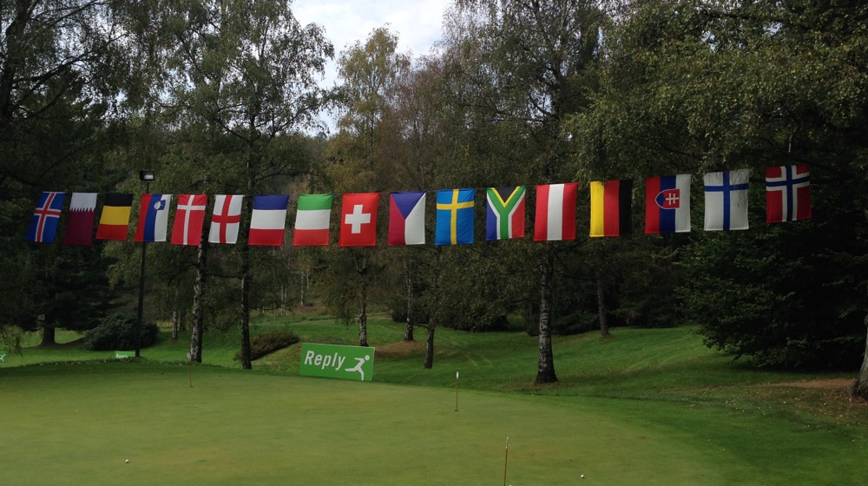
Golf Club Biella Italian International Under 16 Championship

That evening we had a delicious dinner in the club’s main dining room. The calling card for Biella is equal parts golf course and restaurant along with an outstanding wine selection. We also stayed here in basic facilities with a quiet and cool fresh air environment.

On Friday morning we tee off at 8am in 55-degree weather, cloudy, no wind. The sun would come out and the temperature rise to 70. Englishman John Morrison designed the course in 1958. Parts of the course are on steep terrain and the rest slope up, down, and sideways. The course was carved out of a dense forest resulting in all holes being enclosed by tall trees – silver birch, chestnut, and oak. Many are at least 100 years old. Eleven of the holes dogleg one way or the other. Other hazards are 64 bunkers, but many of the greens are open in front. There are a few narrow streams and some ponds, but they are more a visual than strategic danger. There are some rocky outcroppings in and around fairways. The greens are reasonable in size with slopes being the challenge.

Late in the morning we drove 56 miles east to Bogogno (a village with 1,200 residents) and Circolo Golf Bogogno. The Milan airport is 20 miles away and the club is 48 miles from Milan city center. The airport is busier than Rome as Milan in the business capital of Italy.

The club and real estate development was built in 1996 to attract golfers from the Milan area. This is a country club with 36 holes, swimming pool, tennis courts, large clubhouse, and a 22-room hotel (just opened April 2014, modern architecture outside and inside, rooms spacious and cozy, reasonably priced). The project became overextended in 2008. The facilities closed in 2013 and then a few members bought the club so now everything is back in operation.

At 2:30pm we are out in a cart on the Del Conte Course. The other course is called Bonora; American Robert von Hagge designed both. It is cloudy and 65 degrees with no wind. During the round it rose to 80 and became humid. We also had ominous dark clouds with thunder rumbling on the back nine.

The premises are swarming with golfers everywhere. There is a guest tournament on the Bonora course. We have been so spoiled on this trip with morning tee times and courses to ourselves. This afternoon we have several groups in front, but we cannot complain. In order to fit Bogogno into our schedule and the club not permitting visitor play on weekends, we are lucky to even have a tee time.

The architect did a fine job with dead flat terrain surrounded by an Alpine backdrop. The nearby Monte Rosa range is in the eastern part of the Pennine Alps. The highest peak in the range is 15,203 feet, which makes it second highest in the Alps and Western Europe.

Tall trees line some of the holes and others are semi-open with artificial mounding separating parallel holes along with other mounding around many greens. The course looks and plays like Florida. There are eleven large water hazards (ponds, streams, marshes) affecting shots on 16 holes. There are 71 bunkers, most large and deep. One is 70 yards long and two others 110 yards. Most of the greens are guarded on one side by a bunker or water. The greens are large with two being 44 yards deep.

After golf we had a late dinner in the busy club dining room. We then stayed over night in the Bogogno Golf Hotel.
Saturday morning we drove four miles east to Agrate Conturbia (Novara) and Golf Club Castelconturbia. This is a Robert Trent Jones, Sr. 1984 design with three nines (Blue, Yellow, Red). The tournament (1998 Italian Open) combination is Blue/Yellow. Unfortunately, a heavily subscribed club event sponsored by KPMG on this Saturday started on the Yellow nine so we were assigned Blue/Red. When we signed in at the clubhouse there were at least 100 trolleys loaded with clubs lined up for the tournament. Busy is an understatement.

At 9am we are in a buggy in glorious weather – 60 degrees, bright sun, no clouds, and no wind. The first eight holes are tight through beautiful tall trees on all sides. There is nicely rolling terrain producing noticeably sloping stances (up, down, side). Out-of-bounds lurk on five holes. There is a good mix of dogleg holes and straight holes, with a stream running through the middle of one fairway and a ravine on another hole.

Only 29 bunkers are present, many of them large and deep. Seven of the nine greens have a fronting hazard of either a deep bunker or pond. The mostly elevated greens are busy – tiers, shoulders, distinct sections, false fronts and sides, bowls, and humps. One green is serpentine-shaped. The fifth green fit the short par-4 hole perfectly and featured an approach shot off a down-sloping stance to a raised, small, bunkerless green – only 14 yards deep – falling off on all sides. We felt the Blue nine packed a superb amount of variety.

At 11:20am we were on the Red nine, and it was immediately apparent this was a much less desirable nine than the Blue, the Red being more wide open and ordinary in design. Compounding our disappointment was a slow foursome who would not acknowledge our presence despite having no one in front of them. We were wishing for the Yellow nine with reasonable players in front of us. Our guess is that the Yellow nine is equivalent in quality to the Blue. However, considering it is a busy Saturday at the club, we felt fortunate to have had at least a taste of the high quality of golf holes at Castelconturbia.

Our final course in Italy was scheduled two days after playing Castelconturbia. At the crack of dawn on Monday, we drove 52 miles south from Ascona past Lake Como and on to Montorfano (a town of 2,500 residents). We are in the Como hills about 7 miles southeast of Lake Como. Circolo Golf Villa D’Este overlooks Lake Montorfano, but tall trees hide the lake from the clubhouse and the golf holes. The course was built in 1926 to service guests at the Five Star Grand Hotel Villa D’Este Cernobbio (now called Villa D’Este Lago di Como). In its heyday the hotel catered to European royalty and movie stars.

Argentine-born and English-raised Peter Gannon designed the course. Having never heard of him, I did a Google search. I love discovering information on unique people, and Gannon fills that bill: a Roman Catholic priest and a world-class amateur golfer throughout Europe, who became a prolific course designer with projects completed in Italy, Switzerland, Germany, France, and South Africa. From what we experienced at Villa D’Este, Father Gannon was an excellent golf course architect.

On the surface the raw statistics of the course are not impressive (6,381-yard, par 69, six par 3s). Reminds me of Swinley Forest in England (6,062-yard par 69 with five par 3s). However, just like Swinley, Villa D’Este packs a real punch.

In arranging to play we received the following message: “Due to several thunderstorms that affected our area in June and July, many competitions have been canceled. On Monday 8th September we have a replayed competition sponsor by AC Milan Football Club with more than 100 golfers. It will be a shot-gun at 12.30 pm so could we play early in the morning.” This was no problem for us, as we like to play early.

At 7:15am we are out in a buggy on an empty course with the sun rising, 60 degrees, and no wind. We will finish with sunny skies and 75 degrees at 10:45am (long before the AC Milan shotgun). The terrain is hilly and every hole is tree-lined on all sides (tall chestnut, birch, and pine). There are a variety of sloping stances – downhill, side hill, uphill, and even some hanging lies.

The course is divided into two distinctive pieces. After the first two holes you cross the club entrance road to a compact rectangular piece of property for holes three through seven. There are three par 3s here as well as two short par 4s. Then holes eight through eighteen occupy the same terrain as the first two holes. The land within the rectangle is even hillier than the main part of the course.

Most of the fairways on the 12 non- par-3 holes move slightly left or right with only two being doglegs and two being straight. Most of the tee shots are to semi-wide fairways; each succeeding shot becomes narrower as trees move closer to the fairways. There are only 15 fairway bunkers, and water (in the form of a pond) comes into play on only one hole (short par-4 12th). There is out-of-bounds on seven holes.

Many of the 46 greenside bunkers (some very deep) semi-pinch the opening to ten greens by hugging the right and left sides. A few greens require a carry over a fronting bunker. The greens vary nicely in size with slopes being the challenge.

The short par 4 18th reminded me of the finishing hole at The Olympic Club (Lake Course) in San Francisco – very elevated tee, huge uphill approach to perched green with large and distinctive clubhouse as backdrop.

After golf we had a nice conversation with club Segretario Andrea Contigiani who kindly gave me a club history book. Then it was back in the car for a return trip through the mountains to Ascona.

Switzerland Continued

After golf at Castelconturbia in Italy on Saturday we drove north 58 miles to Francesco’s apartment in Ascona, Switzerland. This municipality of about 5,500 people is a popular tourist site on the northern shore of Lake Maggiore on the south side of the Swiss Alps just above the Italian border. Ascona is where Francesco grew up and is a charming town with narrow winding streets, a variety of shops, excellent restaurants, and a romantic shoreline with mountains rising from the lake. Elaine and I were lucky enough to enjoy this relaxing ambience while staying in Francesco’s spacious, beautifully-appointed pied-a-terre near the lake.
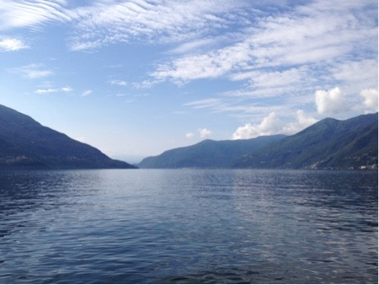
View of Lake Maggiore from Ascona

That afternoon we teed off at Golf Gerre Losone at 4:10pm. The original schedule had us playing a double header on Tuesday followed by a long drive to the Zurich airport. Losone, a private club with lots of tourist play, was nice enough to let us play on this busy Saturday afternoon. We teed off in bright sun, 75 degrees and wind at 10 mph with gusts up to 15 mph.

The course is three miles north of Ascona in a valley surrounded by tall mountains. During play you look down some valleys to several mountain peaks. The course sits on the dead flat ground of an old army training ground. Architect Peter Harradine did a good job in 2001 producing an interesting course on a confining, featureless site. There are three large ponds connected by rocky streams that affect ten holes. Trees and mounds separate many of the mostly parallel holes. We finished play in total darkness.

That evening the three of us enjoyed a delicious fresh seafood meal in the lovely atmosphere of Francesco’s favorite Ascona restaurant, Ristorante della Carra.

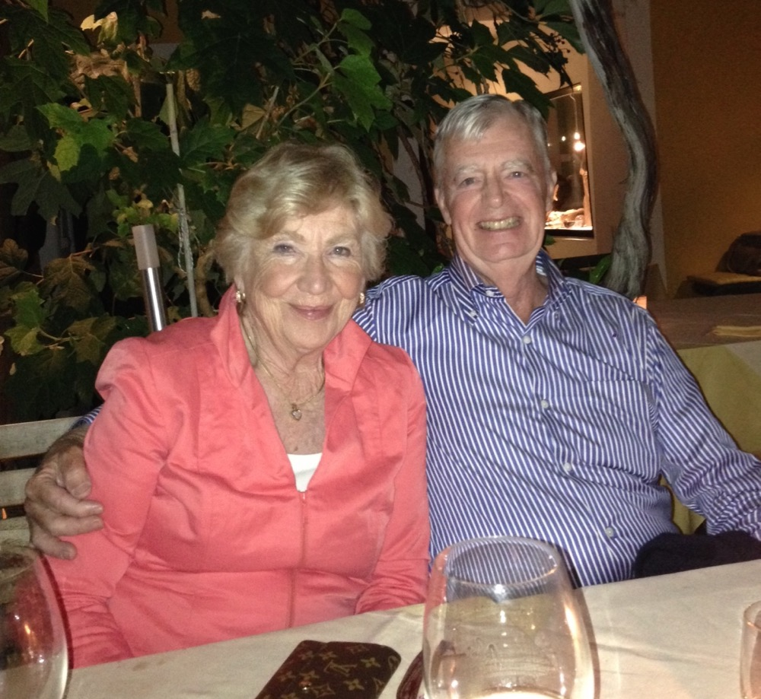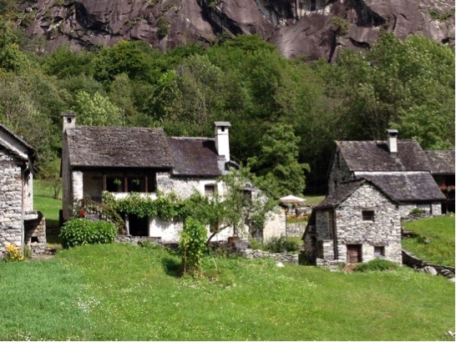
Happy couple at Restorante della Carra 100-Year Old Houses in the Valbavona

Sunday was a rest day. We drove about 45 minutes north of Ascona to the Valbavona, at the very end of the valley called Vallemaggia, which starts just a couple of miles behind Ascona. Steep and high surrounding mountains mark the valley, and some of the best granite quarries in the entire Alps are located here. The area of the Valbavona is particularly worth seeing not only for its natural beauty but also because of its few small villages that have remained untouched for over 100 years. All homes and stables, which these days are used only during the summer months for recreational purposes, are built of granite stones (including the roofs). We stopped for lunch in Foroglio, sitting on the terrace of its only restaurant, facing a magnificent waterfall.

The finale of the trip was Tuesday morning at Francesco’s Golf Club Patriziale Ascona starting at 7:30am. This is where he learned to play golf as a kid. The club was founded in 1928 with nine holes. Colt and Alison did an 18-hole layout in 1932, but it was not until 1957 that 18 holes came to be under the supervision of Englishman C.K. Cotton.

It is 60 degrees, cloudy, and no wind. We are in a cart. The sun came out on the 4th hole and sweaters were off on 8th hole. The flat, compact course is in a beautiful park setting with magnificent old and tall trees surrounding all holes. Holes 16 and 17 run near Lake Maggiore, but the water views are almost totally hidden by tall trees. Three small ponds affect play on holes 2, 3, and 17.

The fairways are wavy so the flat terrain is not as noticeable as you would expect. Many of the holes have subtle movement either left or right with trees hindering approach shots if you are not in the correct position off the tee. The bunkers have attractive shapes and the greens (some large and deep) have subtle contours. With the Swiss Alps nearby three sides of the course I thought the views of the snowcapped mountains were the best experienced near a course on this trip.

After golf and heartfelt thanks to our perfect host and wonderful traveling companion, Francesco, we drove 136 miles north through mountains and tunnels to the Zurich Airport.

Royal St. George’s

From Zurich we flew to London, rented a car, and zipped east 75 miles to Sandwich and our beloved Royal St. George’s Golf Club (RSG). There long time friends Sally and Ronnie McAlister met us. We were joined for lunch by Ronnie’s friend John Pepper and Head Club Professional Justen Fiddler. After lunch the men played a spirited foursomes match.

During the round I reflected back on the wonderful times I have had at this magical place. Thanks to Baltusrol friend Peter Green, I became a member of RSG in 1992. I wanted to join a true links course and RSG was the best links course closest to London. Although the course has lived up to every high expectation I had, it has been the members who’ve made my times here so enjoyable and memorable.

Two families are of particular note. The first year I was a member I came over for the Home Members versus Overseas Members match. One of my opponents that day was Ian Findlay, and I am pleased to say friendship was instantaneous. For many years afterwards we played many games together. More important, Elaine and I enjoyed the kind hospitality offered by Ian and beautiful wife, Alison, at their homes near London and Sandwich. They were both with me on the RSG afternoon during the 1997 100-day trip. Ian was Chairman of Lloyd’s of London and Captain at RSG. If you go to The Addington Golf Club near London you will see Ian’s name all over the club tournament plaques, many times as partner with his dear friend Alaister Nimmo. I can still remember a wonderful Saturday evening with the Findlay’s and Alaister. Sadly, they are no longer with us, but I am pleased to say Elaine and I have continued the Findlay relationship with Ian’s son Graham and wife Libby.

Early on, Ian introduced me to member Major General Ronnie McAlister and bingo, another deep friendship was created. Ronnie and wife Sally have made our visits to Sandwich so enjoyable we always look forward to a return. Ronnie was in charge of Gurkha (Nepal) units while serving in the British Army. He has been Captain, Treasurer, and President of RSG.
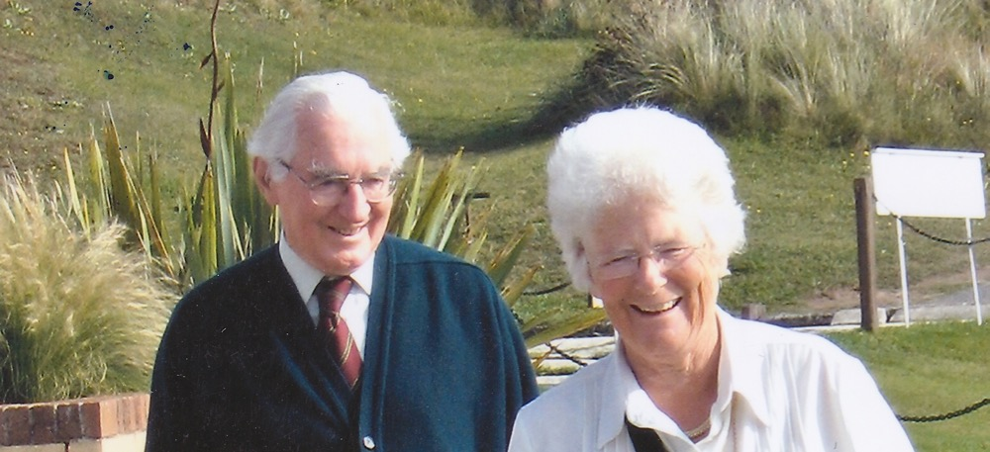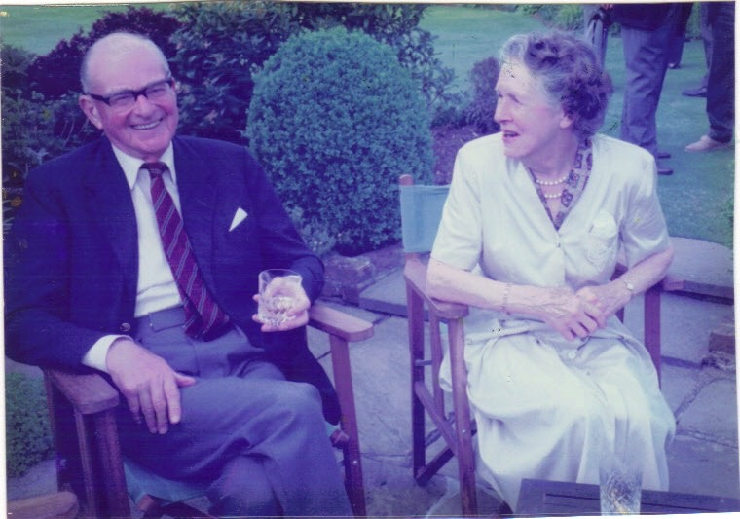
Ronnie and Sally McAlister Ian and Alison Findlay

- Pikewood National -

Pikewood National Golf Club opened in 2009 and entered the 2013 GOLF DIGEST USA Top 100 at number 45. With Pete Dye at French Lick under my belt, Pikewood was the last course I needed to play to stay current in playing all 100 beginning with the 1983 list. I want to maintain this streak for two reasons. The obvious one is the continued momentum of the 30-year accomplishment. The other is to continue to play the best courses in the world for the first time. Any course that achieves a top 100 ranking on any magazine list is something I certainly want to experience.

To say arranging to play Pikewood was a challenge is a huge understatement. The effort commenced in April 2013. After innumerable e-mails, telephone calls, and even a cancelled plane reservation, the happy day finally arrived in early October 2014.

The course is 10 miles east of Morgantown, West Virginia. Leaving the city you are immediately winding your way on narrow, two-lane, very hilly country roads. At the motel the weather is 45 degrees with mist. My Google printed directions, along with the directions from the club’s website, proved useless as I immediately became lost on the winding roads. I became very apprehensive about becoming further lost in the hills and hollows of rural West Virginia.

So Plan B was initiated - verbal directions on my iPhone. Then my anxiety doubled as thick fog settled in so I could now barely see 10 feet in front of the car. After 20 minutes of slow driving the nice lady on the iPhone announced: “You have arrived at your destination.” I had to laugh, as I was on a deserted road with just one lonely house trailer visible. There was no sign of a golf course in any direction.

I did remember that in the club’s directions there was mention of Kingwood Pike and a Citgo station. So I just keep going straight. Lo and behold, Kingwood Pike appeared out of the fog and like an oasis in the desert so did the Citgo station. The few people inside were right out of central West Virginia hillbilly central casting. Two guys had worn and torn overalls, long straggly hair, 2-weeks’ growth of whiskers, and only about half their teeth. I was thinking what are the odds of these guys having ever heard of a golf course let alone knowing where one was in the vicinity. Then the lady store manager appeared out of the back room. Fortunately, she knew exactly what I was talking about and sent me a few hundred yards up the road to the gates of Pikewood National. Sitting in the empty club parking lot I breathed a deep sigh of relief. After 19 months of many obstacles including the final weird drive to the club, I had finally made it here.

Unfortunately the challenge continued as the fog became even thicker. You couldn’t even see the driving range, which is located conveniently just off the modest clubhouse veranda. Then the mist turned into light rain. I decided to wait until the fog lifted, but there was no improvement over the next hour. There seemed no point in waiting any longer so it was out on the course in 45-50 degrees, 10 mph wind, and THICK FOG (not the best circumstances to rate a course). The course is walking only with caddie or carrying your own bag. The club has a group of college students from local West Virginia University on call.

Without golf course design backgrounds, mining company owners of the land created the course. Old time PGA Tour players Johnny Pott and Dow Finsterwald ”… visited the site several times and validated the design with critiques and suggestions.” It took nearly ten years to build the full 18 holes.

I played the first 13 holes in pea soup fog. The very limited “visibility” varied from 20 yards to 150 yards. There was no way I could see either fairway landing areas on tee shots or greens on approach shots.

The course has only two sets of tees – 7,588 yards and 6,890 yards. Soggy turf from an all-night rain made the course play even longer. Very hilly terrain on the downhill holes implied added roll on tee shots, but the soaked fairways produced no roll and even caused balls to plug. On these holes you are hitting from a down- sloping stance to an elevated green. Many of the holes are uphill so there is little roll on the tee shot. The back tees on some of the uphill holes are lower than the forward tees.
There are only four fairway bunkers on the whole course and just nineteen greenside bunkers. Almost every hole is self-contained with a forest of tall trees on all sides. Any semi-errant tee shot is a lost ball in the thick underbrush.
Almost every green is elevated with steep falloffs on all sides. The rough was far away from the greens so the ball funnels 10 to 15 yards away from the greens. You are then left with a delicate pitch or chip off closely- mowed grass. The constant repetition of this look and theme becomes a little boring in my opinion. My favorite aspect of a golf course is variety on every hole. The characteristic of truly great golf course architecture that I admire most is the author producing eighteen distinctive holes, with all seeming to tie together in a rhythmic flow.
The greens at Pikewood are HUGE and undulating. Many are somewhat thin and very deep (up to 50 yards). They were extremely fast and difficult to read. Early on I realized my confident student caddie did not have a clue in the green-reading department even though he acted like an expert.
As a golf course rater, I am often asked what influences the rating beside the actual eighteen holes. My number one answer is weather. Certainly a course presented in pristine weather has a better chance for a favorable rating then one played on a miserable weather day, which is exactly and unfortunately what I encountered at Pikewood. That’s too bad because supposedly one of the Pikewood featured attractions from many holes are the 10- to 50-mile long panorama views of the impressive Allegheny Mountain Range (particularly pretty during fall foliage season, but impossible to see because of today’s thick fog).
The bottom line here is that Pikewood achieved its goal of being one of the most difficult courses in the world.
- Trip South (October) -

Throughout the summer I have been trying to arrange to play Trump Ferry Point in the unlikely location of the Bronx, New York. Thanks to fellow GOLF Magazine panelist Steve Lapper a tee time became available on Monday, October 20, which fit perfectly with my yearly fall routine of relocating from our north summer home near Boston to sunny Florida for the winter months. Thus, I decided to try to play a few more courses along the way.

I cannot say this often enough: I am so lucky to be able to contact courses as a GOLF Magazine course rater and receive a welcoming response. I also cannot thank these courses strongly enough for their warm hospitality.

Trump Golf Links at Ferry Point (Bronx, NY).

Early on Monday morning I was in the middle of New York City area rush hour traffic on the Henry Hudson Parkway. I turned off just before the entrance to the Whitestone Bridge at Exit 18 into Ferry Point Park and then found the under construction temporary clubhouse where I met Steve Lapper and affable and informative club General Manager Joe Roediger. We had the opportunity to have a fairly lengthy conversation. Steve is a consultant to Donald Trump in the golf course area and was able to arrange for a group to play today even though the course does not officially open until the spring of 2015.

The history of the course is a 15-20 year saga. New York City tried to put a world-class public golf course on a former landfill. The final cost is $181 million, which is more than 10 times the estimate when construction started in the year 2000 with Jack Nicklaus as designer. Trump was brought in two years ago to manage the operation and build a permanent clubhouse.

Before playing the course I had seen mid-air pictures of some of the holes and was not impressed with the artificiality of the faux tall dunes surrounding the holes. Combining this with an urban setting – busy highway traffic, flight paths to and from nearby La Guardia Airport, old commercial buildings, four-story lower-income apartments, and even a large cemetery – I was skeptical of this being a positive experience.

At 8:45am I am out by myself in a cart. It is 50 degrees, partly cloudy, and the wind is 10-15 mph. Driving down the first fairway I immediately realized why I do not trust pictures of golf holes to judge the quality of a course. In almost every case the pictures are better than the holes turn out to be, but Ferry Point was the opposite. At eye level, the artificial tall dunes blended nicely with the naturally flat terrain, and they would have looked even better with the tall fescue grass that had just been burned off for winter maintenance.
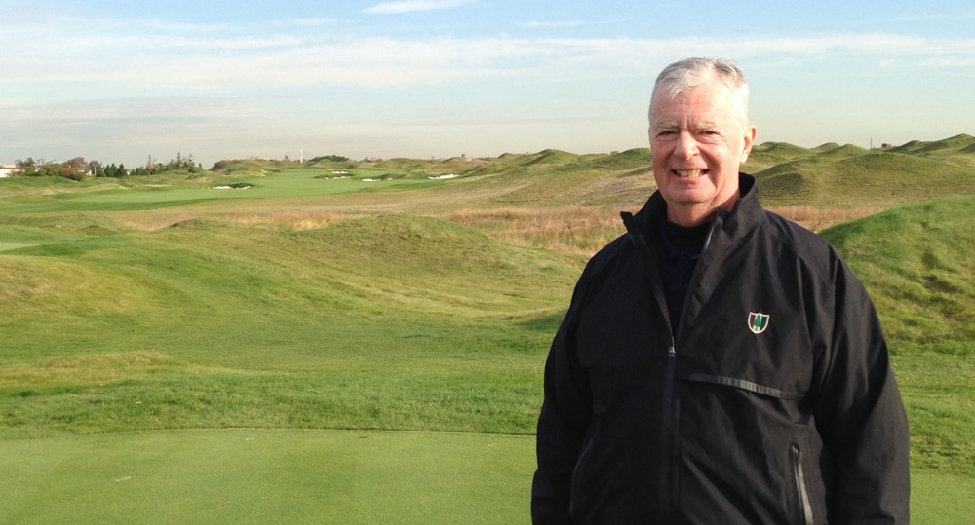
First Tee Trump Ferry Point

I was also immediately struck by the excellent condition of the entire course. A PGA Tour event could have been held here today. The course will be on your TV in the near future with the Barclays tour event and maybe even a US Men’s Open.

The natural terrain is flat, so a lot of dirt was moved to create everything. There is a good mix of elevated tees and tees almost at ground level. The fairways are generous in width, and bunkers (some in the middle of fairways) are abundant. There is quite a bit of movement in the wavy fairways with ridges being a feature. Many of the greens are elevated (perched) and numerous bunkers, some tight to greens and surprisingly small, guard almost all of them. Many greens have steep sides so approach shots could fall off a considerable distance into collection areas.

Most of the greens are large. For instance, #2 46 yards wide, #3 47 yards deep, #5 35 yards wide, #6 42 yards deep, #7 40 yards deep. These measurements continue for the rest of the holes with #18 being 48 yards deep. Some are angled and some are narrow. The greens are busy with tiers, ridges, and bowls. The bent grass greens were pure - smooth as silk and stimped at 10-1/2 to 11.

Ferry Point was designed as a tour course and not as a typical muni. This is good and bad. The good is that the public golfer is in for a real treat of experiencing a Top 100 design in excellent condition. But wait until he digs his teeth into a challenge never seen before. The bad is that the back tees are 7,407 yards, so you know the muscle guys will be there swinging from the heels. As strokes add up on each hole, the potential for slow play enters the picture.

Then there are all the bunkers. How many muni players know how to deal with a delicate greenside bunker shot? I am also worried about how the small and deep greenside bunkers will hold up. I can picture a 5’6” 250- pound guy with stubby legs taking a direct line to his ball in one of these hazards and absolutely destroying the sidewall grass as he lumbers in and then mashes his way out.

Other observations: Ferry Point is in an exposed, windy spot. I was surprised it was so quiet in certain parts of the course. Some water is in play, the course is compact and fairly easy to walk, thin 7-foot high green posts with silver tops stick out of the ground to vent methane seeping out of the landfill, pleasant NYC skyline views in the distance (Empire State Building 13 miles and ½ hour southwest by automobile), a direct look at the nearby Whitestone Bridge walking down the 9th fairway, and finally a nice view on 18 into the bridge and on to the NYC skyline.

The Philadelphia Cricket Club (Wissahickon Course)

From Ferry Point it was over the George Washington Bridge, down the New Jersey Turnpike, then onto the Pennsylvania Turnpike 15 miles north of Philadelphia in Flourtown. At 8am I am on the first tee with a caddy at the newly remodeled The Philadelphia Cricket Club Wissahickon Course (The other course here is Militia Hill, designed by Michael Hurdzan and Dana Fry in 2002). Director of Golf Jim Smith, Jr. was my host.

A.W. Tillinghast designed the Wissahickon Course in 1922. I played it 15 years ago and was unimpressed – it was tired, old, and tree-lined. After being closed for nine months (reopened end of May 2014) with Keith Foster directing complete restoration, the course is outstanding: about a thousand trees removed, the entire course totally re-grassed, some holes rerouted, all bunkers rebuilt, and more bunkers added. The course was in excellent condition with smooth greens running 11+. The Wissahickon Course was fun to play and the staff in the pro shop, on the play deck, and in the clubhouse was friendly and efficient.

The positive of the depression in which new golf course construction in the USA finds itself is the greater attention being paid by course designers to the restoration and renovation/modernization of old courses. The result is an outstanding group of newly worked-on courses. As stated previously, my recently-played top picks in this category are Gil Hanse for Los Angeles Country Club (North Course) 2010, Trump Doral (Blue Course) 2013, and Coore & Crenshaw at Pinehurst #2 in 2011. Now added to the list is Greg Foster’s outstanding work on the Wissahickon Course at The Philadelphia Cricket Club.

Old Town Club (Winston-Salem, NC)

I am here in the northwestern part of North Carolina at the Old Town Club in Winston-Salem with member Dunlop While and GOLF Digest panelist Paul Rudovsky (more on him later). Over the years I had heard of Old Town and was hoping to play it at some point. The impetus for finally being here is another restoration project, where the Coore & Crenshaw team did its magic in 2012-2013. Perry Maxwell originally designed the course in 1939, after Augusta National’s founder Clifford Roberts recommended Maxwell to the club.
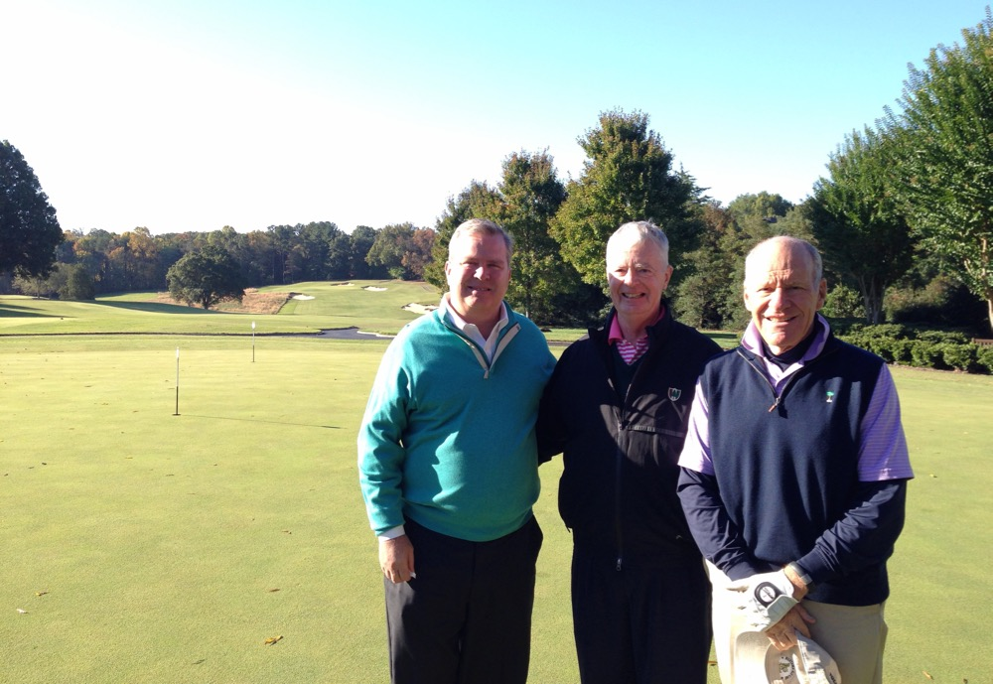
L/R Dunlop White, author, Paul Rudovsky

At 10am Paul and I are on the first tee with cart in 50-degree weather, bright sun, and 10-15 mph wind. It would warm up to 70 degrees with gusts up to 20 mph. Old Town is low key and is the most prestigious club in Winston-Salem. We have the course to ourselves. From the very start of the round it became clear that the terrain moves sharply downhill, uphill, and side hill. Such hilliness produces some semi-blind tee shots over ridges. Water, in the form of streams (varying nicely in width), comes into play on ten holes, some of it hidden. The restored strategic bunkers stand out with an attractive weathered look with jagged edges, rumpled lips, and sand exposed up the faces. Off an abundance of challenging hanging lies, approach shots are to raised and perched greens that feature the famous undulating “Maxwell rolls.” The routing is compact with a double green (#8 and #17) and a double tee (#9 and #18). Many trees have been eliminated, but there are still plenty of beautiful big mature ones remaining. Gorgeous fescue grass is all over the property.

After golf Dunlop joined us for a relaxing lunch in the cozy men’s grill. It immediately became clear that Dunlop loves golf course architecture and Old Town. I could tell that he was a good player as his name is on a number of the club plaques. Sadly, he has had a medical issue for the past four years that precludes him from playing golf and travelling.

Bill Coore grew up 24 miles from Old Town and played golf for the Wake Forest team on this course in the late-1960s. He first began talking about and examining the course with Dunlop for a possible restoration way back in 2004 and stopped by every other year since then. The course closed December, 2012 and reopened September, 2013 for the $1.5 million restoration.

The Wake Forest University campus is directly next door (moved to this current location in 1956), but the school buildings are hidden from view behind tall trees. The Wake Forest golf teams play here and have produced many All-Americans and some became excellent PGA Tour players. Arnold Palmer started the parade in 1948.

Tobacco Road Golf Club - Sanford NC

From Winston-Salem it was an easy drive southeast to Sanford, NC, which is 25 miles north of Pinehurst. For many years good friends Ned Longson and Mitch Hantman have been encouraging me to play Tobacco because they though the design by Mike Strantz in 1998 was totally unconventional. In reading about the course, words such as unique, offbeat, a little goofy, and daring pop up. Strantz’s nickname is the “The Maverick” because he was viewed as a pioneer who took chances. Sadly he passed away at age 50 in 2005.

In total darkness I am driving on a narrow back road in rural North Carolina. The course was built in an abandoned sand quarry and on a former tobacco farm. At the busy pro shop I receive a friendly greeting from Director of Golf Joe Gay, who is engaged handling several eager golfers anxious to get to the first tee. Tobacco is a public course with a no-frills clubhouse. Anyone worried about the popularity of golf should visit this place. I was integrated with a group of six young guys from Chicago on a “buddy trip” to the Pinehurst area. The sun is barely rising at 7:30am as our foursome is on the first tee in gas-powered carts with the starter going over the many ground rules. It is a cool 40 degrees (you can see your breath) with a 5-mph breeze. The sun would come out and sweaters were off by the 11th hole.

The opening tee shot is something I have never ever experienced before. Because it is still semi-dark, I could barely see what I was supposed to do on this 558-yard par 5. With five foursomes of players milling around the tee, I had to carry shrubs and sand just in front of the tee and then maneuver the ball between 100-foot-high mounds pinching the fairway with deep bunkers at their base. The gap between the mounds is only 10 yards wide and the carry over the high mounds starts at 190 yards and finishes at 270 yards. Welcome to Tobacco Road! After playing the first hole one of the guys in the group opined: “This is a course from Mars.”

Well, I immediately fell in love with Tobacco Road. Despite several blind shots, sandy wastelands, and severely undulating greens, you have to think your way around. Even though the design is extreme, it is eminently fair. You cannot just blast away.

Tobacco Road is often referred to as “Pine Valley on steroids.” There is actually much more visible sand here than at Pine Valley, with numerous massive deep bunkers (32 railroad tie steps to climb from the base of the one fronting the 9th green up to the putting surface). “Massive” can also be used to describe some of the greens: the 15th is 80 yards wide, and the 17th stretches 98 yards wide.
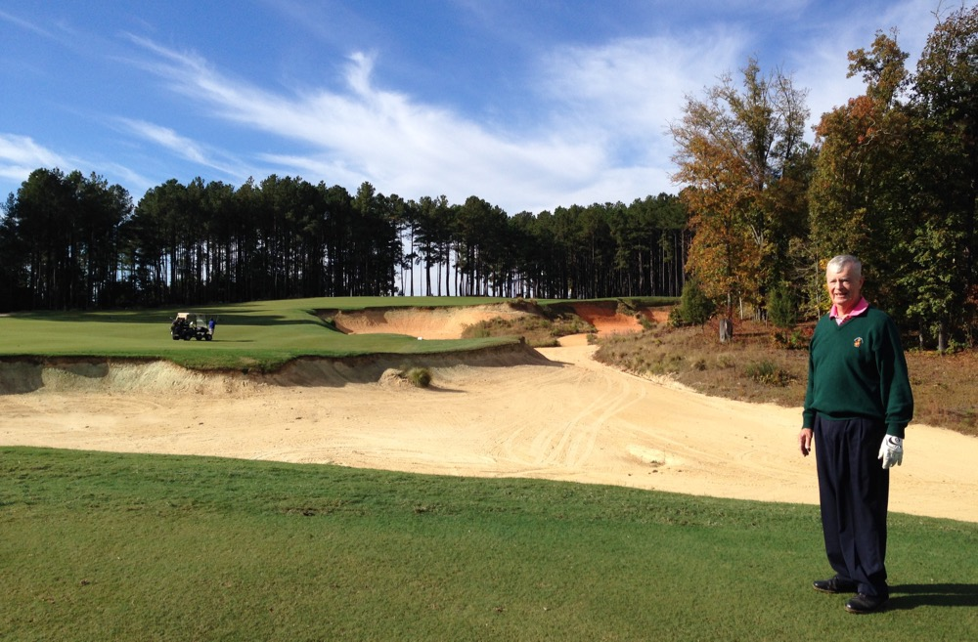
11th Hole Par 5

Some of the shots might seem a little over the top, but you do not mind because the architect used a tremendous amount of imagination in creating this one-of-a-kind course. I felt I could sense what the architect was responding to as he laid out the holes. (The last time I had this feeling was at Sand Hills in 1994.) I could still feel the vibes days later and even now as this is being written. Another time I had these long-lasting vibes was after being one-on-one with Jack Welch, former CEO of GE. He exuded so much energy you felt you were sitting next to a pile of cobalt and could feel the vibes for days afterwards.

Paul Rudovsky (Rudo)

From Tobacco Road it was a quick drive south to Pinehurst and the home of Pat and Paul Rudovsky on the grounds of the Country Club of North Carolina.

In October 2013 friend John Cornish from Kingston Heath in Melbourne, Australia introduced me to Rudo. John thought he and I might have common interests. Turns out this was an understatement. If you think playing the courses on various lists overly obsesses me, get a load of this guy.

Paul is an MIT grad and thus numbers-oriented. He’s created Excel spreadsheets of all the Top 100 lists published by USA magazines plus a few from overseas. Not only is he keeping track of these lists, which date back to 1966 and are published every other year or annually, but he is getting close to playing them all. The lists, number of courses played, and number of courses to be played are:

Golf Magazine - The Top 100 Courses in the World – Played 190/To Play 13
Golf Magazine - The Top 100 Courses in the United States – Played 181/To Play 8
Golf Digest - America's 100 Greatest Golf Courses – Played 248/To Play 41
Golf Digest - World's 100 Greatest Golf Courses – Played 90/To Play 10
Golf Week - America's Best Classic & Modern Courses – Played 195/To Play 22
Links Magazine – Links 100 World – Played 98/To Play 2
Golf Course Architecture - Architect's Choice Top 100 Golf Courses in the World – Played 90/To Play 10
Website - Planet Golf - World 100 – Played 83/To Play 17
Website – Top 100 Golf Courses in the World – Played 140/To Play 10

To complete playing all the lists Rudo calculates a “to do” list of 77 courses in the USA and 57 overseas. Do not bet against this happening. Once I put this Odyssey on the website, I will try to post some or all of the individual lists on the site.

The only problem I have with Rudo is that he insists on comparing the MIT football team’s record to that of my Harvard football team. But first, did any of the readers of this document even know that MIT played organized football? Well, they are in Division III and play in the New England Football Conference. Harvard is in Division I FCS (Football Championship Subdivision). Fortunately for purposes of the Rudo/McCoy rivalry, MIT lost their last game to go 10-1 for the 2014 season. Up the Charles River, Harvard went undefeated (10-0) and beat Yale in the final game of the year to win the Ivy League Championship. I am sure all this is more than you wanted to know about MIT/Harvard football. Admittedly, it certainly is not Ohio State versus Oregon.

Mid-Pines Golf Club (Southern Pines, NC)

Saturday morning I drove seven miles east to the Mid-Pines Inn & Golf Club. Mid-Pines and Pine Needles Inns and Golf Clubs are part of the same company and physically across the street from each other. My hosts today were Graham Gilmore, Director of Golf and Kelly Miller, CEO. Donald Ross designed both courses – Mid-Pines in 1921 and Pine Needles in 1927. Pine Needles received a major restoration effort in 2004 by John Fought. Since then, Mid-Pines was viewed as tired and worn-out, resulting in the mix of play shifting to 70% Pine Needles and 30% Mid-Pines. So Kelly decided Mid-Pines needed some major restoration work.

Taking a page from the nearby brilliant Coore + Crenshaw restoration at Pinehurst #2, Mid-Pines hired Kyle Franz to do the same thing for them. Kyle has been a golf course construction shaper and finisher for Tom Doak, Coore + Crenshaw, and Gil Hanse and was involved with the work on #2 in 2010-2011. Mid-Pines was his first solo effort as an architect; work took place from late 2012 to August, 2013. For less than $1 million dollars Bermuda fairway rough was ripped out and replaced with hardpan sand and wiregrass. Rounded bunkers were rebuilt with jagged edges. All greens were regrassed and restored to original size and contours. About 400 pine trees were removed to bring back strategic angles that had been impeded by overhanging trees.

At 7:40am I am in the busy first tee area with cart. Both Mid-Pines and Pine Needles are available to resort guests and the general public. Being late October it is 45 degrees, clear blue sky, and 5 mph wind. The bright sun quickly brought much warmer temperatures (at finish, 65 degrees). The course is in rolling sand hills terrain, so there is some movement up and down. All the new aspects of the renovation are clearly evident and pleasing to the eye.

The newly regrassed greens were firm and varied in size (the largest 40 yards deep and the smallest 22 deep). Many greens have sloping edges on one or more sides that make them play much smaller than the raw figures. Picture a false front being moved to the sides and backs of greens and you get the idea. After seeing a couple of fairly well-struck approach shots drift off the sides and backs of greens and rolling several yards away, you then take extra care on the following holes. Not only do the sloping sides affect approach shots, they also make the recovery pitch and chip shots a challenge.

Mid-Pines wrapped up my year of playing outstanding redone courses. Starting with the remodeled Trump Doral and then finishing with renovations at Philly Cricket and Old Town, I saw some fine work by talented architects. With the dearth of new course openings, the redo phenomena make life interesting for the golf course rating community.

- Other Items -

Meeting Rory McIlroy (briefly)

Each March for the past several years I’ve been involved in a mini-Harvard Business School section reunion (class of 1965). Tim and Diana Clark come to Naples from Pasadena, CA, and during the week the Clarks and the McCoys zip over Alligator Alley to Jupiter and the Bear’s Club. This is Jack Nicklaus’s high-end real estate development and designed golf course (Jack prefers to continue to live on the water at Lost Tree). Section mate Dan Colussy built a home on the same street as Ernie Els and Michael Jordan. The routine is to play the par-3 course in the afternoon and then the big course the next morning.

Rory McIlroy has been playing and practicing at the Bear’s Club for the past three years (he does not live there). Two years ago I asked an assistant pro at the club, who was in charge of helping members and guests at the range, what was it like to see several PGA Tour pros hit balls on his range on a regular basis. He said they all hit “moon shots” but that Rory’s ball had a much more boring flight along with a different and more authoritative sound. I asked this fellow what he thought of Rory as a person. He said Rory “…was a really good guy.” He then repeated the comment with a strong emphasis “…really good guy.”

This past March the three section mates started out on the totally vacant par-3 course. After a couple of holes a threesome materialized two holes ahead. We kept moving along assuming the threesome would do the same. But they actually remained stationary, which seemed a little odd until we arrived at their tee to find Rory, his caddie JP Fitzgerald with the big tour bag, and swing coach Michael Bannon. It turned out Rory was practicing just one swing for an hour, a slightly downhill punch 100-yard shot. Subsequently, I’ve read that in analyzing his 2013 statistics Rory felt he needed to hit short approach shots closer to the hole. Since that day I’ve seen him use this type of swing on TV many times with great success. So you could say on that day we witnessed something significant that contributed to Rory’s outstanding 2014 season (winning two of the four majors).

While we were playing through Dan introduced us to the McIlroy team and we all shook hands. Rory’s welcoming smile and graceful manner were just as you see on TV. I had just seen a video of him doing a series of rapid chin-ups and pull-ups on a high bar, so I mentioned this impressive activity to him. (You can Google “YouTube rory mcilroy pull ups” to witness how strong he really is.)

Later in the year I would stumble into another Rory situation. At Golf Club Biella in Italy I was looking at plaques on the walls of the club’s tournament history. The four round course record is 16 under par set by Rory McIlroy in the 2006 European Amateur when he was 17 years old. Biella is a difficult mountainous course so 16 under at age 17 is quite an accomplishment.

Mickelson Family

In June 2013 I had a guest group at Pine Valley that included Tim Mickelson, Phil’s younger brother and current men’s golf coach at Arizona State. Tim had taken a red-eye flight from Los Angeles to arrive on time to play his favorite course in the world. I was immediately impressed by his friendly and interesting personality along with his strong golf game (from the tips). I told him that his brother was my absolute favorite player on the PGA Tour, not just for being a great player but also for being such a generous person off the course with his time and money. I then told Tim that he must have terrific parents to have raised such two well-rounded and successful sons. Tim then took out his cell phone to show pictures of the famed backyard short game area that Dad built for Phil when he was 10 years old. Tim said that Phil, Sr. still maintains the area on almost a daily basis.

Listening to the family story, I felt the urge to thank Phil Sr. for being such a wonderful father by way of a golf tour with Tim of Pine Valley, Baltusrol, Winged Foot, and Shinnecock. The tour took place June 23 through June 27. Phil Sr. is a low-key, affable, interesting former Navy jet pilot (F-8 off aircraft carriers and qualifier for the elite Blue Angels), and then a commercial airline pilot. You would never know he had a world-famous son, as there was no bragging about Phil Jr. I tried to give him credit for his two sons, but he deflected the praise by sharing it with his wife Mary. My takeaway from now knowing Phil Sr. and Tim is that the Mickelson family represents all that is good in the world of golf.
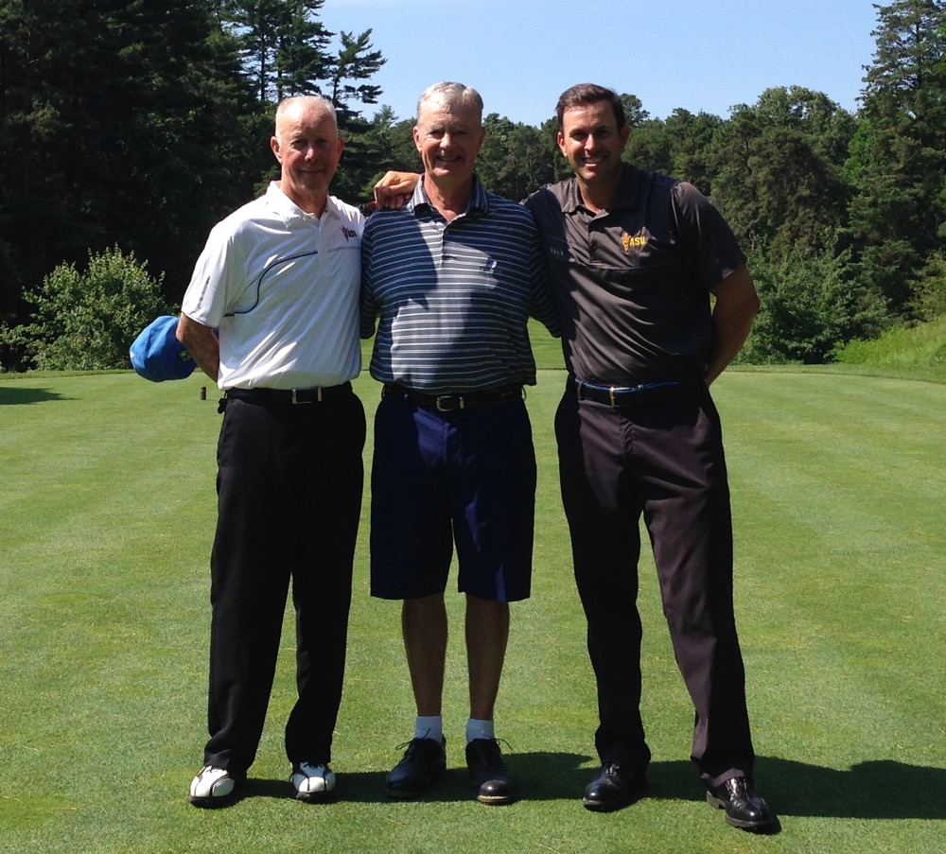
5th Tee Pine Valley Phil Mickelson, Sr & Tim Mickelson
Baltusrol Seniors

I’ve been fortunate enough to be a member of the Baltusrol Golf Club in Springfield, NJ since 1976. Even thought I’ve been a non-resident member since 1998, I drive the 280 miles from Manchester, MA four or five times each summer to play in selected club events, one of which is Seniors Day, a spring and fall one-day competition with about 150 players. I was lucky enough to win the Migel Cup in 2009 and again in 2012 for low spring net, but was in Scotland each September and so missed the fall portion and the opportunity to win the Woodruff Cup for the combined spring and fall winner.

I’m pleased to report the 2014 results from the “Baltusrol News”:

“For the first time in recent history, we had a draw for the Woodruff Cup between Bob McCoy and Jack Windolf, with low net scores of 133 (combining the spring and fall rounds). We also had a tie for the Lindgrove Cup, which is the low net score for the Fall Tournament only, with Bob Burks and Bob McCoy sharing a 64. Also on the Lower, John Walbridge, Bob McCoy, Steve Anderson and Jim Davies rallied for low net honors with a score of 58.”
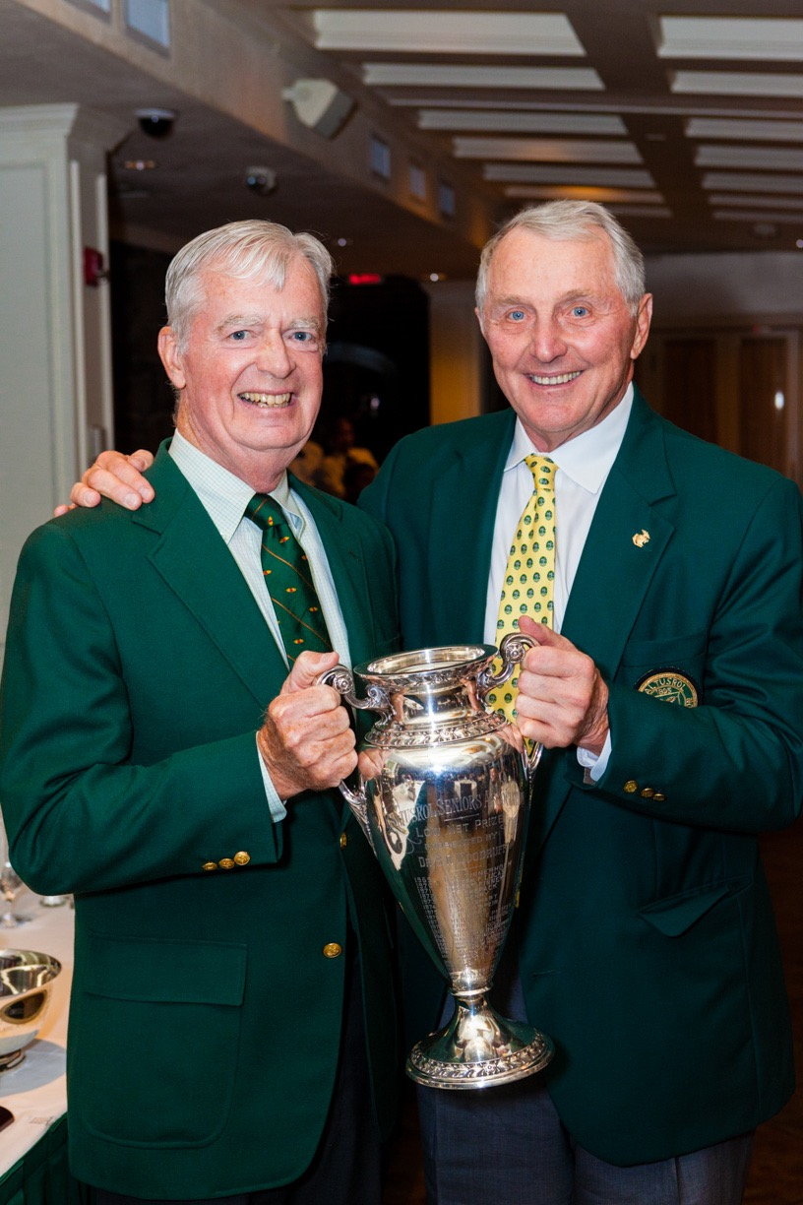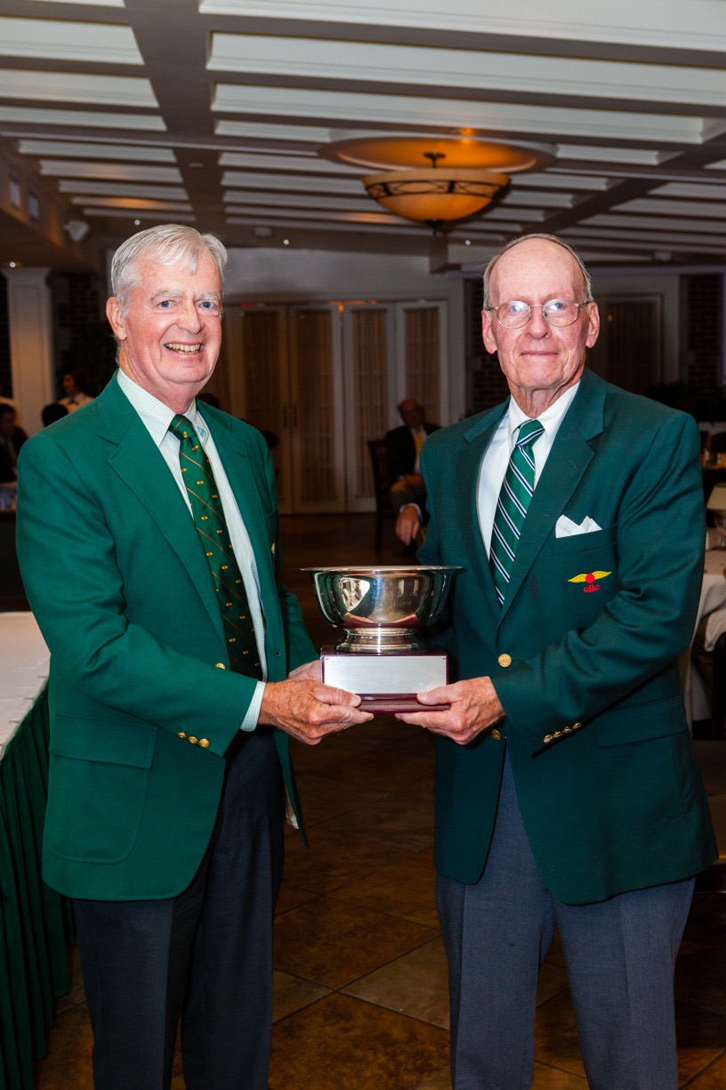
With Jack Windolf With Bob Burks

Website/Blog

I am pleased to say the website/blog “The Odyssey” “thegolfodyssey.com” made great progress in 2014. Kevin Larrabee is my IT guru and he has patiently created what I hope is an excellent working site. To easily locate it just Google “golf odyssey mccoy.

Having “The O” on a website gives everyone various options to read the material – computer, tablet, cell phone.

Some of the subject matter has been broken into sections to speed up the ability to open the document. If the document is too large it might not open at all or just takes too long to open. I do not want any frustrated readers.

Details on the “big trip” can be found under the “Itineraries” heading.

I welcome your visit and would appreciate any comments and/or suggestions you may have about the format and/or content.

The Book

Surprise, surprise!!! No progress was made in 2014 on “The Book.” The excuse is that I am just too busy planning and executing trips, trying to be a better golfer through playing and practicing, writing the yearly “O,” and just enjoying life with Elaine along with family and friends. These priorities overshadow the task of sitting down for extended periods of time pounding on the computer writing a book

After wrestling with many themes, I have decided to narrow the focus to “the life and times of a golf course rater” – the good, the bad, and the ugly. I am trying to whip all previous “O’s” into a continuous flow and then add material from pre-1985.

The working title is A Golf Odyssey with The Real McCoy. This title was the inspiration of San Jose, CA friend Gary Vandeweghe. Projected publication date: ?

Facebook
I have become a fan of Facebook. I like to see what my family and friends are up to. The golf blog on it that I really like is from Geoff Shackelford http://www.geoffshackelford.com. I keep my posts to a minimum, but do like to post something when I am at a course I am playing for the first time. If you are interested you can “friend” me by trying “Bob McCoy Naples Florida.”

Conclusion

I thank everyone who helped make the 2014 events possible. There is no way I could do any of what has happened in 2014, or for that matter all the other years of golf travel, without the help of so many people. As a friend said: “You are living the dream.” How lucky can a guy be!!!

As far as this “O” is concerned, special thanks goes to long-time friend Tony Maramarco for his editing expertise. While on a golf trip, he volunteered his services and I accepted in a nanosecond.

Wishing all the readers of the “O” good health and enjoyable golf in 2015.

Bob McCoy

